

L | T | P | C
2 | 0 | 0 | 2

II Year II Semester

MANAGERIAL ECONOMICS AND FINANCIAL ANALYSIS

Course Objectives:
- To inculcate the basic knowledge of micro economics and financial accounting
- To make the students learn how demand is estimated for different products, input- output relationship for optimizing production and cost
- To Know the Various types of market structure and pricing methods and strategy
- To give an overview on investment appraisal methods to promote the students to learn how to plan long-term investment decisions.
- To provide fundamental skills on accounting and to explain the process of preparing financial statements.

Course Outcomes:
- Define the concepts related to Managerial Economics, financial accounting and management.
- Understand the fundament also Economics viz., Demand, Production, cost, revenue and markets
- Apply the Concept of Production cost and revenues for effective Business decision
- Analyze how to invest their capital and maximize returns
- Evaluate the capital budgeting techniques
- Develop the accounting statements and evaluate the financial performance of business entity.

UNIT-I: -Managerial Economics: Introduction – Nature, meaning, significance, functions, and advantages. Demand-Concept, Function, Law of Demand - Demand Elasticity- Types – Measurement. Demand Forecasting- Factors governing Forecasting, Methods. Managerial Economics and Financial Accounting and Management.

UNIT-II: - Production and Cost Analysis: Introduction – Nature, meaning, significance, functions and advantages. Production Function– Least-cost combination– Short run and long run Production Function- Isoquants and Is costs, MRTS -Cobb-Douglas Production Function - Laws of Returns - Internal and External Economies of scale. Cost & Break-Even Analysis - Cost concepts and Cost behaviour- Break Even Analysis (BEA) -Determination of Break- Even Point (Simple Problems)-Managerial significance and limitations of Break- Even Analysis.

UNIT-III: - Business Organization and Markets: Introduction–Nature, meaning, significance, functions and advantages. Forms of Business Organizations - Sole Proprietary Partnership - Joint Stock Companies - Public Sector Enterprises. Types of Markets - Perfect and
Imperfect Competition - Features of Perfect Competition Monopoly- Monopolistic Competition– Oligopoly-Price-Output Determination-Pricing Methods and Strategies

UNIT-IV: - Capital Budgeting: Introduction – Nature, meaning, significance, functions and advantages. Types of Working Capital, Components, Sources of Short-term and Long-term Capital, Estimating Working Capital requirements. Capital Budgeting–Features, Proposals, Methods and Evaluation.
Projects– Pay Back Method, Accounting Rate of Return (ARR) Net Present Value (NPV) Internal Rate Return (IRR) Method (sample problems)

UNIT-V: - Financial Accounting and Analysis: Introduction – Nature, meaning, significance, functions and advantages. Concepts and Conventions-Double-Entry Book Keeping, Journal, Ledger, Trial Balance-
Final Accounts (Trading Account, Profit and Loss Account and Balance Sheet with simple adjustments).Financial Analysis-Analysis and Interpretation of Liquidity Ratios, Activity Ratios, and Capital structure Ratios and Profitability.

Textbooks:
1. Varshney & Maheswari: Managerial Economics, Sultan Chand, 2013.

Reference Books:
- Managerial Economics: Principles And Worldwide Applications, 9E (Adaptation) by Dominick Salvatore and Siddhartha Rastogi
- Managerial Economics: Principles and Worldwide Applications by Dominick Salvatore

UNIT-I Managerial Economics

MANAGEMENT
Management is the science and art of getting things done through people in formally organized groups. It is necessary that every organization be well managed to enable it to achieve its desired goals. Management includes a number of functions: Planning, organizing, staffing, directing, and controlling. The manager while directing the efforts of his staff communicates to them the goals, objectives, policies, and procedures; coordinates their efforts; motivates them to sustain their enthusiasm; and leads them to achieve the corporate goals.
Welfare Economics

Welfare economics is that branch of economics, which primarily deals with taking of poverty, famine and distribution of wealth in an economy. This is also called Development Economics. The central focus of welfare economics is to assess how well things are going for the members of the society. If certain things have gone terribly bad in some situation, it is necessary to explain why things have gone wrong. Prof. Amartya Sen was awarded the Nobel Prize in Economics in 1998 in recognition of his contributions to welfare economics. Prof. Sen gained recognition for his studies of the 1974 famine in Bangladesh. His work has challenged the common view that food shortage is the major cause of famine.

In the words of Prof. Sen, famines can occur even when the food supply is high but people cannot buy the food because they don’t have money. There has never been a famine in a democratic country because leaders of those nations are spurred into action by politics and free media. In undemocratic countries, the rulers are unaffected by famine and there is no one to hold them accountable, even when millions die.

Welfare economics takes care of what managerial economics tends to ignore. In other words, the growth for an economic growth with societal upliftment is countered productive. In times of crisis, what comes to the rescue of people is their won literacy, public health facilities, a system of food distribution, stable democracy, social safety, (that is, systems or policies that take care of people when things go wrong for one reason or other).

Imagine for a while that you have finished your studies and have joined as an engineer in a manufacturing organization. What do you do there? You plan to produce maximum quantity of goods of a given quality at a reasonable cost. On the other hand, if you are a sale manager, you have to sell a maximum amount of goods with minimum advertisement costs. In other words, you want to minimize your costs and maximize your returns and by doing so, you are practicing the principles of managerial economics.
Managers, in their day-to-day activities, are always confronted with several issues such as how much quantity is to be supplied; at what price; should the product be made internally; or whether it should be bought from outside; how much quantity is to be produced to make a given amount of profit and so on. Managerial economics provides us a basic insight into seeking solutions for managerial problems.
ECONOMICS
Economics is a study of human activity both at individual and national level. The economists of early age treated economics merely as the science of wealth. The reason for this is clear.
Every one of us in involved in efforts aimed at earning money and spending this money to satisfy our wants such as food, Clothing, shelter, and others. Such activities of earning and spending money are called “Economic activities”.
It was only during the eighteenth century that Adam Smith, the Father of Economics, defined economics as the study of nature and uses of national wealth’.
Dr. Alfred Marshall, one of the greatest economists of the nineteenth century, writes
“Economics is a study of man’s actions in the ordinary business of life: it enquires how he gets his income and how he uses it”. Thus, it is one side, a study of wealth; and on the other, and more important side; it is the study of man. As Marshall observed, the chief aim of economics is to promote ‘human welfare’, but not wealth.

How to produce?

What to produce?

When to produce?

Where to pro
duce

Why to produce?

Scarcity

Unlimited wants

Limited resources

All the above questions will lead to a business problem. The science which gives optimal solution for the above business problems is managerial economic

Business problem

Management/manager
decision

Traditional economics

Optimal solution

Managerial Economics

Meaning & Definition:
Managerial Economics as a subject gained popularity in USA after the publication of the book “Managerial Economics” by Joel Dean in 1951.
Managerial Economics refers to the firm’s decision making process. It could be also interpreted as “Economics of Management” or “Economics of Management”. Managerial Economics is also called as “Industrial Economics” or “Business Economics”.
“Managerial Economics is the integration of economic theory with business practice for the purpose of facilitating decision making and forward planning by management”. --M. H. Spencer and Louis Seigelman
Managerial economics shows how economic analysis can be used in formulating police.
-- Joel Dean Managerial economics is designed to provide a rigorous treatment of those aspects of economic theory and analysis that are most use for managerial decision analysis
------ J. L. Pappas and E. F. Brigham.

Nature of Managerial Economics

Managerial economics is, perhaps, the youngest of all the social sciences. Since it originates from Economics, it has the basis features of economics, such as assuming that other things remaining the same (or the Latin equivalent ceteris paribus). This assumption is made to simplify the complexity of the managerial phenomenon under study in a dynamic business environment so many things are changing simultaneously. This set a limitation that we cannot really hold other things remaining the same. In such a case, the observations made out of such a study will have a limited purpose or value. Managerial economics also has inherited this problem from economics.

Further, it is assumed that the firm or the buyer acts in a rational manner (which normally does not happen). The buyer is carried away by the advertisements, brand loyalties, incentives and so on, and, therefore, the innate behaviour of the consumer will be rational is not a realistic assumption. Unfortunately, there are no other alternatives to understand the subject other than by making such assumptions. This is because the behaviour of a firm or a consumer is a complex phenomenon.

The other features/ characteristics of managerial economics are explained as below:

- Close to microeconomics: Managerial economics is concerned with finding the solutions for different managerial problems of a particular firm. Thus, it is more close to microeconomics.
- Operates against the backdrop of macroeconomics: The macroeconomics conditions of the economy are also seen as limiting factors for the firm to operate. In other words, the managerial economist has to be aware of the limits set by the macroeconomics conditions such as government industrial policy, inflation and so on.
- Normative statements: A normative statement usually includes or implies the words ‘ought’ or ‘should’. They reflect people’s moral attitudes and are expressions of what a team of people ought to do. For instance, it deals with statements such as ‘Government of India should open up the economy. Such statement are based on value judgments and express views of what is ‘good’ or ‘bad’, ‘right’ or ‘ wrong’. One problem with normative statements is that they cannot to verify by looking at the facts, because they mostly deal with the future. Disagreements about such statements are usually settled by voting on them.
- Prescriptive actions: Prescriptive action is goal oriented. Given a problem and the objectives of the firm, it suggests the course of action from the available alternatives for optimal solution. If does not merely mention the concept, it also explains whether the concept can be applied in a given context on not. For instance, the fact that variable costs are marginal costs can be used to judge the feasibility of an export order.
- Applied in nature: ‘Models’ are built to reflect the real life complex business situations and these models are of immense help to managers for decisionmaking. The different areas where models are extensively used include inventory control, optimization, project management etc. In managerial economics, we also employ case study methods to conceptualize the problem, identify that alternative and determine the best course of action.
- Offers scope to evaluate each alternative: Managerial economics provides an opportunity to evaluate each alternative in terms of its costs and revenue. The managerial economist can decide which is the better alternative to maximize the profits for the firm.
- Interdisciplinary: The contents, tools and techniques of managerial economics are drawn from different subjects such as economics, management, mathematics, statistics, accountancy, psychology, organizational behavior, sociology and etc.
- Assumptions and limitations: Every concept and theory of managerial economics is based on certain assumption and as such their validity is not universal. Where there is change in assumptions, the theory may not hold good at all.

SCOPE OF MANAGERIAL ECONOMICS:
The scope of managerial economics refers to its area of study. Managerial economics refers to its area of study. Managerial economics is help to find out the optimal solution for different managerial problems such as Production, Capital Management Decisions, Pricing Decisions, Promotion Strategies, Demand Analyses and Forecasting, Resource Allocation Profit analysis ,Capital or investment analyses, Profit Expectation and Management
The production department, marketing and sales department and the finance department usually handle these five types of decisions.

Production

Capital Management Decisions

Pricing Decisions

Promotion Strategies

Demand
Analyses and Forecasting:

Resource Allocation:

Profit analysis:

Capital or investment analyses:

Profit Expectation and Management

Concepts of
Managerial
economics

Optimum solution

- Production
It means inputs are transfer to output. Production analysis is in physical terms. While the cost analysis is in monetary terms cost concepts and classifications, cost-out-put relationships, economies and diseconomies of scale and production functions are some of the points constituting cost and production analysis.
- Capital Management Decisions
Capital management decision carries lot of weight age in the organization. It deals with various options of capital employment and respective returns with that investment. A manager has to select optimal investment decision among the available options with the use of managerial economics using discounted cash flow techniques and non discounted can flow techniques.
- Pricing Decisions
Pricing plays a vital role in the success of product as well as the organization. Managerial Economics provides different types of prices for products. Managerial Economics has a close watch on the factors affecting the pricing. How the organization has to price the items, when to do changes in pricing like questions will be answered by managerial Economics. Pricing decisions have been always within the preview of managerial economics. Pricing policies are merely a subset of broader class of managerial economic problems. Price theory helps to explain how prices are determined under different types of market conditions.
- Promotion Strategies
Whatever many be the quality of product, if it was not reached to final customer, it cannot get success. So, proper promotion has to be done in all products and services. Managerial Economics guides managers how to promote and what is the sector they need to concentrate more and what should be the advertisement budget etc.

- Demand Analyses and Forecasting:
A firm can survive only if it is able to the demand for its product at the right time, within the right quantity. Understanding the basic concepts of demand is essential for demand forecasting. Demand analysis should be a basic activity of the firm because many of the other activities of the firms depend upon the outcome of the demand forecast.
- Resource Allocation:
Managerial Economics is the traditional economic theory that is concerned with the problem of optimum allocation of scarce resources. Marginal analysis is applied to the problem of determining the level of output, which maximizes profit. In this respect linear programming techniques has been used to solve optimization problems. In fact lines programming is one of the most practical and powerful managerial decision making tools currently available.
- Profit analysis:
Profit making is the major goal of firms. There are several constraints here an account of competition from other products, changing input prices and changing business environment hence in spite of careful planning, there is always certain risk involved.
Managerial economics deals with techniques of averting of minimizing risks. Profit theory guides in the measurement and management of profit, in calculating the pure return on capital, besides future profit planning.
- Capital or investment analyses:
Capital is the foundation of business. Lack of capital may result in small size of operations. Availability of capital from various sources like equity capital, institutional finance etc. may help to undertake large-scale operations. Hence efficient allocation and management of capital is one of the most important tasks of the managers. The major issues related to capital analysis are:
  - The choice of investment project
  - Evaluation of the efficiency of capital
  - Most efficient allocation of capital
Knowledge of capital theory can help very much in taking investment decisions. This involves, capital budgeting, feasibility studies, analysis of cost of capital etc.
- Profit Expectation and Management
In addition to the all the above, sales of product takes place. Managerial economics tells us when can we reach the breakeven point and when can be we get profit. It also guides as in holders or reinvest in the same product.
These are the application areas where managerial economics can be used to take a decision.

Managerial economics relationship with other disciplines/ subjects:

Many new subjects have evolved in recent years due to the interaction among basic disciplines. While there are many such new subjects in natural and social sciences, managerial economics can be taken as the best example of such a phenomenon among social sciences. Hence it is necessary to trace its roots and relation ship with other disciplines.

- Relationship with economics:

The relationship between managerial economics and economics theory may be viewed form the point of view of the two approaches to the subject Viz. Micro Economics and Marco Economics. Microeconomics is the study of the economic behavior of individuals, firms and other such micro organizations. Managerial economics is rooted in Micro Economic theory. Managerial Economics makes use to several Micro Economic concepts such as marginal cost, marginal revenue, elasticity of demand as well as price theory and theories of market structure to name only a few. Macro theory on the other hand is the study of the economy as a whole. It deals with the analysis of national income, the level of employment, general price level, consumption and investment in the economy and even matters related to international trade, Money, public finance, etc.
The relationship between managerial economics and economics theory is like that of engineering science to physics or of medicine to biology. Managerial economics has an applied bias and its wider scope lies in applying economic theory to solve real life problems of enterprises. Both managerial economics and economics deal with problems of scarcity and resource allocation.

- Management theory and accounting:

Managerial economics has been influenced by the developments in management theory and accounting techniques. Accounting refers to the recording of pecuniary transactions of the firm in certain books. A proper knowledge of accounting techniques is very essential for the success of the firm because profit maximization is the major objective of the firm.

Managerial Economics requires a proper knowledge of cost and revenue information and their classification. A student of managerial economics should be familiar with the generation, interpretation and use of accounting data. The focus of accounting within the firm is fast changing from the concepts of store keeping to that if managerial decision making, this has resulted in a new specialized area of study called “Managerial Accounting”.

- Managerial Economics and mathematics:

The use of mathematics is significant for managerial economics in view of its profit maximization goal long with optional use of resources. The major problem of the firm is how to minimize cost, hoe to maximize profit or how to optimize sales. Mathematical concepts and techniques are widely used in economic logic to solve these problems. Also mathematical methods help to estimate and predict the economic factors for decision making and forward planning.

Mathematical symbols are more convenient to handle and understand various concepts like incremental cost, elasticity of demand etc., Geometry, Algebra and calculus are the major branches of mathematics which are of use in managerial economics. The main concepts of mathematics like logarithms, and exponentials, vectors and determinants, input-output models etc., are widely used. Besides these usual tools, more advanced techniques designed in the recent years viz. linear programming, inventory models and game theory fine wide application in managerial economics.

- Managerial Economics and Statistics:

Managerial Economics needs the tools of statistics in more than one way. A successful businessman must correctly estimate the demand for his product. He should be able to analyses the impact of variations in tastes. Fashion and changes in income on demand only then he can adjust his output. Statistical methods provide and sure base for decisionmaking. Thus statistical tools are used in collecting data and analyzing them to help in the decision making process.

Statistical tools like the theory of probability and forecasting techniques help the firm to predict the future course of events. Managerial Economics also make use of correlation and multiple regressions in related variables like price and demand to estimate the extent of dependence of one variable on the other. The theory of probability is very useful in problems involving uncertainty.

- Managerial Economics and Operations Research:

Taking effectives decisions is the major concern of both managerial economics and operations research. The development of techniques and concepts such as linear programming, inventory models and game theory is due to the development of this new subject of operations research in the postwar years. Operations research is concerned with the complex problems arising out of the management of men, machines, materials and money.

Operation research provides a scientific model of the system and it helps managerial economists in the field of product development, material management, and inventory control, quality control, marketing and demand analysis. The varied tools of operations Research are helpful to managerial economists in decision-making.

- Managerial Economics and the theory of Decision- making:

The Theory of decision-making is a new field of knowledge grown in the second half of this century. Most of the economic theories explain a single goal for the consumer i.e., Profit maximization for the firm. But the theory of decision-making is developed to explain multiplicity of goals and lot of uncertainty.

As such this new branch of knowledge is useful to business firms, which have to take quick decision in the case of multiple goals. Viewed this way the theory of decision making is more practical and application oriented than the economic theories.

Managerial Economics and Computer Science:

Computers have changes the way of the world functions and economic or business activity is no exception. Computers are used in data and accounts maintenance, inventory and stock controls and supply and demand predictions. What used to take days and months is done in a few minutes or hours by the computers. In fact computerization of business activities on a large scale has reduced the workload of managerial personnel. In most countries a basic knowledge of computer science, is a compulsory programme for managerial trainees.

To conclude, managerial economics, which is an offshoot traditional economics, has gained strength to be a separate branch of knowledge. It strength lies in its ability to integrate ideas from various specialized subjects to gain a proper perspective for decision-making.

A successful managerial economist must be a mathematician, a statistician and an economist. He must be also able to combine philosophic methods with historical methods to get the right perspective only then; he will be good at predictions. In short managerial practices with the help of other allied sciences.

THE ROLE OF MANAGERIAL ECONOMIST

Making decisions and processing information are the two primary tasks of the managers. Managerial economists have gained importance in recent years with the emergence of an organizational culture in production and sales activities.

A management economist with sound knowledge of theory and analytical tools for information system occupies a prestigious place among the personnel. A managerial economist is nearer to the policy-making. Equipped with specialized skills and modern techniques he analyses the internal and external operations of the firm. He evaluates and helps in decision making regarding sales, Pricing financial issues, labour relations and profitability. He helps in decision-making keeping in view the different goals of the firm.

His role in decision-making applies to routine affairs such as price fixation, improvement in quality, Location of plant, expansion or contraction of output etc. The role of managerial economist in internal management covers wide areas of production, sales and inventory schedules of the firm.

The most important role of the managerial economist relates to demand forecasting because an analysis of general business conditions is most vital for the success of the firm. He prepares a short-term forecast of general business activity and relates general economic forecasts to specific market trends. Most firms require two forecasts one covering the short term (for nest three months to one year) and the other covering the long term, which represents any period exceeding one-year. He has to be ever alert to gauge the changes in tastes and preferences of the consumers. He should evaluate the market potential. The need to know forecasting techniques on the part of the managerial economics means, he should be adept at market research. The purpose of market research is to provide a firm with information about current market position as well as present and possible future trends in the industry. A managerial economist who is well equipped with this knowledge can help the firm to plan product improvement, new product policy, pricing, and sales promotion strategy.

The fourth function of the managerial economist is to undertake an economic analysis of the industry. This is concerned with project evaluation and feasibility study at the firm level i.e., he should be able to judge on the basis of cost benefit analysis, whether it is advisable and profitable to go ahead with the project. The managerial economist should be adept at investment appraisal methods. At the external level, economic analysis involves the knowledge of competition involved, possibility of internal and foreign sales, the general business climate etc.

Another function is security management analysis. This is very important in the case of defense-oriented industries, power projects, and nuclear plants where security is very essential. Security management means, also that the production and trade secrets concerning technology, quality and other such related facts should not be leaked out to others. This security is more necessary in strategic and defense-oriented projects of national importance; a managerial economist should be able to manage these issues of security management analysis.

The sixth function is an advisory function. Here his advice is required on all matters of production and trade. In the hierarchy of management, a managerial economist ranks next to the top executives or the policy maker who may be doyens of several projects. It is the managerial economist of each firm who has to advise them on all matters of trade since they are in the know of actual functioning of the unit in all aspects, both technical and financial.

Another function of importance for the managerial economist is a concerned with pricing and related problems. The success of the firm depends upon a proper pricing strategy. The pricing decision is one of the most difficult decisions to be made in business because the information required is never fully available. Pricing of established products is different from new products. He may have to operate in an atmosphere constrained by government regulation. He may have to anticipate the reactions of competitors in pricing. The managerial economist has to be very alert and dynamic to take correct pricing decision in changing environment.

Finally the specific function of a managerial economist includes an analysis of environment issues. Modern theory of managerial economics recognizes the social responsibility of the firm. It refers to the impact of a firm on environmental factors. It should not have adverse impact on pollution and if possible try to contribute to environmental preservation and protection in a positive way.

The role of management economist lies not in taking decision but in analyzing, concluding and recommending to the policy maker. He should have the freedom to operate and analyze and must possess full knowledge of facts. He has to collect and provide the quantitative data from within the firm. He has to get information on external business environment such as general market conditions, trade cycles, and behavior pattern of the consumers. The managerial economist helps to co-ordinate policies relating to production, investment, inventories and price.

He should have equanimity to meet crisis. He should act only after analysis and discussion with relevant departments. He should have diplomacy to act in advisory capacity to the top executive as well as getting co-operation from different departments for his economic analysis. He should do well to have intuitive ability to know what is good or bad for the firm.

He should have sound theoretical knowledge to take up the challenges he has to face in actual day to day affairs. “BANMOL” referring to the role of managerial economist points out. “A managerial economist can become a for more helpful member of a management group by virtue of studies of economic analysis, primarily because there he learns to become an effective model builder and because there he acquires a very rich body of tools and techniques which can help to deal with the problems of the firm in a far more rigorous, a far more probing and a far deeper manner”.

DEMAND ANALYSIS
INTRODUCTION & MEANING:
Demand in common parlance means the desire for an object. But in economics demand is something more than this. According to Stonier and Hague, “Demand in economics means demand backed up by enough money to pay for the goods demanded”. This means that the demand becomes effective only it if is backed by the purchasing power in addition to this there must be willingness to buy a commodity.
Thus demand in economics means the desire backed by the willingness to buy a commodity and the purchasing power to pay. In the words of “Benham” “The demand for anything at a given price is the amount of it which will be bought per unit of time at that Price”. (Thus demand is always at a price for a definite quantity at a specified time.) Thus demand has three essentials – price, quantity demanded and time. Without these, demand has to significance in economics.
A product or services is said to have demand when three conditions are satisfied:

Desire + Ability to pay + Willingness to pay for it = Demand

Price of Apple (In. Rs.) | Quantity  Demanded
10 | 1
8 | 2
6 | 3
4 | 4
2 | 5

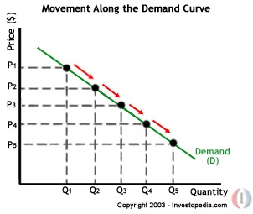

TYPES OF DEMAND:-

The different types of demand are;
i) Direct and Derived Demands
Direct demand refers to demand for goods meant for final consumption; it is the demand for consumers’ goods like food items, readymade garments and houses. By contrast, derived demand refers to demand for goods which are needed for further production; it is the demand for producers’ goods like industrial raw materials, machine tools and equipments. Thus the demand for an input or what is called a factor of production is a derived demand; its demand depends on the demand for output where the input enters. In fact, the quantity of demand for the final output as well as the degree of substitutability/complementary between inputs would determine the derived demand for a given input.

For example, the demand for gas in a fertilizer plant depends on the amount of fertilizer to be produced and substitutability between gas and coal as the basis for fertilizer production. However, the direct demand for a product is not contingent upon the demand for other products.

- Domestic and Industrial Demands
The example of the refrigerator can be restated to distinguish between the demand for domestic consumption and the demand for industrial use. In case of certain industrial raw materials which are also used for domestic purpose, this distinction is very meaningful. For example, coal has both domestic and industrial demand, and the distinction is important from the standpoint of pricing and distribution of coal.

- Autonomous and Induced Demand
When the demand for a product is tied to the purchase of some parent product, its demand is called induced or derived.
For example, the demand for cement is induced by (derived from) the demand for housing. As stated above, the demand for all producers’ goods is derived or induced. In addition, even in the realm of consumers’ goods, we may think of induced demand. Consider the complementary items like tea and sugar, bread and butter etc. The demand for butter (sugar) may be induced by the purchase of bread (tea). Autonomous demand, on the other hand, is not derived or induced. Unless a product is totally independent of the use of other products, it is difficult to talk about autonomous demand. In the present world of dependence, there is hardly any autonomous demand. Nobody today consumers just a single commodity; everybody consumes a bundle of commodities. Even then, all direct demand may be loosely called autonomous.

- Perishable and Durable Goods’ Demands
Both consumers’ goods and producers’ goods are further classified into perishable/nondurable/single-use goods and durable/non-perishable/repeated-use goods. The former refers to final output like bread or raw material like cement which can be used only once. The latter refers to items like shirt, car or a machine which can be used repeatedly. In other words, we can classify goods into several categories: single-use consumer goods, single-use producer goods, durable-use consumer goods and durable-use producer’s goods.

This distinction is useful because durable products present more complicated problems of demand analysis than perishable products. Non-durable items are meant for meeting immediate (current) demand, but durable items are designed to meet current as well as future demand as they are used over a period of time. So, when durable items are purchased, they are considered to be an addition to stock of assets or wealth. Because of continuous use, such assets like furniture or washing machine, suffer depreciation and thus call for replacement. Thus durable goods demand has two varieties – replacement of old products and expansion of total stock. Such demands fluctuate with business conditions, speculation and price expectations. Real wealth effect influences demand for consumer durables.

- New and Replacement Demands
This distinction follows readily from the previous one. If the purchase or acquisition of an item is meant as an addition to stock, it is a new demand. If the purchase of an item is meant for maintaining the old stock of capital/asset, it is replacement demand. Such replacement expenditure is to overcome depreciation in the existing stock.
Producers’ goods like machines. The demand for spare parts of a machine is replacement demand, but the demand for the latest model of a particular machine (say, the latest generation computer) is a new demand. In course of preventive maintenance and breakdown maintenance, the engineer and his crew often express their replacement demand, but when a new process or a new technique or a new product is to be introduced, there is always a new demand.
You may now argue that replacement demand is induced by the quantity and quality of the existing stock, whereas the new demand is of an autonomous type. However, such a distinction is more of degree than of kind. For example, when demonstration effect operates, a new demand may also be an induced demand. You may buy a new VCR, because your neighbour has recently bought one. Yours is a new purchase, yet it is induced by your neighbour’s demonstration.

- Final and Intermediate Demands
This distinction is again based on the type of goods- final or intermediate. The demand for semi-finished products, industrial raw materials and similar intermediate goods are all derived demands, i.e., induced by the demand for final goods. In the context of input-output models, such distinction is often employed.

- Individual and Market Demands
This distinction is often employed by the economist to study the size of the buyers’ demand, individual as well as collective. A market is visited by different consumers, consumer differences depending on factors like income, age, sex etc. They all react differently to the prevailing market price of a commodity. For example, when the price is very high, a low-income buyer may not buy anything, though a high income buyer may buy something. In such a case, we may distinguish between the demand of an individual buyer and that of the market which is the market which is the aggregate of individuals. You may note that both individual and market demand schedules (and hence curves, when plotted) obey the law of demand. But the purchasing capacity varies between individuals. For example, A is a high income consumer, B is a middle-income consumer and C is in the low-income group. This information is useful for personalized service or target-group-planning as a part of sales strategy formulation.

- Total Market and Segmented Market Demands
This distinction is made mostly on the same lines as above. Different individual buyers together may represent a given market segment; and several market segments together may represent the total market. For example, the Hindustan Machine Tools may compute the demand for its watches in the home and foreign markets separately; and then aggregate them together to estimate the total market demand for its HMT watches. This distinction takes care of different patterns of buying behaviour and consumers’ preferences in different segments of the market. Such market segments may be defined in terms of criteria like location, age, sex, income, nationality, and so on

x) Company and Industry Demands
An industry is the aggregate of firms (companies). Thus the Company’s demand is similar to an individual demand, whereas the industry’s demand is similar to aggregated total demand. You may examine this distinction from the standpoint of both output and input. For example, you may think of the demand for cement produced by the Cement Corporation of India (i.e., a company’s demand), or the demand for cement produced by all cement manufacturing units including the CCI (i.e., an industry’s demand). Similarly, there may be demand for engineers by a single firm or demand for engineers by the industry as a whole, which is an example of demand for an input. You can appreciate that the determinants of a company’s demand may not always be the same as those of an industry. The inter-firm differences with regard to technology, product quality, financial position, market (demand) share, market leadership and competitiveness- all these are possible explanatory factors. In fact, a clear understanding of the relation between company and industry demands necessitates an understanding of different market structures.

FACTORS AFFECTING DEMAND:
There are factors on which the demand for a commodity depends. These factors are economic, social as well as political factors. The effect of all the factors on the amount demanded for the commodity is called Demand Function.
These factors are as follows:
- Price of the Commodity:
The most important factor-affecting amount demanded is the price of the commodity. The amount of a commodity demanded at a particular price is more properly called price demand. The relation between price and demand is called the Law of Demand. It is not only the existing price but also the expected changes in price, which affect demand
- Income of the Consumer:
The second most important factor influencing demand is consumer income. In fact, we can establish a relation between the consumer income and the demand at different levels of income, price and other things remaining the same. The demand for a normal commodity goes up when income rises and falls down when income falls. But in case of Giffen goods the relationship is the opposite.

3. Prices of related goods:
The demand for a commodity is also affected by the changes in prices of the related goods also. Related goods can be of two types:
- Substitutes which can replace each other in use; for example, tea and coffee are substitutes. The change in price of a substitute has effect on a commodity’s demand in the same direction in which price changes. The rise in price of coffee shall raise the demand for tea;
- Complementary goods are those which are jointly demanded, such as pen and ink. In such cases complementary goods have opposite relationship between price of one commodity and the amount demanded for the other. If the price of pens goes up, their demand is less as a result of which the demand for ink is also less.
The price and demand go in opposite direction. The effect of changes in price of a commodity on amounts demanded of related commodities is called Cross Demand.
- Tastes of the Consumers:
The amount demanded also depends on consumer’s taste. Tastes include fashion, habit, customs, etc. A consumer’s taste is also affected by advertisement. If the taste for a commodity goes up, its amount demanded is more even at the same price. This is called increase in demand. The opposite is called decrease in demand.
- Population:
Increase in population increases demand for necessaries of life. The composition of population also affects demand. Composition of population means the proportion of young and old and children as well as the ratio of men to women. A change in composition of population has an effect on the nature of demand for different commodities.
- Expectations regarding the future:
If consumers expect changes in price of commodity in future, they will change the demand at present even when the present price remains the same. Similarly, if consumers expect their incomes to rise in the near future they may increase the demand for a commodity just now.
- Advertisement expenditure:
Advertisement promotes sales. Other factors remaining same, with every increase in the advertisement expense there will be an increase in sales.
- Demonstration effect:
Demand for luxury item is always great among the rich. This naturally influences the less affluent or the lower income group in the neighborhood. They also begin to buy luxury item to imitate their rich neighbors even when they do not have any genuine need for them
- Climate and weather:
The climate of an area and the weather prevailing there has a decisive effect on consumer’s demand. In cold areas woolen cloth is demanded. During hot summer days, ice is very much in demand. On a rainy day, ice cream is not so much demanded.

LAW OF DEMAND
Law of demand shows the relation between price and quantity demanded of a commodity in the market. In the words of Marshall, “the amount demand increases with a fall in price and diminishes with a rise in price”.
Generally, a person demands more at a lower price and less at a higher price. The relation of price to demand or sales is known in Economics as the Law of Demand.
The Law of Demand states that “higher the price, lower the demand and vice versa, other things remaining the same”.
The demand curve slopes downward from left to rights showing that more quantities are demanded at lower prices. That is, demand responds to price in the reverse direction. The reasons for the inverse relation between price and quantity demanded are the following:
Demand Schedule

Price of Apple  (In. Rs.) | Quantity  Demanded
10 | 1
8 | 2
6 | 3
4 | 4
2 | 5
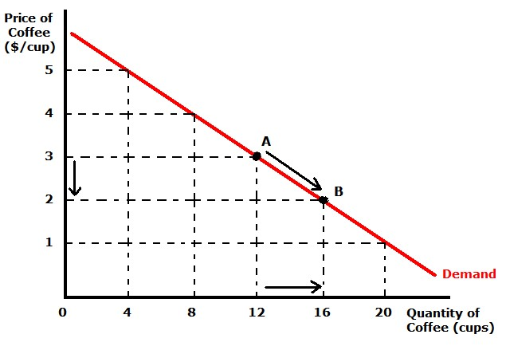
When the price falls from Rs. 10 to 8 quantity demand increases from 1 to 2. In the same way as price falls, quantity demand increases on the basis of the demand schedule we can draw the demand curve The demand curve DD shows the inverse relation between price and quantity demand of apple. It is downward sloping.
Income Effect:
A fall in price results in an increase in incomes of the consumer. As the price falls he can buy the same quantity as before with less amount of money. Thus he gains some money a part of which can be used for purchasing some more unit of the same commodity. This results in an increase in demand for that commodity. This results in an increase in demand for that commodity. When the price rises the consumers’ income is reduced. This causes fall in the purchasing power of the consumer. Now he can buy lesser quantity with the same amount. Hence, we can observe a decrease in demand o that commodity.

Substitute Effect:
When the price of a commodity rises, the consumer may substitute that relatively costly commodity with less costly one if the substitutes are available. When tea becomes cheaper some people may shift their consumption from coffee to tea. Similarly if the price rises consumers, to some extent, may substitute the costly commodity with a comparatively low priced commodity of a similar kind.
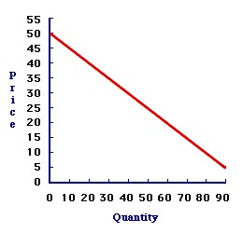

Diminishing of Marginal Utility:
If a person consumes more units of the same commodity, he will get less and less satisfaction from the additional units i.e., the utility from each additional units goes on diminishing. The consumer will be ready to buy the additional unit only if is available at a lower price. That is why consumers buy more at lower prices. He goes on buying till the marginal utility of the product is equal to its price.
Assumptions:
- Law is demand is based on certain assumptions:
- This is no change in consumers taste and preferences.
- Income should remain constant.
- Prices of other goods should not change.
- There should be no substitute for the commodity
- The commodity should not confer at any distinction
- The demand for the commodity should be continuous
- People should not expect any change in the price of the commodity
EXCEPTIONAL DEMAND CURVE
Sometimes the demand curve slopes upwards from left to right. In this case the demand curve has a positive slope.
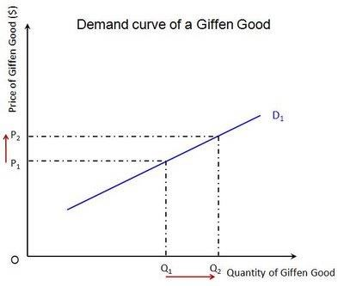
When price increases from OP to Op1 quantity demanded also increases from to OQ1 and vice versa. The reasons for exceptional demand curve are as follows.
- Giffen paradox:
Robert Giffen has observed an effect of goods which has increase in demand even if price raised and goods demand decreases even if price decreased. He named above the goods as
  - Superior goods
  - Inferior goods
Ex: if a person buy bread and meat daily, If the price of bread is decreased, he will not purchases more breads, for the balance of money he will purchases meat . Decrease in the price of an inferior goods does not increases its demand, dut increase the demand for superior goods
The Giffen good or inferior good is an exception to the law of demand. When the price of an inferior good falls, the poor will buy less and vice versa. For example, when the price of maize falls, the poor are willing to spend more on superior goods than on maize if the price of maize increases, he has to increase the quantity of money spent on it. Otherwise he will have to face starvation. Thus a fall in price is followed by reduction in quantity demanded and vice versa. “Giffen” first explained this and therefore it is called as Giffen’s paradox.
- Demonstration effect:
‘Veblen’ has explained the exceptional demand curve through his doctrine of conspicuous consumption. Rich people buy certain good because it gives social distinction or prestige for example diamonds are bought by the richer class for the prestige it possess. It the price of diamonds falls poor also will buy is hence they will not give prestige. Therefore, rich people may stop buying this commodity.
- Ignorance:
Sometimes, the quality of the commodity is Judge by its price. Consumers think that the product is superior if the price is high. As such they buy more at a higher price.

- Speculative effect:
If the price of the commodity is increasing the consumers will buy more of it because of the fear that it increase still further, Thus, an increase in price may not be accomplished by a decrease in demand.
- Fear of shortage:
During the times of emergency of war People may expect shortage of a commodity. At that time, they may buy more at a higher price to keep stocks for the future.
- Necessaries:
In the case of necessaries like rice, vegetables etc. people buy more even at a higher price.
- Goods don’t have substitutes:
As a general tendency, demand has to be decrease with increase in price, but if any goods don’t have substitutes, like salt and medicines, the demand will not get decreases. People will definitely buy as they don’t have other alternative
- Insignificant income spent on goods:
If consumers spend a small amount for any goods the price changes will not influence the demand for that sort of goods, as they spent insignificant income or match boxes they might not reduce buying even if price rises
- Conspicuous consumption:
Goods like diamonds, pearls etc. are purchased by rich and wealthy section of the society because the price of such goods are so high that they are beyond the reach of a common man. most of these goods are demand when their price go up very high

ELASTICITY OF DEMAND
Elasticity of demand explains the relationship between a change in price and consequent change in amount demanded. “Marshall” introduced the concept of elasticity of demand. Elasticity of demand shows the extent of change in quantity demanded to a change in price.
In the words of “Marshall”, “The elasticity of demand in a market is great or small according as the amount demanded increases much or little for a given fall in the price and diminishes much or little for a given rise in Price”
Elastic demand: A small change in price may lead to a great change in quantity demanded. In this case, demand is elastic.
In-elastic demand: If a big change in price is followed by a small change in demanded then the demand in “inelastic”.
Proportionate change in the quantity demand of commodity
Elasticity of Demand (Ed) = ------------------------------------------------------------------------------------
Proportionate change in the factors of commodity
MEASUREMENT OF ELASTICITY OF DEMAND
- Perfectly elastic demand
- Perfectly in-elastic Demand
- Relatively elastic demand
- Relatively in-elastic demand
- Unit elasticity of demand

- Perfectly Elastic Demand:

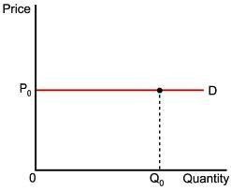

When small change in price leads to an infinitely large change is quantity demand, it is called perfectly or infinitely elastic demand. In this case E=∞
The demand curve DD1 is horizontal straight line. It shows the at “OP” price any amount is demand and if price increases, the consumer will not purchase the commodity.
- Perfectly Inelastic Demand
In this case, even a large change in price fails to bring about a change in quantity demanded.
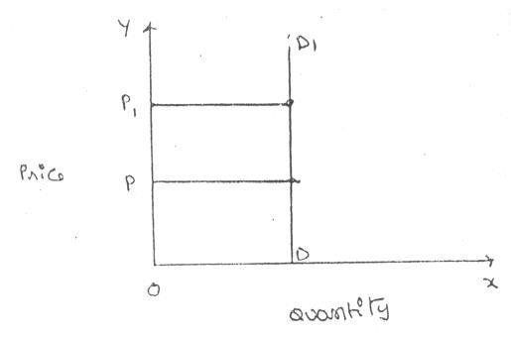
When price increases from ‘OP’ to ‘OP1’, the quantity demanded remains the same. In other words the response of demand to a change in Price is nil. In this case ‘E’=0. C. Relatively Elastic Demand:
Demand changes more than proportionately to a change in price. i.e. a small change in price loads to a very big change in the quantity demanded. In this caseE > 1. This demand curve will be flatter.
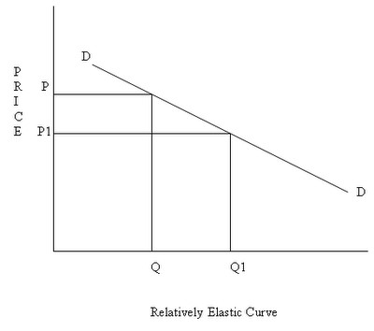
When price falls from ‘OP’ to ‘OP1’, amount demanded increase from “OQ’ to “OQ1’ which is larger than the change in price.
D. Relatively In-Elastic Demand.
Quantity demanded changes less than proportional to a change in price. A large change in price leads to small change in amount demanded. Here E < 1. Demanded carve will be steeper.
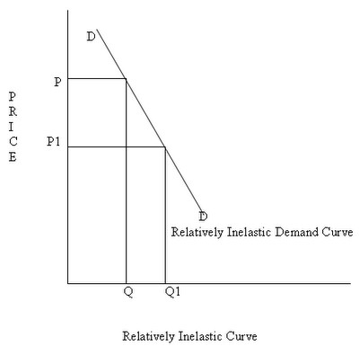
When price falls from “OP’ to ‘OP1 amount demanded increases from OQ to OQ1, which is smaller than the change in price. E. Unit Elasticity Of Demand:
The change in demand is exactly equal to the change in price. When both are equal E=1 and elasticity if said to be unitary.
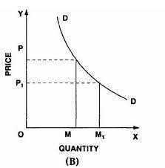
When price falls from ‘OP’ to ‘OP1’ quantity demanded increases from ‘OP’ to ‘OP1’, quantity demanded increases from ‘OM’ to ‘OM1’. Thus a change in price has resulted in an equal change in quantity demanded so price elasticity of demand is equal to unity.
TYPES OF ELASTICITY OF DEMAND:
There are three types of elasticity of demand:
- Price elasticity of demand
- Income elasticity of demand
- Cross elasticity of demand
- Advertising elasticity of demand

- PRICE ELASTICITY OF DEMAND:
Marshall was the first economist to define price elasticity of demand. Price elasticity of demand measures changes in quantity demand to a change in Price. It is the ratio of percentage change in quantity demanded to a percentage change in price.
Proportionate change in the quantity demand of commodity
Price elasticity = -----------------------------------------------------------------------------------
Proportionate change in the price of commodity

There are three cases of price elasticity of demand
  - Price elasticity greater than unity
  - Price elasticity leas than unity
  - Unit price elasticity

  - Price elasticity greater than unity:
Demand changes more than proportionately to a change in price. i.e. a small change in price loads to a very big change in the quantity demanded. In this caseE > 1. This demand curve will be flatter.
When price falls from ‘OP’ to ‘OP1’, amount demanded increase from “OQ’ to “OQ1’ which is larger than the change in price.
  - Price elasticity less than unity:
Quantity demanded changes less than proportional to a change in price. A large change in price leads to small change in amount demanded. Here E < 1. Demanded carve will be steeper.
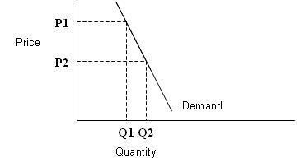
When price falls from “OP1’ to ‘OP2 amount demanded increases from OQ1 to OQ2, which is smaller than the change in price.
  - Unit price elasticity:
The change in demand is exactly equal to the change in price. When both are equal E=1 and elasticity I said to be unitary.
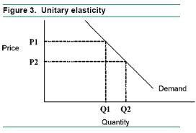

- INCOME ELASTICITY OF DEMAND:
Income elasticity of demand shows the change in quantity demanded as a result of a change in income. Income elasticity of demand may be slated in the form of a formula.

Proportionate change in the quantity demand of commodity
Income Elasticity = ------------------------------------------------------------------ Proportionate change in the income of the people
Income elasticity of demand can be classified in to five types.
- Zero income elasticity:
Quantity demanded remains the same, even though money income increases. Symbolically, it can be expressed as Ey=0. It can be depicted in the following way:
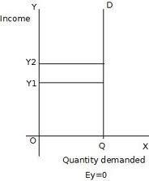
As income increases from OY to OY1, quantity demanded never changes.
- Negative Income elasticity:
When income increases, quantity demanded falls. In this case, income elasticity of demand is negative. i.e., Ey< 0
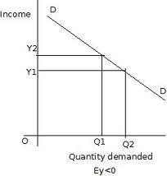
When income increases from OY1 to OY2, demand falls from OQ1 to OQ2.
- Unit income elasticity:
When an increase in income brings about a proportionate increase in quantity demanded, and then income elasticity of demand is equal to one. Ey = 1
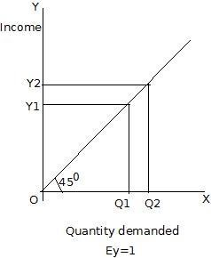
When income increases from OY1 to OY2, Quantity demanded also increases from OQ1 to OQ2.
- Income elasticity less than unity:
In this case, an increase in come brings about a more than proportionate increase in quantity demanded. Symbolically it can be written as Ey< 1.
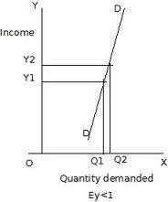
It shows high-income elasticity of demand. When income increases from OY to OY1, Quantity demanded increases from OQ to OQ1.
- Income elasticity greater than unity:
When income increases quantity demanded also increases but less than proportionately. In this case Ey >1.
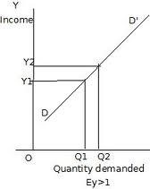

An increase in income from OY1 to OY2, brings what an increase in quantity demanded from OQ1 to OQ2, But the increase in quantity demanded is smaller than the increase in income. Hence, income elasticity of demand is less than one.

3. CROSS ELASTICITY OF DEMAND:
A change in the price of one commodity leads to a change in the quantity demanded of another commodity. This is called a cross elasticity of demand. The formula for cross elasticity of demand is:
Proportionate change in the quantity demand of commodity “X”
Cross elasticity = -------------------------------------------------------------------------------------------
Proportionate change in the price of commodity “Y”
- In case of substitutes, cross elasticity of demand is positive. Eg: Coffee and Tea. When the price of coffee increases, Quantity demanded of tea increases. Both are substitutes.
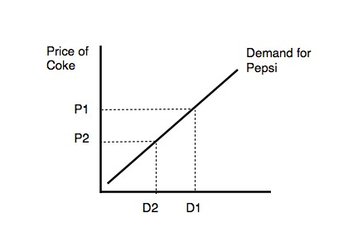
- In case of compliments, cross elasticity is negative. If increase in the price of one commodity leads to a decrease in the quantity demanded of another and vice versa.
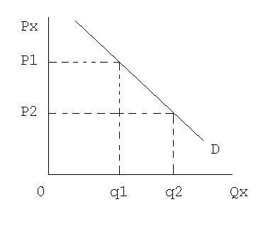
When price of car goes up from OP to OP1 the quantity demanded of petrol decreases from OQ1 to OQ2. The cross-demanded curve has negative slope.

4. ADVERTISING ELASTICITY OF DEMAND
It refers to increase in the sale revenue because of changes in the advertising expenditure. In other words there is a direct relationship between the amount of money spent on advertising and its impact on sales. It is always positive

Proportionate change in the quantity demand of product “X”
Advertising elasticity = ---------------------------------------------------------------------------------------- Proportionate change in the advertising cost
Advertising elasticity greater than unity:
In this case, an increase in come brings about a more than proportionate increase in quantity demanded. Symbolically it can be written as Ey> 1.
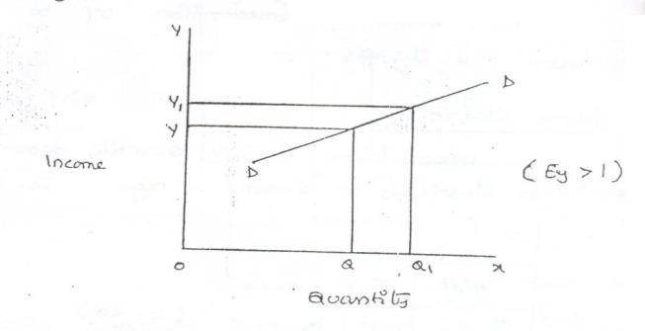
It shows high-income elasticity of demand. When income increases from OY to OY1, Quantity demanded increases from OQ to OQ1.
Advertising elasticity leas than unity:
When income increases quantity demanded also increases but less than proportionately. In this case E < 1.
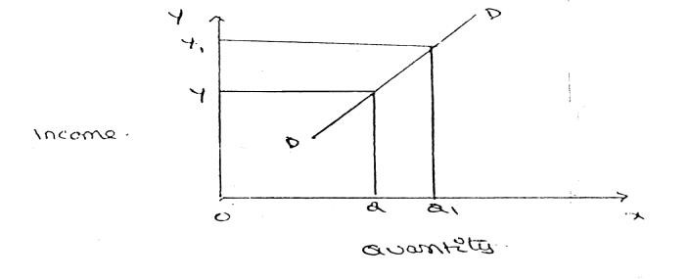

Unit advertising elasticity:
When an increase in income brings about a proportionate increase in quantity demanded, and then income elasticity of demand is equal to one. Eye = 1

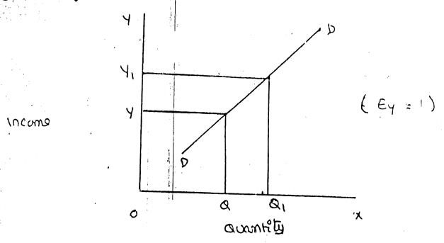

5. POINT ELASTICITY AND ARC ELASTICITY

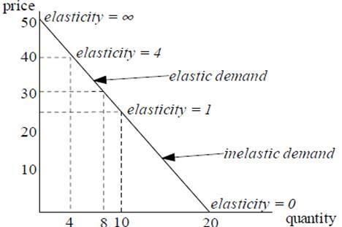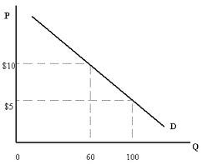

FACTORS INFLUENCING THE ELASTICITY OF DEMAND
Elasticity of demand depends on many factors.

- Nature of commodity:
Elasticity or in-elasticity of demand depends on the nature of the commodity i.e. whether a commodity is a necessity, comfort or luxury, normally; the demand for Necessaries like salt, rice etc is inelastic. On the other band, the demand for comforts and luxuries is elastic.
- Availability of substitutes:
Elasticity of demand depends on availability or non-availability of substitutes. In case of commodities, which have substitutes, demand is elastic, but in case of commodities, which have no substitutes, demand is in elastic.
- Variety of uses:
If a commodity can be used for several purposes, than it will have elastic demand. i.e. electricity. On the other hand, demanded is inelastic for commodities, which can be put to only one use.
- Postponement of demand:
If the consumption of a commodity can be postponed, than it will have elastic demand. On the contrary, if the demand for a commodity cannot be postpones, than demand is in elastic. The demand for rice or medicine cannot be postponed, while the demand for Cycle or umbrella can be postponed.
- Amount of money spent:
Elasticity of demand depends on the amount of money spent on the commodity. If the consumer spends a smaller for example a consumer spends a little amount on salt and matchboxes. Even when price of salt or matchbox goes up, demanded will not fall. Therefore, demand is in case of clothing a consumer spends a large proportion of his income and an increase in price will reduce his demand for clothing. So the demand
is elastic.
- Time:
Elasticity of demand varies with time. Generally, demand is inelastic during short period and elastic during the long period. Demand is inelastic during short period because the consumers do not have enough time to know about the change is price. Even if they are aware of the price change, they may not immediately switch over to a new commodity, as they are accustomed to the old commodity.
- Range of Prices:
Range of prices exerts an important influence on elasticity of demand. At a very high price, demand is inelastic because a slight fall in price will not induce the people buy more. Similarly at a low price also demand is inelastic. This is because at a low price all those who want to buy the commodity would have bought it and a further fall in price will not increase the demand. Therefore, elasticity is low at very him and very low prices.
IMPORTANCE OF ELASTICITY OF DEMAND:
The concept of elasticity of demand is of much practical importance.
- Price fixation:
The manufacturer can decide the amount of price that can be fixed for his product based on the concept of elasticity. If there is no competition the manufacturer is free to fix his price. Where there is a competition it difficult to fix the price
- Production:
Producers generally decide their production level on the basis of demand for the product. Hence elasticity of demand helps the producers to take correct decision regarding the level of cut put to be produced.

- Distribution:
Elasticity of demand also helps in the determination of rewards for factors of production. For example, if the demand for labour is inelastic, trade unions will be successful in raising wages. It is applicable to other factors of production.
- International Trade:
Elasticity of demand helps in finding out the terms of trade between two countries. Terms of trade refers to the rate at which domestic commodity is exchanged for foreign commodities. Terms of trade depends upon the elasticity of demand of the two countries for each other goods.
- Public Finance:
Elasticity of demand helps the government in formulating tax policies. For example, for imposing tax on a commodity, the Finance Minister has to take into account the elasticity of demand.
- Nationalization: The concept of elasticity of demand enables the government to decide about nationalization of industries.
- Forecasting demand:
Income elasticity is used to forecasting demand for product. The demand for the product can be forecasting a given level. Other words, the impact of changing income level on the demand of the product can be assessed with the help of income elasticity.
- Planning the level of output and price:
The knowing of price elasticity is very useful to producers. If the demand for the product is inelasticity, a little higher price may be to him to get huge profits
- Public utilities:
The government uses the concept of elasticity in fixing chargers for the public utility such as electricity, water etc.

DEMAND FORECASTING
INTRODUCTION:
The information about the future is essential for both new firms and those planning to expand the scale of their production. Demand forecasting refers to an estimate of future demand for the product. Forecasting helps to assess the likely demand for products and services and to plan production accordingly
In recent times, forecasting plays an important role in business decision-making. Demand forecasting has an important influence on production planning. It is essential for a firm to produce the required quantities at the right time.
It is essential to distinguish between forecasts of demand and forecasts of sales. Sales forecast is important for estimating revenue cash requirements and expenses. Demand forecasts relate to production, inventory control, timing, reliability of forecast etc. However, there is not much difference between these two terms.
THE NEED FOR DEMAND FORECASTING
The importance of demand forecasting is paramount when either production or demand is uncertain. Where the supply is not in accordance with the demand, it results in the development of a black market or excessive prices.
Where there is a lot of competition, the entrepreneur has to estimate the demand for his production and services so that he can plan his material inputs, such as manpower, finances, advertising and other overheads.
TYPES OF DEMAND FORECASTING:
Based on the time span and planning requirements of business firms, demand forecasting can be classified in to
- Short-term demand forecasting and
- Long – term demand forecasting.
- Short-term demand forecasting: Short-term demand forecasting is limited to short periods, usually for one year. It relates to policies regarding sales, purchase, price and finances. It refers to existing production capacity of the firm. Short-term forecasting is essential for formulating is essential for formulating a suitable price policy. If the business people expect of rise in the prices of raw materials of shortages, they may buy early... Production may be undertaken based on expected sales and not on actual sales.
- Long – term forecasting: In long-term forecasting, the businessmen should now about the long-term demand for the product. Planning of a new plant or expansion of an existing unit depends on long-term demand. Similarly a multi product firm must take into account the demand for different items. When forecast are mode covering long periods, the probability of error is high. It is very difficult to forecast the production, the trend of prices and the nature of competition.

FORECASTING LEVELS

INDUSTRY LEVEL
FIRM LEVEL
ECONOMIC LEVEL
Economic forecasting is concerned with the economics, its covers whole economy. It based on levels of income saving of the customers.
Industrial level forecasting is used for inter-industry comparisons and is being supplied by trade association or chamber of commerce.
Firm level forecasting relates to individual firm. Estimate the demand for product and services offered by a single firm

Functional nature o demand
Higher volumes of sales can be realized with higher level of advertisements. However, there could be some minimum value sales even when there are no advertisements on a large scale.

Degree of orientation
The fore casting in terms of total sales can be viewed as general forecasting whereas product and service wise forecasting is refered to specific forecasting.
Types of Demand Forecasting:
- Economic and Non-economic Forecast: Social Technology and political forecast are all examples of non-economic forecasts. E.g. one can forecast the crime rate, technology obsolescence, lection results etc.
- Micro and Macro economic forecast: Micro economic forecasting may take the form of company forecasting or industry forecasting. Whereas macro level forecasting is concerned with forecasting general economic environment & business conditions in the country as a whole. The income growth rates, production indices, price indices provide useful insights into the future demand for most of the commodities. The based data is generally supplied by governmental organization on which the demand can be forecasted.
- Active and passive Forecast: Active forecasting is a method of forecasting the demand on the consideration that a firm likely to initiate some actions like changes in product, quality, size, price etc. Passive forecasts on the other hand are made on the assumption that the same product is being offered without any changes.
- Short run & Long run Forecast: Short run forecasts normally extend up to one year. These forecasts are useful for product scheduling, inventory planning & mobilization of working capital etc. Long run forecasts extended beyond one year. They are helpful in capital budgeting, production diversification, personnel recruitment etc.
- Conditional & Non conditional Forecast: In conditional forecasting we estimate the likely impact of certain known or assumed changes in the independent variables on the dependent variables. Non-Conditional forecasting in contrast requires the estimation of the changes in the independent variables themselves.
Steps in Demand forecasting:
Demand forecasting is an intricate exercise and conducted in a systematic and meticulous manner. Demand forecasting involves the following steps.

(1) Identification of the objective: -
The first step in Demand forecasting is the identification of the objective or purpose for which Demand forecasting is undertaken. Based on the objective the type, level and the method of forecasting will be selected.

(2) Nature of the product: -
Before proceeding towards Demand forecasting, the forecaster should be clear about the nature of the product whether a consumer good or capital good, Durable goods or an intermediate product. This is essential since the factors affecting the demand and the decisions variables widely differ from one product to other.

(3) Determination of demand: -
Demand for different products depends on different variables. Therefore, a forecaster should identify the relevant determinants of the demand for a commodity before he proceeds with demand forecasting.

(4) Choice of appropriate method: -
The forecaster should select an appropriate method of forecasting based on the nature of the product. There is nothing like a universal method of Demand forecasting. The techniques used for forecasting demand for an existing product may not be suitable for a new product.

- Collection of required data: - After identification of demand forecasting method by depending either through primary or secondary sources.

- Analysis: - When once the demand is forecasted, the forecaster has to apply his analytical powers to properly understand and interpret the results. If necessary, he should subject the results to the available statistical tests like coefficient of variation, percentage absolute tests etc.

- Review: - Continuously the forecasts should compare with the actual performance. The variance between forecasts and actual should be studied and analyzed carefully to revise the forecasts.
Importance of Demand Forecasting:
  - Production Planning and product scheduling A business firm cannot function in wilderness. It has to take crucial decisions about what to produce and how much to produce. This in turn depends upon its estimate of future demand for the product. If the forecasted demand is likely to rise, the firm can plan expansion of its production capabilities to meet the growing demand at the right point of time. In the eventuality of declining demand it should either resort to product improvement, diversification, and design changes on even pursue an aggressive sales promotion strategy.
  - Inventory planning Demand forecasting is useful for the firm to acquire the right quantum of inventory at the right point of time, to meet the needs of the production same time without unnecessarily locking up the finances of the firm in inventory accumulation.
  - Capital planning
Increased production requires increased capital resources fixed as well as working capital. Availability of demand forecasts helps the firm to mobilize the capital resources in time.
  - Marketing strategy
Demand forecasting will be useful in devising appropriate sales promotion or marketing strategies. If the demand forecasts indicate a declining trend in sales, it should resort to intensive sales promotion campaign to sustain its sales.
  - Manpower planning
A firm has to recruit and train the appropriate level of work force. This calls for forecasting the demand well in advance so that the required contingent of the labor resources could be obtained.

  - Pricing strategies
Devising and setting the optimum pricing depends upon the forecasted demand. If the forecasts indicate a declining share in the market demand then it has to slash the prices to sustain demand. Conversely, if the forecasts indicate increased demand for the prod act over a longer period it can charge higher prices subject to the other considerations.

Factors affecting demand forecasts:

  - Nature of Goods:- Demand forecasting differs on the basis of fact that goods may be producer goods, consumer goods or services etc. apart from this demand forecasting also depends on basis of durable and non durable goods.
  - Level of Competition:- Market competition affects the process of demand forecasting. In a highly competitive market the forecast is conservative taking into account the action of competition. It also depends on future outlook of the industry due to entry of new firms.
  - Price: - Demand forecasting is deeply influenced by a firms pricing policy. Higher prices in the future may influence demand of the product or services unless it is supplemented by high quality of the product.
  - Level of the technology:- Rapid changes in the technology have the potential of rendering the existing product obsolete in future. Technology also plays a vital role in arriving at a reliable demand forecasts in the future.

METHODS OF DEMANDFORECASTING
- SURVEY METHOD
  - Census methods
  - Sample method
- STATISTICAL METHODS
  - Trend Projection Methods
    - Moving Average Method
    - Exponential Smoothing
  - Barometric Techniques
  - Correlation and Regression Methods
- OTHERS METHODS
(a)Expert Opinion
(B)Test Marketing
(C)Controlled Experiments
(D)Judgmental Approach
1. Survey method :
It is the most useful source of information would be the buyers themselves. It is better to draw list of all potential buyers, approach each buyers to ask how much he plans to buy of the given product at a given point of time. The survey of buyers can be conducted either by covering the whole populations or by selecting a sample group of buyers. Suppose there are 10000 buyers for a particular product.
If the company wishes to elicit the opinion of all the buyers, this method is called census or total enumeration methods. This methods is not only time consuming but also costly. The firm can select a group of buyers who can represent the whole populations this methods is called the sample method.
The survey method is considered more advantages in the following situations.
- Where the product is new on the market for which no data previously exists
- When the buyers are few and they are accessible
- When the cost of reaching them is not significant
- When the consumers stick to their intentions
(5) When they are willing to disclose what they intend to do.
This method has certain disadvantages also. They are:
- SURVEYS MAY BE EXPENSIVE;-Quite often the value of information supplied by the customer is not worth the cost of gathering it.
- SAMPLE SIZE AND TIMING OF SURVEY;-Sample size should be large enough to yield meaningful results on the desired aspects of study. Also the sample should be selected in such a way that it represents the whole population under the study. This increase the cost and also the time needed to undertake the analysis. The forecast results can deeply be influenced by the timing of the survey. For example, the number of residents preferring to stay in multi-stored apartments soon after the news about an earthquake may drastically come down when compared to the normal times.
Where the surveys are conducted by a group of firms, these costs can be shared.
- METHODS OF SAMPLING -The survey should be based on appropriate method of sampling. The method so selected should be capable of providing result with no bays. For instance, the surveys conducted on the internet will have a built-in bias towards those in the higher socio-economic groups who have access to interment.

- INCONSISTENT BUYING BEHAVIOUR;-The buyers also may not express their intentions freely. Even the buyers do no act upon the way they express. Most of the buyers are susceptible to the advertisement strategies and are emotional when it really comes to the question of buying the product or services.

STATISTICAL METHODS
For forecasting the demand for goods and services in the long-run, statistical and mathematical methods are used considering the past data.
- TREND PROJECTION METHODS:-These are generally based on analysis of past sales patterns. These methods dispense with the need for costly market research because the necessary information is often already available in company files in terms of different time periods, that is, a time series data.
(b)MOVING AVERAGE METHOD:-This method considers that the average of past events determine the future events. In other words, this method provides consistent results when the past events are consistent and unaffected by wide changes. As the name itself suggest, under this method, the average keeps on moving depending up on the number of years selected. Selection of the number of years is the decisive factor in this method. Moving averages get updated as new information flows in.
(c)EXPONENTIAL SMOOTIHING:-This is a more popular technique used for short forecasts. This method is an improvement over moving averages method. Unlike in moving averages method, all time periods (ranging from the immediate past) here are given varying weights, that is, the values of the given variable in the recent time are given higher weights and the values of the given variable in the distant past are given relatively lower weights for further processing.
- BAROMETRIC TECHNIQUES:-In other words, to forecast demand for a particular product or service, use some other relevant indicator (Which is known as a barometer) of future demand. How the statistical data relating to the economy comes handy for this purpose is explained in the following examples.
- CORRELATION AND REGRESSION METHODS:-Correlation and regression methods
are statistical techniques. When the two variables tend to change together, then they are said to be correlated. The extent to which they are correlated is measured by correlation coefficient. Of these two variables, one is a dependent variable and the other is an independent. If the high values of one variable are associated with the high values of another, they are said to be positively correlated. For example, if the advertisement are positively correlated. Similarly, if the high values of one variable are associated with the low values of another, then they are said to be negatively correlated. For example, if the price of a product has come down; and as result, there is increase in its demand; the demand and the price are negatively correlated.

OTHERS METHODS
(a)EXPERT OPINION: Well informed person are called experts. Experts constitute another source of information. These people are generally the outside experts and they do not have any vested in the result of particular survey
An expert is good at forecasting and analyzing the future trends in a given product or service at a given level of technology. The service of an expert could be advantageously used when a firm uses general economic forecast or special industry forecast prepared outside the firm. It may be easy to administer this method where there are parameters clearly defined to make forecast. This act as guidelines
This method has certain advantages and disadvantages.
- Result of this method would be more reliable as the expert is unbiased, has no direct involvement in its primary activities
- Independent demand forecast can be made relatively quickly and cheaply
- Where there is different point of view among different experts, consensus can be arrived through an objective analysis. These experts can be asked to explain the reasons why the forecasts are out of line with consensus. These can be taken into account before taking the final decisions. Sorting out difference in estimates in this way is called DELPHI TECNIQUE
(b)TEST MAREKETING: It is likely that opinions given by buyers, sales man or other experts may be, at times, misleading. This is the reason why of the manufacturers favor to test their product or service in a limited market as test –run before they launch their product nationwide. Based on the result of test marketing, valuable lessons can be learnt in how customer reacts to the given product and necessary changes can be introduced to gain wider acceptability. To forecast the sales of a new product or the likely sales of an established product in a new channel of distribution or territory, it is customary to find test marketing in practice.
Automobiles companies maintain a panel of consumers who give feedback on style and design and specification of the new models. Accordingly these companies make changes, if any, and launch the product in the wider markets
The advantages of test marketing are:
- The acceptability of the product can be judged in a limited market
- Before this is too late, the correction can be made to the product design, if necessary. Thus, major atrophy, in term of failure, can be avoided.
- The customer psychology is more focused in this method and the product and service are aligned or redesigned accordingly to gain more customer acceptance
The following are the disadvantages of this method:
- It reveals the quality of product to the competitors before it is launched in the wider markets. The competitors may bring about the similar product or often misuse the result of test marketing against the given company.
- It is not always easy to select a representative audience or market.
- It may also be difficult to extrapolate the feedback received from such a test market, particularly where the chosen market is not fully representative.
(c)CONTROLLED EXPERIMENTS: It refers to such exercises of the major determinants of demand are manipulated to suit to the customer with taste and preferences, income groups, and such other. It is further factors remain same in this method in this method the product is introduced in different packages, different prices in different markets or same markets.
This method is still in the infancy stage and not much tried because of the following reasons:
- It is costly and consuming
- It involves elaborate model of studying different markets and different permutations and combinations that can push the product aggressively
- It fails in one market, it may affect other market also
(d)JUDGEMENTAL APPROACH: When none of the above methods are directly related to the given product or service, the management has no alternative other than using its own judgment. Even when the above methods are used, the forecasting process is supplemented with the factor of judgment for the following reasons:
- Historical data for significantly long period is not available
- Turning points in terms of polices or procedure

DEMAND ANALYSIS

Introduction & Meaning:

Demand in common parlance means the desire for an object. But in economics demand is something more than this. According to Stonier and Hague, “Demand in economics means demand backed up by enough money to pay for the goods demanded”. This means that the demand becomes effective only it if is backed by the purchasing power in addition to this there must be willingness to buy a commodity.

Thus demand in economics means the desire backed by the willingness to buy a commodity and the purchasing power to pay. In the words of “Benham” “The demand for anything at a given price is the amount of it which will be bought per unit of time at that Price”. (Thus demand is always at a price for a definite quantity at a specified time.) Thus demand has three essentials – price, quantity demanded and time. Without these, demand has to significance in economics.

LAW of Demand:

Law of demand shows the relation between price and quantity demanded of a commodity in the market. In the words of Marshall, “the amount demand increases with a fall in price and diminishes with a rise in price”.

A rise in the price of a commodity is followed by a reduction in demand and a fall in price is followed by an increase in demand, if a condition of demand remains constant.

The law of demand may be explained with the help of the following demand schedule.

Demand Schedule.

Price of Appel (In. Rs.) | Quantity Demanded
10 | 1
8 | 2
6 | 3
4 | 4
2 | 5

When the price falls from Rs. 10 to 8 quantity demand increases from 1 to 2. In the same way as price falls, quantity demand increases on the basis of the demand schedule we can draw the demand curve.

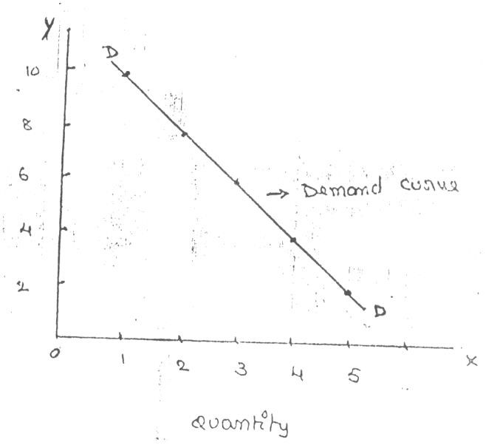

Price

The demand curve DD shows the inverse relation between price and quantity demand of apple. It is downward sloping.

Assumptions:

Law is demand is based on certain assumptions:

- This is no change in consumers taste and preferences.
- Income should remain constant.
- Prices of other goods should not change.
- There should be no substitute for the commodity
- The commodity should not confer at any distinction
- The demand for the commodity should be continuous
- People should not expect any change in the price of the commodity

Exceptional demand curve:

Some times the demand curve slopes upwards from left to right. In this case the demand curve has a positive slope.

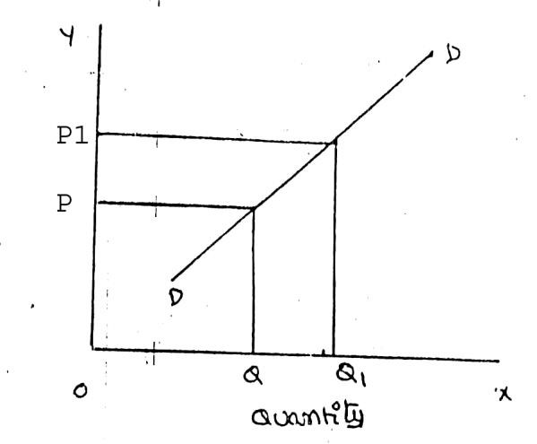

Price

When price increases from OP to Op1 quantity demanded also increases from to OQ1 and vice versa. The reasons for exceptional demand curve are as follows.

- Giffen paradox:

The Giffen good or inferior good is an exception to the law of demand. When the price of an inferior good falls, the poor will buy less and vice versa. For example, when the price of maize falls, the poor are willing to spend more on superior goods than on maize if the price of maize increases, he has to increase the quantity of money spent on it. Otherwise he will have to face starvation. Thus a fall in price is followed by reduction in quantity demanded and vice versa. “Giffen” first explained this and therefore it is called as Giffen’s paradox.

- Veblen or Demonstration effect:

‘Veblan’ has explained the exceptional demand curve through his doctrine of conspicuous consumption. Rich people buy certain good because it gives social distinction or prestige for example diamonds are bought by the richer class for the prestige it possess. It the price of diamonds falls poor also will buy is hence they will not give prestige. Therefore, rich people may stop buying this commodity.

- Ignorance:

Sometimes, the quality of the commodity is Judge by its price. Consumers think that the product is superior if the price is high. As such they buy more at a higher price.

- Speculative effect:

If the price of the commodity is increasing the consumers will buy more of it because of the fear that it increase still further, Thus, an increase in price may not be accomplished by a decrease in demand.

- Fear of shortage:

During the times of emergency of war People may expect shortage of a commodity. At that time, they may buy more at a higher price to keep stocks for the future.

5. Necessaries:

In the case of necessaries like rice, vegetables etc. people buy more even at a higher price.

Factors Affecting Demand:

There are factors on which the demand for a commodity depends. These factors are economic, social as well as political factors. The effect of all the factors on the amount demanded for the commodity is called Demand Function.
These factors are as follows:

- Price of the Commodity:

The most important factor-affecting amount demanded is the price of the commodity. The amount of a commodity demanded at a particular price is more properly called price demand. The relation between price and demand is called the Law of Demand. It is not only the existing price but also the expected changes in price, which affect demand.

- Income of the Consumer:

The second most important factor influencing demand is consumer income. In fact, we can establish a relation between the consumer income and the demand at different levels of income, price and other things remaining the same. The demand for a normal commodity goes up when income rises and falls down when income falls. But in case of Giffen goods the relationship is the opposite.

- Prices of related goods:

The demand for a commodity is also affected by the changes in prices of the related goods also. Related goods can be of two types:

(i). Substitutes which can replace each other in use; for example, tea and coffee are substitutes. The change in price of a substitute has effect on a commodity’s demand in the same direction in which price changes. The rise in price of coffee shall raise the demand for tea;

(ii). Complementary foods are those which are jointly demanded, such as pen and ink. In such cases complementary goods have opposite relationship between price of one commodity and the amount demanded for the other. If the price of pens goes up, their demand is less as a result of which the demand for ink is also less. The price and demand go in opposite direction. The effect of changes in price of a commodity on amounts demanded of related commodities is called Cross Demand.

- Tastes of the Consumers:

The amount demanded also depends on consumer’s taste. Tastes include fashion, habit, customs, etc. A consumer’s taste is also affected by advertisement. If the taste for a commodity goes up, its amount demanded is more even at the same price. This is called increase in demand. The opposite is called decrease in demand.

- Wealth:

The amount demanded of commodity is also affected by the amount of wealth as well as its distribution. The wealthier are the people; higher is the demand for normal commodities. If wealth is more equally distributed, the demand for necessaries and comforts is more. On the other hand, if some people are rich, while the majorities are poor, the demand for luxuries is generally higher.

- Population:

Increase in population increases demand for necessaries of life. The composition of population also affects demand. Composition of population means the proportion of young and old and children as well as the ratio of men to women. A change in composition of population has an effect on the nature of demand for different commodities.

- Government Policy:

Government policy affects the demands for commodities through taxation. Taxing a commodity increases its price and the demand goes down. Similarly, financial help from the government increases the demand for a commodity while lowering its price.

- Expectations regarding the future:

If consumers expect changes in price of commodity in future, they will change the demand at present even when the present price remains the same. Similarly, if consumers expect their incomes to rise in the near future they may increase the demand for a commodity just now.

- Climate and weather:

The climate of an area and the weather prevailing there has a decisive effect on consumer’s demand. In cold areas woolen cloth is demanded. During hot summer days, ice is very much in demand. On a rainy day, ice cream is not so much demanded.

- State of business:

The level of demand for different commodities also depends upon the business conditions in the country. If the country is passing through boom conditions, there will be a marked increase in demand. On the other hand, the level of demand goes down during depression.

ELASTICITY OF DEMAND

Elasticity of demand explains the relationship between a change in price and consequent change in amount demanded. “Marshall” introduced the concept of elasticity of demand. Elasticity of demand shows the extent of change in quantity demanded to a change in price.

In the words of “Marshall”, “The elasticity of demand in a market is great or small according as the amount demanded increases much or little for a given fall in the price and diminishes much or little for a given rise in Price”

Elastic demand: A small change in price may lead to a great change in quantity demanded. In this case, demand is elastic.

In-elastic demand: If a big change in price is followed by a small change in demanded then the demand in “inelastic”.

Types of Elasticity of Demand:
There are three types of elasticity of demand:

- Price elasticity of demand
- Income elasticity of demand
- Cross elasticity of demand

1. Price elasticity of demand:

Marshall was the first economist to define price elasticity of demand. Price elasticity of demand measures changes in quantity demand to a change in Price. It is the ratio of percentage change in quantity demanded to a percentage change in price.

Proportionate change in the quantity demand of commodity
Price elasticity = ------------------------------------------------------------------
Proportionate change in the price of commodity There are five cases of price elasticity of demand

- Perfectly elastic demand:

When small change in price leads to an infinitely large change is quantity demand, it is called perfectly or infinitely elastic demand. In this case E=∞

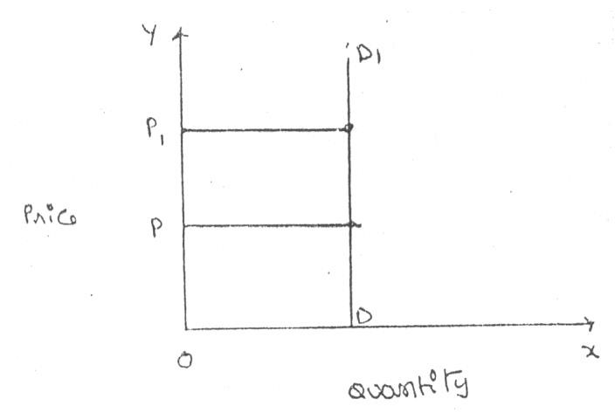
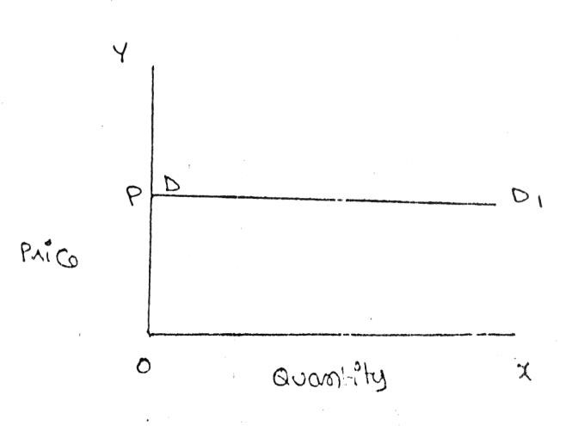
The demand curve DD1 is horizontal straight line. It shows the at “OP” price any amount is demand and if price increases, the consumer will not purchase the commodity.

- Perfectly Inelastic Demand

In this case, even a large change in price fails to bring about a change in quantity demanded.

When price increases from ‘OP’ to ‘OP’, the quantity demanded remains the same. In other words the response of demand to a change in Price is nil. In this case ‘E’=0.

Relatively elastic demand:

Demand changes more than proportionately to a change in price. i.e. a small change in price loads to a very big change in the quantity demanded. In this case E > 1. This demand curve will be flatter.
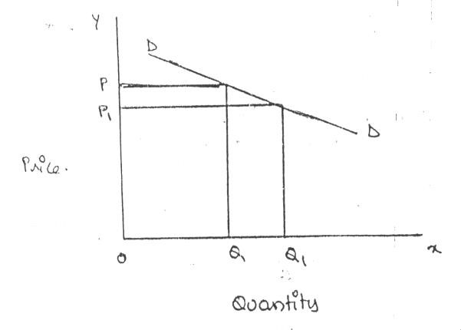

When price falls from ‘OP’ to ‘OP’, amount demanded in crease from “OQ’ to “OQ1’ which is larger than the change in price.

- Relatively in-elastic demand.

Quantity demanded changes less than proportional to a change in price. A large change in price leads to small change in amount demanded. Here E < 1. Demanded carve will be steeper.
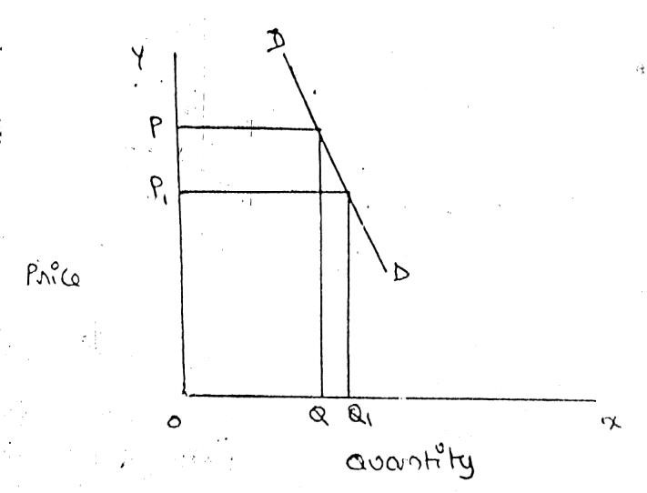

When price falls from “OP’ to ‘OP1 amount demanded increases from OQ to OQ1, which is smaller than the change in price.

- Unit elasticity of demand:

The change in demand is exactly equal to the change in price. When both are equal E=1 and elasticity if said to be unitary.

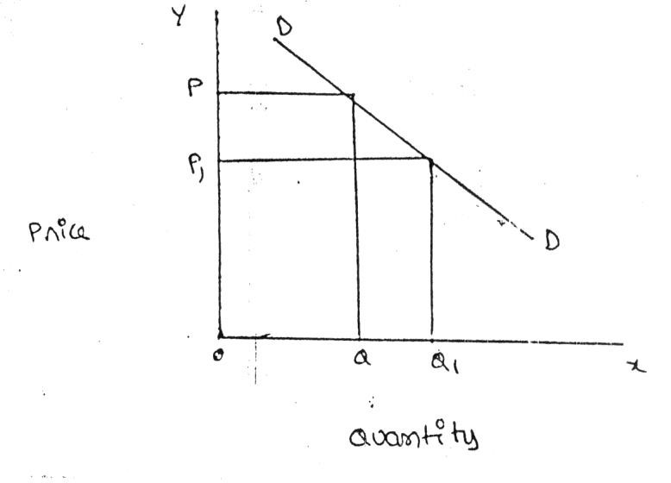
When price falls from ‘OP’ to ‘OP1’ quantity demanded increases from ‘OP’ to ‘OP1’, quantity demanded increases from ‘OQ’ to ‘OQ1’. Thus a change in price has resulted in an equal change in quantity demanded so price elasticity of demand is equal to unity.

2. Income elasticity of demand:

Income elasticity of demand shows the change in quantity demanded as a result of a change in income. Income elasticity of demand may be slated in the form of a formula.

Proportionate change in the quantity demand of commodity
Income Elasticity = ------------------------------------------------------------------
Proportionate change in the income of the people

Income elasticity of demand can be classified in to five types.

- Zero income elasticity:

Quantity demanded remains the same, even though money income increases.
Symbolically, it can be expressed as Ey=0. It can be depicted in the following way:
As income increases from OY to
OY1, quantity demanded never changes.

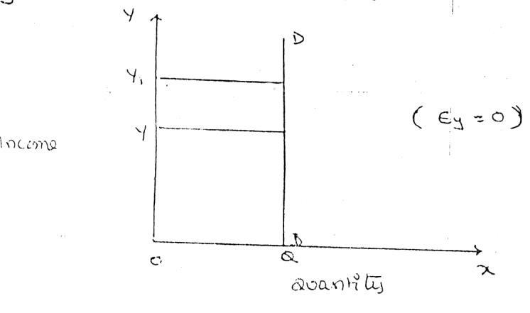

- Negative Income elasticity:

When income increases, quantity demanded falls. In this case, income elasticity of demand is negative. i.e., Ey < 0. When income increases from OY to OY1, demand falls from OQ to OQ
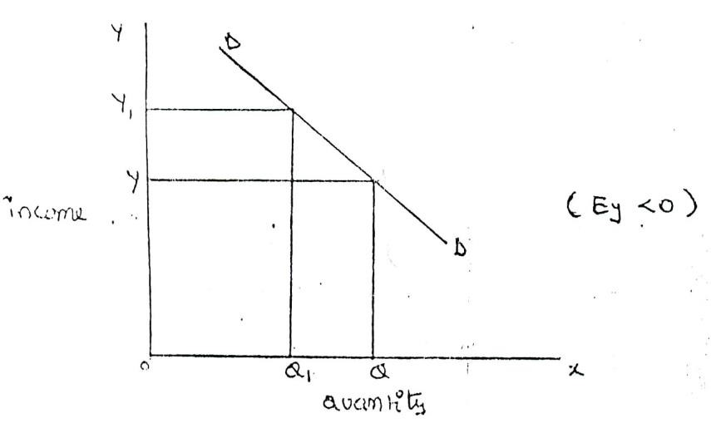

- Unit income elasticity:

When an increase in income brings about a proportionate increase in quantity demanded, and then income elasticity of demand is equal to one. Ey = 1

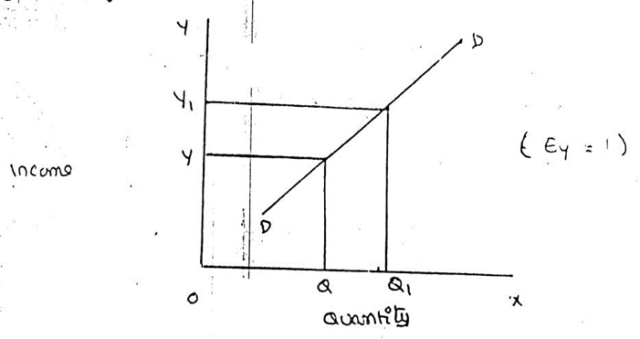

When income increases from OY to OY1, Quantity demanded also increases from OQ to OQ1.
- Income elasticity greater than unity:

In this case, an increase in come brings about a more than proportionate increase in quantity demanded. Symbolically it can be written as Ey > 1.

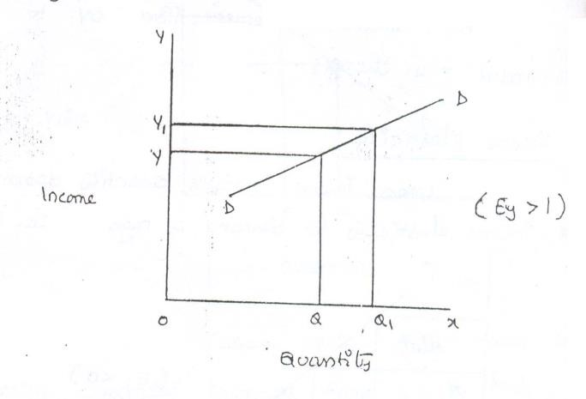

It shows high-income elasticity of demand. When income increases from OY to OY1, Quantity demanded increases from OQ to OQ1.

E. Income elasticity leas than unity:

When income increases quantity demanded also increases but less than proportionately.
In this case E < 1.
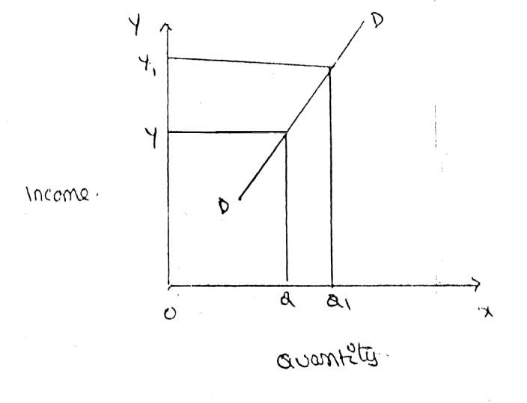

An increase in income from OY to OY, brings what an increase in quantity demanded from OQ to OQ1, But the increase in quantity demanded is smaller than the increase in income.
Hence, income elasticity of demand is less than one.

3. Cross elasticity of Demand:

A change in the price of one commodity leads to a change in the quantity demanded of another commodity. This is called a cross elasticity of demand. The formula for cross elasticity of demand is:

Proportionate change in the quantity demand of commodity “X”
Cross elasticity = -----------------------------------------------------------------------
Proportionate change in the price of commodity “Y”

- In case of substitutes, cross elasticity of demand is positive. Eg: Coffee and Tea

When the price of coffee increases, Quantity demanded of tea increases. Both are substitutes.

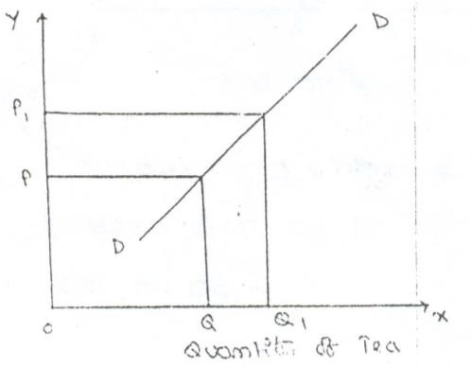

Price of Coffee

- Incase of compliments, cross elasticity is negative. If increase in the price of one commodity leads to a decrease in the quantity demanded of another and vice versa.

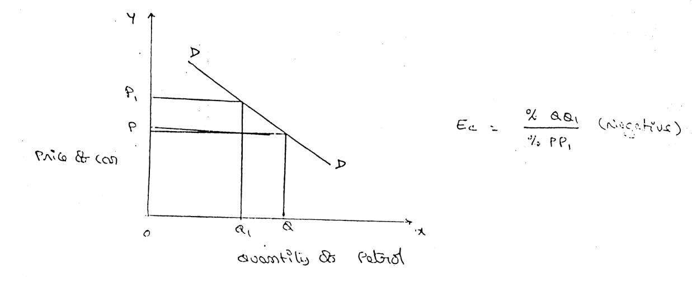
When price of car goes up from OP to OP!, the quantity demanded of petrol decreases from OQ to OQ!. The cross-demanded curve has negative slope.

- In case of unrelated commodities, cross elasticity of demanded is zero. A change in the price of one commodity will not affect the quantity demanded of another.

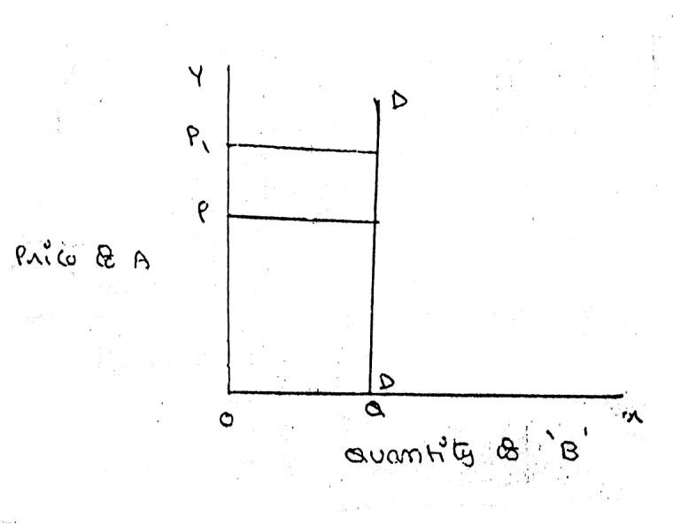

Quantity demanded of commodity “b” remains unchanged due to a change in the price of ‘A’, as both are unrelated goods.

Factors influencing the elasticity of demand

Elasticity of demand depends on many factors.

- Nature of commodity:

Elasticity or in-elasticity of demand depends on the nature of the commodity i.e. whether a commodity is a necessity, comfort or luxury, normally; the demand for Necessaries like salt, rice etc is inelastic. On the other band, the demand for comforts and luxuries is elastic.

- Availability of substitutes:

Elasticity of demand depends on availability or non-availability of substitutes. In case of commodities, which have substitutes, demand is elastic, but in case of commodities, which have no substitutes, demand is in elastic.

- Variety of uses:

If a commodity can be used for several purposes, than it will have elastic demand. i.e. electricity. On the other hand, demanded is inelastic for commodities, which can be put to only one use.

- Postponement of demand:

If the consumption of a commodity can be postponed, than it will have elastic demand. On the contrary, if the demand for a commodity cannot be postpones, than demand is in elastic. The demand for rice or medicine cannot be postponed, while the demand for Cycle or umbrella can be postponed.

- Amount of money spent:

Elasticity of demand depends on the amount of money spent on the commodity. If the consumer spends a smaller for example a consumer spends a little amount on salt and matchboxes. Even when price of salt or matchbox goes up, demanded will not fall. Therefore, demand is in case of clothing a consumer spends a large proportion of his income and an increase in price will reduce his demand for clothing. So the demand is elastic.

- Time:

Elasticity of demand varies with time. Generally, demand is inelastic during short period and elastic during the long period. Demand is inelastic during short period because the consumers do not have enough time to know about the change is price. Even if they are aware of the price change, they may not immediately switch over to a new commodity, as they are accustomed to the old commodity.

- Range of Prices:

Range of prices exerts an important influence on elasticity of demand. At a very high price, demand is inelastic because a slight fall in price will not induce the people buy more. Similarly at a low price also demand is inelastic. This is because at a low price all those who want to buy the commodity would have bought it and a further fall in price will not increase the demand. Therefore, elasticity is low at very him and very low prices.

Importance of Elasticity of Demand:

The concept of elasticity of demand is of much practical importance.

- Price fixation:

Each seller under monopoly and imperfect competition has to take into account elasticity of demand while fixing the price for his product. If the demand for the product is inelastic, he can fix a higher price.

- Production:

Producers generally decide their production level on the basis of demand for the product. Hence elasticity of demand helps the producers to take correct decision regarding the level of cut put to be produced.

- Distribution:

Elasticity of demand also helps in the determination of rewards for factors of production. For example, if the demand for labour is inelastic, trade unions will be successful in raising wages. It is applicable to other factors of production.

- International Trade:

Elasticity of demand helps in finding out the terms of trade between two countries. Terms of trade refers to the rate at which domestic commodity is exchanged for foreign commodities. Terms of trade depends upon the elasticity of demand of the two countries for each other goods.

- Public Finance:

Elasticity of demand helps the government in formulating tax policies. For example, for imposing tax on a commodity, the Finance Minister has to take into account the elasticity of demand.

- Nationalization:

The concept of elasticity of demand enables the government to decide about nationalization of industries.

Demand Forecasting

Introduction:

The information about the future is essential for both new firms and those planning to expand the scale of their production. Demand forecasting refers to an estimate of future demand for the product.

It is an ‘objective assessment of the future course of demand”. In recent times, forecasting plays an important role in business decision-making. Demand forecasting has an important influence on production planning. It is essential for a firm to produce the required quantities at the right time.

It is essential to distinguish between forecasts of demand and forecasts of sales. Sales forecast is important for estimating revenue cash requirements and expenses. Demand forecasts relate to production, inventory control, timing, reliability of forecast etc.
However, there is not much difference between these two terms.

Types of demand Forecasting:

Based on the time span and planning requirements of business firms, demand forecasting can be classified in to 1. Short-term demand forecasting and
2. Long – term demand forecasting.

- Short-term demand forecasting:

Short-term demand forecasting is limited to short periods, usually for one year. It relates to policies regarding sales, purchase, price and finances. It refers to existing production capacity of the firm. Short-term forecasting is essential for formulating is essential for formulating a suitable price policy. If the business people expect of rise in the prices of raw materials of shortages, they may buy early. This price forecasting helps in sale policy formulation. Production may be undertaken based on expected sales and not on actual sales. Further, demand forecasting assists in financial forecasting also. Prior information about production and sales is essential to provide additional funds on reasonable terms.

- Long – term forecasting:

In long-term forecasting, the businessmen should now about the long-term demand for the product. Planning of a new plant or expansion of an existing unit depends on longterm demand. Similarly a multi product firm must take into account the demand for different items. When forecast are mode covering long periods, the probability of error is high. It is vary difficult to forecast the production, the trend of prices and the nature of competition. Hence quality and competent forecasts are essential.

Prof. C. I. Savage and T.R. Small classify demand forecasting into time types. They are 1. Economic forecasting, 2. Industry forecasting, 3. Firm level forecasting. Economics forecasting is concerned with the economics, while industrial level forecasting is used for inter-industry comparisons and is being supplied by trade association or chamber of commerce. Firm level forecasting relates to individual firm.

Methods of forecasting:

Several methods are employed for forecasting demand. All these methods can be grouped under survey method and statistical method. Survey methods and statistical methods are further subdivided in to different categories.

1. Survey Method:

Under this method, information about the desires of the consumer and opinion of exports are collected by interviewing them. Survey method can be divided into four type’s viz., Option survey method; expert opinion; Delphi method and consumers interview methods.

a. Opinion survey method:

This method is also known as sales-force composite method (or) collective opinion method. Under this method, the company asks its salesman to submit estimate of future sales in their respective territories. Since the forecasts of the salesmen are biased due to their optimistic or pessimistic attitude ignorance about economic developments etc. these estimates are consolidated, reviewed and adjusted by the top executives. In case of wide differences, an average is struck to make the forecasts realistic.

This method is more useful and appropriate because the salesmen are more knowledge. They can be important source of information. They are cooperative. The implementation within unbiased or their basic can be corrected.

- Expert opinion method:

Apart from salesmen and consumers, distributors or outside experts may also e used for forecasting. In the United States of America, the automobile companies get sales estimates directly from their dealers. Firms in advanced countries make use of outside experts for estimating future demand. Various public and private agencies all periodic forecasts of short or long term business conditions.

- Delphi Method:

A variant of the survey method is Delphi method. It is a sophisticated method to arrive at a consensus. Under this method, a panel is selected to give suggestions to solve the problems in hand. Both internal and external experts can be the members of the panel. Panel members one kept apart from each other and express their views in an anonymous manner. There is also a coordinator who acts as an intermediary among the panelists. He prepares the questionnaire and sends it to the panelist. At the end of each round, he prepares a summary report. On the basis of the summary report the panel members have to give suggestions. This method has been used in the area of technological forecasting. It has proved more popular in forecasting. It has provided more popular in forecasting noneconomic rather than economic variables.

D. Consumers interview method:

In this method the consumers are contacted personally to know about their plans and preference regarding the consumption of the product. A list of all potential buyers would be drawn and each buyer will be approached and asked how much he plans to buy the listed product in future. He would be asked the proportion in which he intends to buy. This method seems to be the most ideal method for forecasting demand.

2. Statistical Methods:

Statistical method is used for long run forecasting. In this method, statistical and mathematical techniques are used to forecast demand. This method relies on post data.

a. Time series analysis or trend projection methods:

A well-established firm would have accumulated data. These data are analyzed to determine the nature of existing trend. Then, this trend is projected in to the future and the results are used as the basis for forecast. This is called as time series analysis. This data can be presented either in a tabular form or a graph. In the time series post data of sales are used to forecast future.

- Barometric Technique:

Simple trend projections are not capable of forecasting turning paints. Under Barometric method, present events are used to predict the directions of change in future. This is done with the help of economics and statistical indicators. Those are (1) Construction Contracts awarded for building materials (2) Personal income (3) Agricultural Income. (4) Employment (5) Gross national income (6) Industrial Production (7) Bank Deposits etc.

- Regression and correlation method:

Regression and correlation are used for forecasting demand. Based on post data the future data trend is forecasted. If the functional relationship is analyzed with the independent variable it is simple correction. When there are several independent variables it is multiple correlation. In correlation we analyze the nature of relation between the variables while in regression; the extent of relation between the variables is analyzed. The results are expressed in mathematical form. Therefore, it is called as econometric model building. The main advantage of this method is that it provides the values of the independent variables from within the model itself.

FINANCIAL ACCOUNTING AND MANAGEMENT WITH MANAGERIAL ECONOMICS
Managerial Economics refers to the firm’s decision-making process. It could be also interpreted
as “Economics of Management”. The economic analysis also a part of human analysis or mind analysis,
so it does totally inter related each other. The major objective of the managerial economics is profit
maximization.
Relation with Financial Accounting:
          - Capital Budgeting
          - Budgetary control
          - Cost and revenue
          - Financial analysis and information
          - Generation and interpretation of accounting data
Relationship with Management:
        - Assumptions
        - Decision making
        - Allocation of resources
        - Planning and controlling
        - Organizing and directing

UNIT - II

PRODUCTION FUNCTION

Introduction:
The production function expresses a functional relationship between physical inputs and physical outputs of a firm at any particular time period. The output is thus a function of inputs
Definition:
Samuelson defines the production function as "the technical relationship which reveals the maximum amount of output capable of being produced by each set of inputs". It is defined for a given state of technical knowledge.
Input-Output Relationship or Production Function
The inputs for any product or service are land, labour, capital, organization and technology. In other words, the production here is the function here of these five variable inputs. Mathematically, this is expressed as
Q=F (L1, L2, C, O, T)
L1 =land
L2 =labour
C = capital
O = organization
T = technology
Where Q is the quantity of production, f explains the function, that is, the type of relation between inputs and outputs these inputs have been taken in conventional terms. In reality, materials also can be included in a set of inputs.
In a specific situation, some factors of production may be important and the relative importance of the factors depends upon the final product to be manufactured. For example, in the case of the software industry, land is not an input factor as significant as that in case of an agricultural product.
In the case of an agricultural product, increasing the other factors of production can increase the production; but beyond a point, increased output can be had only with increased use of agricultural land. Investment in land forms a significant portion of the total cost of production for output. With change in industry and the requirements, the production function also needs to be modified to suit to the situation.

Assumptions:
Production function has the following assumptions.
- The production function is related to a particular period of time.
- There is no change in technology.
- The producer is using the best techniques available.
- The factors of production are divisible.
- Production function can be fitted to a short run or to long run.

Production Function with One Variable Inputs and Laws of Returns
Assume that a firms production function consists of fixed quantities of all inputs (land, equipment, etc.) except labour which is a variable input when the firm expands output by employing more and more labour it alters the proportion between fixed and the variable inputs. The law can be stated as follows:
“When total output or production of a commodity is increased by adding units of a variable input while the quantities of other inputs are held constant, the increase in total production becomes after some point, smaller and smaller”.
Three stages of law:
The behaviors of the Output when the varying quantity of one factor is combines with a fixed quantity of the other can be divided in to three district stages. The three stages can be better understood by following the table.
Fixed factor | Variable  (Labour) | factor | Total product | Average Product | Marginal  Product
1 | 1 |  | 100 | 100 | - | Stage I
1 | 2 |  | 220 | 120 | 120 | Stage I
1 | 3 |  | 270 | 90 | 50 | Stage I
1 | 4 |  | 300 | 75 | 30 | Stage II
1 | 5 |  | 320 | 64 | 20 | Stage II
1 | 6 |  | 330 | 55 | 10 | Stage II
1 | 7 |  | 330 | 47 | 0 | Stage  III
1 | 8 |  | 320 | 40 | -10 | Stage  III

Above table reveals that both average product and marginal product increase in the beginning and then decline of the two marginal products drops of faster than average product.
Total product is maximum when the farmer employs 6th worker, nothing is produced by the 7th worker and its marginal productivity is zero, whereas marginal product of 8th worker is ‘-10’, by just creating credits 8th worker not only fails to make a positive contribution but leads to a fall in the total output.
Production function with one variable input and the remaining fixed inputs is illustrated as below

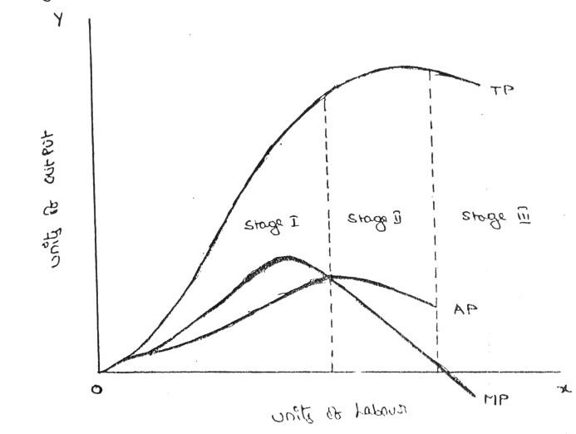

From the above graph the law of variable proportions operates in three stages. In the first stage, total product increases at an increasing rate. The marginal product in this stage increases at an increasing rate resulting in a greater increase in total product. The average product also increases. This stage continues up to the point where average product is equal to marginal product. The law of increasing returns is in operation at this stage.
The law of diminishing returns starts operating from the second stage awards. At the second stage total product increases only at a diminishing rate. The average product also declines. The second stage comes to an end where total product becomes maximum and marginal product becomes zero. The marginal product becomes negative in the third stage.
So the total product also declines. The average product continues to decline

STAGES | TP | MP | AP
1 | Increase at an increasing rate | Increase reach  the maximum | Increase and reach the maximum
2 | Increase at Diminishing rate Till it reaches Maximum | Diminish equal  to zero | Starts Diminish
3 | Start declining | Because negative | Continues to decline

Production Function with Two Variable Inputs and Laws of Returns
Let us consider a production process that requires two inputs, capital(c) and labour (L) to produce a given output (Q). There could be more than two inputs in a real life situation, but for a simple analysis, we restrict the number of inputs to two only. In other words, the production function based on two inputs can be expressed as:
Q=f(C, L)
Normally, both capital and labour are required to produce a product. To some extent, these two inputs can be substituted for each other. Hence the product may choose any combination of labour and capital that gives him the required number of units of output. For any given level of output, a producer may hire both capital and labour, but he is free to choose any one combination of labour and capital out of several such combinations. The alternative combinations of labour and capital yielding a given level of output are such that if the use of one factor input is increased, that of another will decrease and vice versa.
ISOQUANTS:
The term Isoquants is derived from the words ‘iso’ and ‘quant’ – ‘Iso’ means equal and ‘quant’ implies quantity. Isoquant therefore, means equal quantity. A family of isoproduct curves or Isoquants or production difference curves can represent a production function with two variable inputs, which are substitutable for one another within limits.
Isoquants are the curves, which represent the different combinations of inputs producing a particular quantity of output. Any combination on the isoquant represents the some level of output.
Q= f (L, K)
Where ‘Q’, the units of output is a function of the quantity of two inputs ‘L’ and ‘K’.
Thus an isoquant shows all possible combinations of two inputs, which are capable of producing equal or a given level of output. Since each combination yields same output, the producer becomes indifferent towards these combinations.
Combinations | Labour (units) | Capital (Units) | Output (quintals)
A | 1 | 10 | 50
B | 2 | 7 | 50
C | 3 | 4 | 50
D | 4 | 4 | 50
E | 5 | 1 | 50

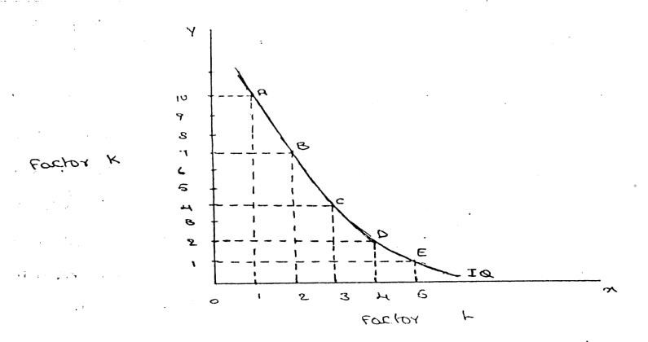

FEATURES OF AN ISOQUANT
(1).DOWNWARD SLOPING:-Isoquants are downward sloping curves because, if one input increases, the other one reduces. There is no question of increase in both the inputs to yield a given output.
A degree of substitution is assumed between the factors of production. In other words, an isoquant cannot be increasing, as increase in both the inputs does not yield same level of output. If it is constant, it means that the output remains constant though the use of one of the factors is increasing, which is not true, Isoquants slope from left to right.
(2).CONVEX TO ORIGIN:-Isoquants are convex to the origin. It is because the input factors are not perfect substitutes. One input factors were perfect substituted by other input factor in a 'diminishing marginal rate'. If the input factors were perfect substitutes, the isoquant would be a falling straight line. When the inputs are used in fixed proportion, and substitution of one input for the other cannot take place, the isoquant will be L shaped.
(3).DO NOT INTERSECT:-Two isoproducts do not intersect with each other. It is because, each of these denote a particular level of output. If the manufacturer wants to operate at a higher level of output, he has to switch over to another isoquant with a higher level of output and vice versa.
(4).DO NOT TOUCH AXIS:-The isoquant touches neither x-axis nor y-axis, as both inputs are required to produce a given product.
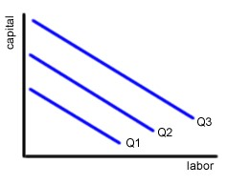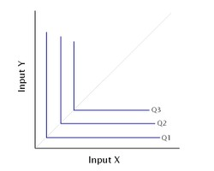
Isoquant is perfect substitute isoquant is not perfect substitute
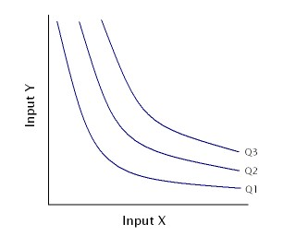
It showing different volume of output

ISO COST
Definition:
A firm can produce a given level of output using efficiently different combinations of two inputs. For choosing efficient combination of the inputs, the producer selects that combination of factors which has the lower cost of production. The information about the cost can be obtained from the isocost lines.
Explanation:
An isocost line is also called outlay line or price line or factor cost line. An isocost line shows all the combinations of labor and capital that are available for a given total cost to-the producer.

In economics, the isocost is the set of combinations of goods that have the same total cost; this can be represented by a curve on a graph.
In economics an `isocost` line shows all combinations of inputs which cost the same total amount
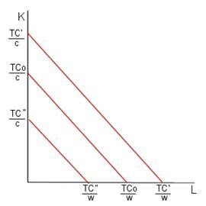
Isoquant and Isocost

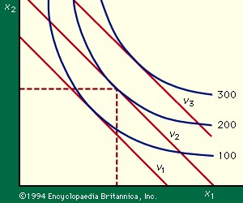

Marginal rate of technical substitution
In economic theory, the Marginal Rate of Technical Substitution (MRTS) - or Technical Rate of Substitution (TRS) - is the amount by which the quantity of one input has to be reduced (− Δx₂) when one extra unit of another input is used (Δx₁ = 1), so that output remains constant ().
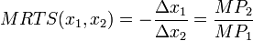
where MP₁ and MP₂ are the marginal products of input 1 and input 2, respectively, and MRTS(x₁,x₂) is Marginal Rate of Technical Substitution of the input x₁ for x₂.Along an isoquant, the MRTS shows the rate at which one input (e.g. capital or labor) may be substituted for another, while maintaining the same level of output. The MRTS can also be seen as the slope of an isoquant at the point in question.

Combinations | Labour (units) | Capital (Units) | Output (quintals) | MRTS
A | 20 | 1 | 50
B | 15 | 2 | 50 | 5:1
C | 11 | 3 | 50 | 4:1
D | 8 | 4 | 50 | 3:1
E | 6 | 5 | 50 | 2:1
F | 5 | 6 | 50 | 1:1

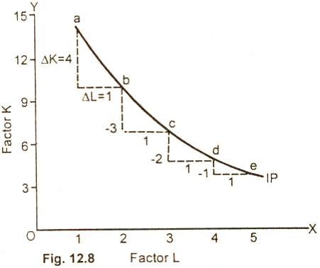

Least cost combination of inputs
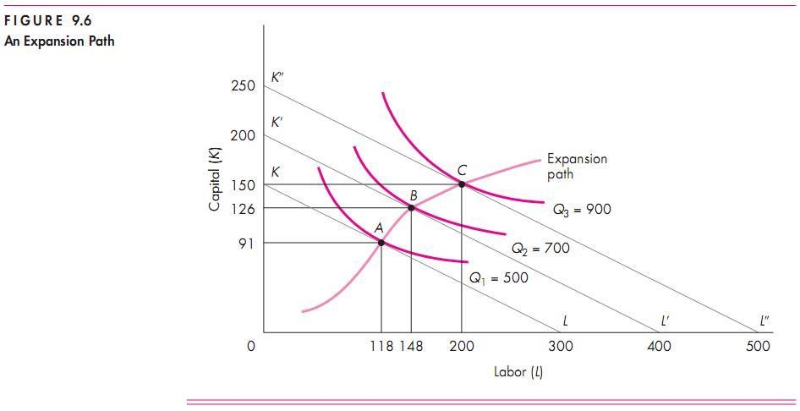

Cobb-Douglas production function:
Production function of the linear homogenous type is invested by and first tested by C. W. Cobb and P. H. Douglas in 1899 to1922. This famous statistical production function is known as Cobb-Douglas production function. Originally the function is applied on the empirical study of the American manufacturing industry. Cobb – Douglas production function takes the following mathematical form.
Y= (b K^{X} L^{1-x})
Where Y=output k=Capital L=Labour
The production function shows that one percent change in labour, capital reaming the same is associated with a 0.75 %change in output. One percent change in capital, labour reaming the same, is associated with a 0.25 %change in output.
Assumptions:
It has the following assumptions
- The function assumes that output is the function of two factors viz. capital and labour.
- It is a linear homogenous production function of the first degree
- The function assumes that the logarithm of the total output of the economy is a linear function of the logarithms of the labour force and capital stock.
- There are constant returns to scale
- All inputs are homogenous(same)

RETURNS TO SCALE

Another important attribute of production function is how output responds in the long run to changes in the scale of the firm i.e. when all inputs are increased in the same proportion (by say 10%), how does output change.
Clearly, there are 3 possibilities. If output increases by more than an increase in inputs (i.e.by more than 10%), then the situation is one of increasing returns to scale (IRS).
If output increases by less than the increase in inputs, then it is a case of decreasing returns to scale (DRS).
Lastly, output may increase by exactly the same proportion as inputs. For example a doubling of inputs may
Lead to a doubling of output. This is a case of constant returns to scale (CRS).

Capital  (Units) | Labour  (units) | % increase in both  inputs | Output  (quintals) | % increase in both output | Law  applications
1 | 3 |  | 50
A2 | 6 | 100 | 120 | 140 | increase
4 | 12 | 100 | 240 | 100 | constant
8 | 24 | 100 | 360 | 50 | decrease

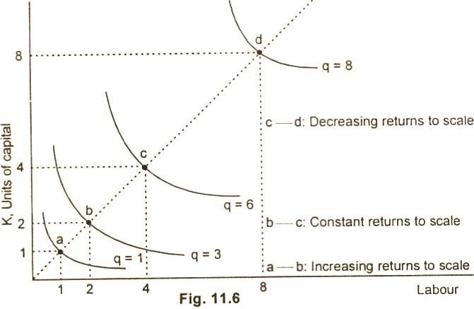

ECONOMIES OF SCALE

Production may be carried on a small scale or o a large scale by a firm. When a firm expands its size of production by increasing all the factors, it secures certain advantages known as economies of production. Marshall has classified these economies of large-scale production into internal economies and external economies.

Internal economies are those, which are opened to a single factory or a single firm independently of the action of other firms. They result from an increase in the scale of output of a firm and cannot be achieved unless output increases. Hence internal economies depend solely upon the size of the firm and are different for different firms.

External economies are those benefits, which are shared in by a number of firms or industries when the scale of production in an industry or groups of industries increases. Hence external economies benefit all firms within the industry as the size of the industry expands.

Causes of internal economies:
Internal economies are generally caused by two factors
1. Indivisibilities 2. Specialization.

- Indivisibilities
Many fixed factors of production are indivisible in the sense that they must be used in a fixed minimum size. For instance, if a worker works half the time, he may be paid half the salary. But he cannot be chopped into half and asked to produce half the current output. Thus as output increases the indivisible factors which were being used below capacity can be utilized to their full capacity thereby reducing costs. Such indivisibilities arise in the case of labour, machines, marketing, finance and research.

- Specialization.

Division of labour, which leads to specialization, is another cause of internal economies. Specialization refers to the limitation of activities within a particular field of production. Specialization may be in labour, capital, machinery and place. For example, the production process may be split into four departments relation to manufacturing, assembling, packing and marketing under the charge of separate managers who may work under the overall charge of the general manger and coordinate the activities of the for departments. Thus specialization will lead to greater productive efficiency and to reduction in costs.

Internal Economies:

Internal economies may be of the following types.

A). Technical Economies.

Technical economies arise to a firm from the use of better machines and superior techniques of production. As a result, production increases and per unit cost of production falls. A large firm, which employs costly and superior plant and equipment, enjoys a technical superiority over a small firm. Another technical economy lies in the mechanical advantage of using large machines. The cost of operating large machines is less than that of operating mall machine. More over a larger firm is able to reduce it’s per unit cost of production by linking the various processes of production. Technical economies may also be associated when the large firm is able to utilize all its waste materials for the development of by-products industry. Scope for specialization is also available in a large firm. This increases the productive capacity of the firm and reduces the unit cost of production.

B). Managerial Economies:

These economies arise due to better and more elaborate management, which only the large size firms can afford. There may be a separate head for manufacturing, assembling, packing, marketing, general administration etc. Each department is under the charge of an expert. Hence the appointment of experts, division of administration into several departments, functional specialization and scientific co-ordination of various works make the management of the firm most efficient.

C). Marketing Economies:

The large firm reaps marketing or commercial economies in buying its requirements and in selling its final products. The large firm generally has a separate marketing department. It can buy and sell on behalf of the firm, when the market trends are more favorable. In the matter of buying they could enjoy advantages like preferential treatment, transport concessions, cheap credit, prompt delivery and fine relation with dealers. Similarly it sells its products more effectively for a higher margin of profit.

D). Financial Economies:

The large firm is able to secure the necessary finances either for block capital purposes or for working capital needs more easily and cheaply. It can barrow from the public, banks and other financial institutions at relatively cheaper rates. It is in this way that a large firm reaps financial economies.

E). Risk bearing Economies:

The large firm produces many commodities and serves wider areas. It is, therefore, able to absorb any shock for its existence. For example, during business depression, the prices fall for every firm. There is also a possibility for market fluctuations in a particular product of the firm. Under such circumstances the risk-bearing economies or survival economies help the bigger firm to survive business crisis.

F). Economies of Research:

A large firm possesses larger resources and can establish it’s own research laboratory and employ trained research workers. The firm may even invent new production techniques for increasing its output and reducing cost.

G). Economies of welfare:

A large firm can provide better working conditions in-and out-side the factory. Facilities like subsidized canteens, crèches for the infants, recreation room, cheap houses, educational and medical facilities tend to increase the productive efficiency of the workers, which helps in raising production and reducing costs.

External Economies.

Business firm enjoys a number of external economies, which are discussed below:

A). Economies of Concentration:

When an industry is concentrated in a particular area, all the member firms reap some common economies like skilled labour, improved means of transport and communications, banking and financial services, supply of power and benefits from subsidiaries. All these facilities tend to lower the unit cost of production of all the firms in the industry.

B). Economies of Information

The industry can set up an information centre which may publish a journal and pass on information regarding the availability of raw materials, modern machines, export potentialities and provide other information needed by the firms. It will benefit all firms and reduction in their costs.

C). Economies of Welfare:

An industry is in a better position to provide welfare facilities to the workers. It may get land at concessional rates and procure special facilities from the local bodies for setting up housing colonies for the workers. It may also establish public health care units, educational institutions both general and technical so that a continuous supply of skilled labour is available to the industry. This will help the efficiency of the workers.

D). Economies of Disintegration:

The firms in an industry may also reap the economies of specialization. When an industry expands, it becomes possible to spilt up some of the processes which are taken over by specialist firms. For example, in the cotton textile industry, some firms may specialize in manufacturing thread, others in printing, still others in dyeing, some in long cloth, some in dhotis, some in shirting etc. As a result the efficiency of the firms specializing in different fields increases and the unit cost of production falls.

Thus internal economies depend upon the size of the firm and external economies depend upon the size of the industry.

DISECONOMIES OF LARGE SCALE PRODUCTION

Internal and external diseconomies are the limits to large-scale production. It is possible that expansion of a firm’s output may lead to rise in costs and thus result diseconomies instead of economies. When a firm expands beyond proper limits, it is beyond the capacity of the manager to manage it efficiently. This is an example of an internal diseconomy. In the same manner, the expansion of an industry may result in diseconomies, which may be called external diseconomies. Employment of additional factors of production becomes less efficient and they are obtained at a higher cost. It is in this way that external diseconomies result as an industry expands.

The major diseconomies of large-scale production are discussed below:

Internal Diseconomies:

A). Financial Diseconomies:

For expanding business, the entrepreneur needs finance. But finance may not be easily available in the required amount at the appropriate time. Lack of finance retards the production plans thereby increasing costs of the firm.

B). Managerial diseconomies:

There are difficulties of large-scale management. Supervision becomes a difficult job. Workers do not work efficiently, wastages arise, decision-making becomes difficult, coordination between workers and management disappears and production costs increase.

C). Marketing Diseconomies:

As business is expanded, prices of the factors of production will rise. The cost will therefore rise. Raw materials may not be available in sufficient quantities due to their scarcities. Additional output may depress the price in the market. The demand for the products may fall as a result of changes in tastes and preferences of the people. Hence cost will exceed the revenue.

D). Technical Diseconomies:

There is a limit to the division of labour and splitting down of production p0rocesses. The firm may fail to operate its plant to its maximum capacity. As a result cost per unit increases. Internal diseconomies follow.

E). Diseconomies of Risk-taking:

As the scale of production of a firm expands risks also increase with it. Wrong decision by the management may adversely affect production. In large firms are affected by any disaster, natural or human, the economy will be put to strains.

External Diseconomies:

When many firm get located at a particular place, the costs of transportation increases due to congestion. The firms have to face considerable delays in getting raw materials and sending finished products to the marketing centers. The localization of industries may lead to scarcity of raw material, shortage of various factors of production like labour and capital, shortage of power, finance and equipments. All such external diseconomies tend to raise cost per unit.

COST ANALYSIS
Profit is the ultimate aim of any business and the long-run prosperity of a firm depends upon its ability to earn sustained profits. Profits are the difference between selling price and cost of production. In general the selling price is not within the control of a firm but many costs are under its control. The firm should therefore aim at controlling and minimizing cost. Since every business decision involves cost consideration, it is necessary to understand the meaning of various concepts for clear business thinking and application of right kind of costs.
COST CONCEPTS:
A managerial economist must have a clear understanding of the different cost concepts for clear business thinking and proper application. The several alternative bases of classifying cost and the relevance of each for different kinds of problems are to be studied. The various relevant concepts of cost are:
- Opportunity costs and outlay costs:
Out lay cost also known as actual costs obsolete costs are those expends which are actually incurred by the firm these are the payments made for labour, material, plant, building, machinery traveling, transporting etc., These are all those expense item appearing in the books of account, hence based on accounting cost concept.
On the other hand opportunity cost implies the earnings foregone on the next best alternative, has the present option is undertaken. This cost is often measured by assessing the alternative, which has to be scarified if the particular line is followed.
The opportunity cost concept is made use for long-run decisions. This concept is very important in capital expenditure budgeting. This concept is very important in capital expenditure budgeting. The concept is also useful for taking short-run decisions opportunity cost is the cost concept to use when the supply of inputs is strictly limited and when there is an alternative. If there is no alternative, Opportunity cost is zero. The opportunity cost of any action is therefore measured by the value of the most favorable alternative course, which had to be foregoing if that action is taken.
- Explicit and implicit costs:
Explicit costs are those expenses that involve cash payments. These are the actual or business costs that appear in the books of accounts. These costs include payment of wages and salaries, payment for raw-materials, interest on borrowed capital funds, rent on hired land, Taxes paid etc.
Implicit costs are the costs of the factor units that are owned by the employer himself. These costs are not actually incurred but would have been incurred in the absence of employment of self – owned factors. The two normal implicit costs are depreciation, interest on capital etc. A decision maker must consider implicit costs too to find out appropriate profitability of alternatives.
- Historical and Replacement costs:
Historical cost is the original cost of an asset. Historical cost valuation shows the cost of an asset as the original price paid for the asset acquired in the past. Historical valuation is the basis for financial accounts.
A replacement cost is the price that would have to be paid currently to replace the same asset. During periods of substantial change in the price level, historical valuation gives a poor projection of the future cost intended for managerial decision. A replacement cost is a relevant cost concept when financial statements have to be adjusted for inflation.
- Short – run and Long – run costs:
Short-run is a period during which the physical capacity of the firm remains fixed. Any increase in output during this period is possible only by using the existing physical capacity more extensively. So short run cost is that which varies with output when the plant and capital equipment in constant.
Long run costs are those, which vary with output when all inputs are variable including plant and capital equipment. Long-run cost analysis helps to take investment decisions.
- Out-of pocket and Books costs:
Out-of pocket costs also known as explicit costs are those costs that involve current cash payment. Book costs also called implicit costs do not require current cash payments. Depreciation, unpaid interest, salary of the owner is examples of book costs.
But the book costs are taken into account in determining the level dividend payable during a period. Both book costs and out-of-pocket costs are considered for all decisions. Book cost is the cost of self-owned factors of production.
- Fixed and Variable costs:
Fixed cost is that cost which remains constant for a certain level to output. It is not affected by the changes in the volume of production. But fixed cost per unit decrease, when the production is increased. Fixed cost includes salaries, Rent, Administrative expenses depreciations etc.
Variable is that which varies directly with the variation is output. An increase in total output results in an increase in total variable costs and decrease in total output results in a proportionate decline in the total variables costs. The variable cost per unit will be constant. Ex: Raw materials, labour, direct expenses, etc.

- Past and Future costs:
Past costs also called historical costs are the actual cost incurred and recorded in the book of account these costs are useful only for valuation and not for decision making.
Future costs are costs that are expected to be incurred in the futures. They are not actual costs. They are the costs forecasted or estimated with rational methods. Future cost estimate is useful for decision making because decision are meant for future.
- Traceable and Common costs:
Traceable costs otherwise called direct cost, is one, which can be identified with a products process or product. Raw material, labour involved in production is examples of traceable cost.
Common costs are the ones that common are attributed to a particular process or product. They are incurred collectively for different processes or different types of products. It cannot be directly identified with any particular process or type of product.
- Avoidable and Unavoidable costs:
Avoidable costs are the costs, which can be reduced if the business activities of a concern are curtailed. For example, if some workers can be retrenched with a drop in a product – line, or volume or production the wages of the retrenched workers are escapable costs.
The unavoidable costs are otherwise called sunk costs. There will not be any reduction in this cost even if reduction in business activity is made. For example cost of the ideal machine capacity is unavoidable cost.
- Controllable and Uncontrollable costs:
Controllable costs are ones, which can be regulated by the executive who is in change of it. The concept of controllability of cost varies with levels of management. Direct expenses like material, labour etc. are controllable costs.
Some costs are not directly identifiable with a process of product. They are appointed to various processes or products in some proportion. This cost varies with the variation in the basis of allocation and is independent of the actions of the executive of that department.
These apportioned costs are called uncontrollable costs.
- Incremental and Sunk costs:
Incremental cost also known as different cost is the additional cost due to a change in the level or nature of business activity. The change may be caused by adding a new product, adding new machinery, replacing a machine by a better one etc.
Sunk costs are those which are not altered by any change – They are the costs incurred in the past. This cost is the result of past decision, and cannot be changed by future decisions. Investments in fixed assets are examples of sunk costs.
- Total, average and marginal costs:
Total cost is the total cash payment made for the input needed for production. It may be explicit or implicit. It is the sum total of the fixed and variable costs. Average cost is the cost per unit of output. If is obtained by dividing the total cost (TC) by the total quantity produced (Q)

TC
Average cost = ------
Q
Marginal cost is the additional cost incurred to produce and additional unit of output or it is the cost of the marginal unit produced.

- Accounting and Economics costs:
Accounting costs are the costs recorded for the purpose of preparing the balance sheet and profit and ton statements to meet the legal, financial and tax purpose of the company. The accounting concept is a historical concept and records what has happened in the post.
Economics concept considers future costs and future revenues, which help future planning, and choice, while the accountant describes what has happened, the economics aims at projecting what will happen.

BREAKEVEN ANALYSIS
The study of cost-volume-profit relationship is often referred as BEA. The term BEA is interpreted in two senses. In its narrow sense, it is concerned with finding out BEP; BEP is the point at which total revenue is equal to total cost. It is the point of no profit, no loss. In its broad determine the probable profit at any level of production

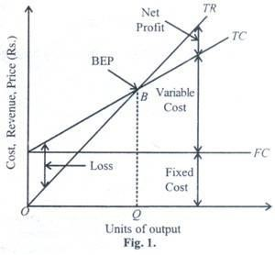
- Fixed cost: Expenses that do not vary with the volume of production are known as fixed expenses. Eg. Manager’s salary, rent and taxes, insurance etc. It should be noted that fixed changes are fixed only within a certain range of plant capacity. The concept of fixed overhead is most useful in formulating a price fixing policy. Fixed cost per unit is not fixed.
- Variable Cost: Expenses that vary almost in direct proportion to the volume of production of sales are called variable expenses. Eg. Electric power and fuel, packing materials consumable stores. It should be noted that variable cost per unit is fixed.
- Contribution: Contribution is the difference between sales and variable costs and it contributed towards fixed costs and profit. It helps in sales and pricing policies and measuring the profitability of different proposals. Contribution is a sure test to decide whether a product is worthwhile to be continued among different products. Contribution = Sales – Variable cost
Contribution = Fixed Cost + Profit.
- Margin of safety: Margin of safety is the excess of sales over the break even sales. It can be expressed in absolute sales amount or in percentage. It indicates the extent to which the sales can be reduced without resulting in loss. A large margin of safety indicates the soundness of the business. The formula for the margin of safety is:
Profit
Present sales – Break even sales or
P.V. ratio
- Break – Even- Point: If we divide the term into three words, then it does not require further explanation.
    - Break-divide
    - Even-equal
    - Point-place or position
Break Even Point refers to the point where total cost is equal to total revenue. It is a point of no profit, no loss. This is also a minimum point of no profit, no loss. This is also a minimum point of production where total costs are recovered. If sales go up beyond the Break Even Point, organization makes a profit. If they come down, a loss is incurred.

Fixed Expenses Contributi on per unit
- Break Even point (Units) =
Fixed expenses
- Break Even point (In Rupees) =
Contributi on

- Angle of incidence: This is the angle between sales line and total cost line at the Breakeven point. It indicates the profit earning capacity of the concern. Large angle of incidence indicates a high rate of profit; a small angle indicates a low rate of earnings. To improve this angle, contribution should be increased either by raising the selling price and/or by reducing variable cost. It also indicates as to what extent the output and sales price can be changed to attain a desired amount of profit.

- Profit Volume Ratio is usually called P. V. ratio. It is one of the most useful ratios for studying the profitability of business. The ratio of contribution to sales is the P/V ratio. It may be expressed in percentage. Therefore, every organization tries to improve the P. V. ratio of each product by reducing the variable cost per unit or by increasing the selling price per unit. The concept of P. V. ratio helps in determining break even-point, a desired amount of profit etc.

Contribution
The formula is, X 100
Sales
Assumptions:
  - All costs are classified into two – fixed and variable.
  - Fixed costs remain constant at all levels of output.
  - Variable costs vary proportionally with the volume of output.
  - Selling price per unit remains constant in spite of competition or change in the volume of production.
  - There will be no change in operating efficiency.
  - There will be no change in the general price level.
  - Volume of production is the only factor affecting the cost.
  - Volume of sales and volume of production are equal. Hence there is no unsold stock.
  - There is only one product or in the case of multiple products. Sales mix remains constant.
Merits:
  - Information provided by the Break-Even Chart can be understood more easily than those contained in the profit and Loss Account and the cost statement.
  - Break Even Chart discloses the relationship between cost, volume and profit. It reveals how changes in profit. So, it helps management in decision-making.
  - It is very useful for forecasting costs and profits long term planning and growth
  - The chart discloses profits at various levels of production.
  - It serves as a useful tool for cost control.
  - It can also be used to study the comparative plant efficiencies of the industry.
  - Analytical Break-even chart present the different elements, in the costs – direct material, direct labour, fixed and variable overheads.
Demerits:
  - Break-even chart presents only cost volume profits. It ignores other considerations such as capital amount, marketing aspects and effect of government policy etc., which are necessary in decision making.
  - It is assumed that sales, total cost and fixed cost can be represented as straight lines. In actual practice, this may not be so.
  - It assumes that profit is a function of output. This is not always true. The firm may increase the profit without increasing its output.
  - A major drawback of BEC is its inability to handle production and sale of multiple products.
  - It is difficult to handle selling costs such as advertisement and sale promotion in BEC.
  - It ignores economics of scale in production.
  - Fixed costs do not remain constant in the long run.
  - Semi-variable costs are completely ignored.
  - When production increases variable cost per unit may not remain constant but may reduce on account of bulk buying etc.

.

COST ANALYSIS

Profit is the ultimate aim of any business and the long-run prosperity of a firm depends upon its ability to earn sustained profits. Profits are the difference between selling price and cost of production. In general the selling price is not within the control of a firm but many costs are under its control. The firm should therefore aim at controlling and minimizing cost. Since every business decision involves cost consideration, it is necessary to understand the meaning of various concepts for clear business thinking and application of right kind of costs.

COST CONCEPTS:

A managerial economist must have a clear understanding of the different cost concepts for clear business thinking and proper application. The several alternative bases of classifying cost and the relevance of each for different kinds of problems are to be studied.
The various relevant concepts of cost are:

- Opportunity costs and outlay costs:

Out lay cost also known as actual costs obsolete costs are those expends which are actually incurred by the firm these are the payments made for labour, material, plant, building, machinery traveling, transporting etc., These are all those expense item appearing in the books of account, hence based on accounting cost concept.

On the other hand opportunity cost implies the earnings foregone on the next best alternative, has the present option is undertaken. This cost is often measured by assessing the alternative, which has to be scarified if the particular line is followed.

The opportunity cost concept is made use for long-run decisions. This concept is very important in capital expenditure budgeting. This concept is very important in capital expenditure budgeting. The concept is also useful for taking short-run decisions opportunity cost is the cost concept to use when the supply of inputs is strictly limited and when there is an alternative. If there is no alternative, Opportunity cost is zero. The opportunity cost of any action is therefore measured by the value of the most favorable alternative course, which had to be foregoing if that action is taken.

- Explicit and implicit costs:

Explicit costs are those expenses that involve cash payments. These are the actual or business costs that appear in the books of accounts. These costs include payment of wages and salaries, payment for raw-materials, interest on borrowed capital funds, rent on hired land, Taxes paid etc.

Implicit costs are the costs of the factor units that are owned by the employer himself. These costs are not actually incurred but would have been incurred in the absence of employment of self – owned factors. The two normal implicit costs are depreciation, interest on capital etc. A decision maker must consider implicit costs too to find out appropriate profitability of alternatives.

- Historical and Replacement costs:

Historical cost is the original cost of an asset. Historical cost valuation shows the cost of an asset as the original price paid for the asset acquired in the past. Historical valuation is the basis for financial accounts.

A replacement cost is the price that would have to be paid currently to replace the same asset. During periods of substantial change in the price level, historical valuation gives a poor projection of the future cost intended for managerial decision. A replacement cost is a relevant cost concept when financial statements have to be adjusted for inflation.

- Short – run and long – run costs:

Short-run is a period during which the physical capacity of the firm remains fixed. Any increase in output during this period is possible only by using the existing physical capacity more extensively. So short run cost is that which varies with output when the plant and capital equipment in constant.

Long run costs are those, which vary with output when all inputs are variable including plant and capital equipment. Long-run cost analysis helps to take investment decisions.

- Out-of pocket and books costs:

Out-of pocket costs also known as explicit costs are those costs that involve current cash payment. Book costs also called implicit costs do not require current cash payments.
Depreciation, unpaid interest, salary of the owner is examples of back costs.

But the book costs are taken into account in determining the level dividend payable during a period. Both book costs and out-of-pocket costs are considered for all decisions. Book cost is the cost of self-owned factors of production.

- Fixed and variable costs:

Fixed cost is that cost which remains constant for a certain level to output. It is not affected by the changes in the volume of production. But fixed cost per unit decrease, when the production is increased. Fixed cost includes salaries, Rent, Administrative expenses depreciations etc.

Variable is that which varies directly with the variation is output. An increase in total output results in an increase in total variable costs and decrease in total output results in a proportionate decline in the total variables costs. The variable cost per unit will be constant. Ex: Raw materials, labour, direct expenses, etc.

- Post and Future costs:

Post costs also called historical costs are the actual cost incurred and recorded in the book of account these costs are useful only for valuation and not for decision making.

Future costs are costs that are expected to be incurred in the futures. They are not actual costs. They are the costs forecasted or estimated with rational methods. Future cost estimate is useful for decision making because decision are meant for future.

- Traceable and common costs:

Traceable costs otherwise called direct cost, is one, which can be identified with a products process or product. Raw material, labour involved in production is examples of traceable cost.

Common costs are the ones that common are attributed to a particular process or product. They are incurred collectively for different processes or different types of products. It cannot be directly identified with any particular process or type of product.

- Avoidable and unavoidable costs:

Avoidable costs are the costs, which can be reduced if the business activities of a concern are curtailed. For example, if some workers can be retrenched with a drop in a product – line, or volume or production the wages of the retrenched workers are escapable costs.

The unavoidable costs are otherwise called sunk costs. There will not be any reduction in this cost even if reduction in business activity is made. For example cost of the ideal machine capacity is unavoidable cost.

- Controllable and uncontrollable costs:

Controllable costs are ones, which can be regulated by the executive who is in change of it. The concept of controllability of cost varies with levels of management. Direct expenses like material, labour etc. are controllable costs.

Some costs are not directly identifiable with a process of product. They are appointed to various processes or products in some proportion. This cost varies with the variation in the basis of allocation and is independent of the actions of the executive of that department.
These apportioned costs are called uncontrollable costs.

- Incremental and sunk costs:

Incremental cost also known as different cost is the additional cost due to a change in the level or nature of business activity. The change may be caused by adding a new product, adding new machinery, replacing a machine by a better one etc.

Sunk costs are those which are not altered by any change – They are the costs incurred in the past. This cost is the result of past decision, and cannot be changed by future decisions. Investments in fixed assets are examples of sunk costs.

- Total, average and marginal costs:

Total cost is the total cash payment made for the input needed for production. It may be explicit or implicit. It is the sum total of the fixed and variable costs. Average cost is the cost per unit of output. If is obtained by dividing the total cost (TC) by the total quantity produced (Q)
TC
Average cost = ------
Q
Marginal cost is the additional cost incurred to produce and additional unit of output or it is the cost of the marginal unit produced.

- Accounting and Economics costs:

Accounting costs are the costs recorded for the purpose of preparing the balance sheet and profit and ton statements to meet the legal, financial and tax purpose of the company. The accounting concept is a historical concept and records what has happened in the post.

Economics concept considers future costs and future revenues, which help future planning, and choice, while the accountant describes what has happened, the economics aims at projecting what will happen.

COST-OUTPUT RELATIONSHIP

A proper understanding of the nature and behavior of costs is a must for regulation and control of cost of production. The cost of production depends on money forces and an understanding of the functional relationship of cost to various forces will help us to take various decisions. Output is an important factor, which influences the cost.
The cost-output relationship plays an important role in determining the optimum level of production. Knowledge of the cost-output relation helps the manager in cost control, profit prediction, pricing, promotion etc. The relation between cost and its determinants is technically described as the cost function.

C= f (S, O, P, T ….)

Where;
C= Cost (Unit or total cost)
S= Size of plant/scale of production
O= Output level
P= Prices of inputs
T= Technology

Considering the period the cost function can be classified as (a) short-run cost function and (b) long-run cost function. In economics theory, the short-run is defined as that period during which the physical capacity of the firm is fixed and the output can be increased only by using the existing capacity allows to bring changes in output by physical capacity of the firm.

(a) Cost-Output Relation in the short-run:

The cost concepts made use of in the cost behavior are total cost, Average cost, and marginal cost.

Total cost is the actual money spent to produce a particular quantity of output. Total cost is the summation of fixed and variable costs.

TC=TFC+TVC

Up to a certain level of production total fixed cost i.e., the cost of plant, building, equipment etc, remains fixed. But the total variable cost i.e., the cost of labour, raw materials etc., Vary with the variation in output. Average cost is the total cost per unit. It can be found out as follows.

TC
AC=
Q
Q
The total of average fixed cost (TFC/Q) keep coming down as the production is increased and average variable cost (TVC/Q) will remain constant at any level of output.

Marginal cost is the addition to the total cost due to the production of an additional unit of product. It can be arrived at by dividing the change in total cost by the change in total output.

In the short-run there will not be any change in total fixed cost. Hence change in total cost implies change in total variable cost only.

Cost – output relations

Units of  Output  Q | Total fixed cost TFC | Total variable cost TVC | Total cost  (TFC +  TVC) TC | Average variable cost  (TVC /  Q) AVC | Average fixed cost  (TFC /  Q) AFC | Average cost  (TC/Q)  AC | Marginal cost  MC
0 | - | - | 60 | - | - | - | -
1 | 60 | 20 | 80 | 20 | 60 | 80 | 20
2 | 60 | 36 | 96 | 18 | 30 | 48 | 16
3 | 60 | 48 | 108 | 16 | 20 | 36 | 12
4 | 60 | 64 | 124 | 16 | 15 | 31 | 16
5 | 60 | 90 | 150 | 18 | 12 | 30 | 26
6 | 60 | 132 | 192 | 22 | 10 | 32 | 42

The above table represents the cost-output relation. The table is prepared on the basis of the law of diminishing marginal returns. The fixed cost Rs. 60 May include rent of factory building, interest on capital, salaries of permanently employed staff, insurance etc. The table shows that fixed cost is same at all levels of output but the average fixed cost, i.e., the fixed cost per unit, falls continuously as the output increases. The expenditure on the variable factors (TVC) is at different rate. If more and more units are produced with a given physical capacity the AVC will fall initially, as per the table declining up to 3rd unit, and being constant up to 4th unit and then rising. It implies that variable factors produce more efficiently near a firm’s optimum capacity than at any other levels of output.

And later rises. But the rise in AC is felt only after the start rising. In the table ‘AVC’ starts rising from the 5th unit onwards whereas the ‘AC’ starts rising from the 6th unit only so long as ‘AVC’ declines ‘AC’ also will decline. ‘AFC’ continues to fall with an increase in Output. When the rise in ‘AVC’ is more than the decline in ‘AFC’, the total cost again begin to rise. Thus there will be a stage where the ‘AVC’, the total cost again begin to rise thus there will be a stage where the ‘AVC’ may have started rising, yet the ‘AC’ is still declining because the rise in ‘AVC’ is less than the droop in ‘AFC’.

Thus the table shows an increasing returns or diminishing cost in the first stage and diminishing returns or diminishing cost in the second stage and followed by diminishing returns or increasing cost in the third stage.

The short-run cost-output relationship can be shown graphically as follows.

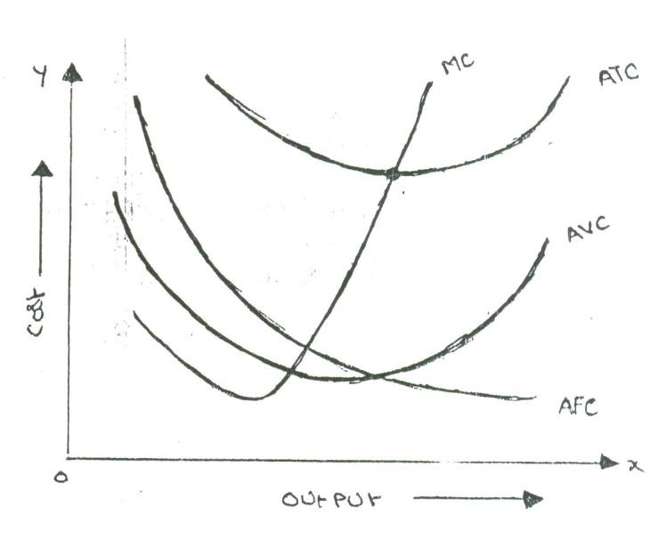

In the above graph the “AFC’ curve continues to fall as output rises an account of its spread over more and more units Output. But AVC curve (i.e. variable cost per unit) first falls and than rises due to the operation of the law of variable proportions. The behavior of “ATC’ curve depends upon the behavior of ‘AVC’ curve and ‘AFC’ curve. In the initial stage of production both ‘AVC’ and ‘AFC’ decline and hence ‘ATC’ also decline. But after a certain point ‘AVC’ starts rising. If the rise in variable cost is less than the decline in fixed cost, ATC will still continue to decline otherwise AC begins to rise. Thus the lower end of ‘ATC’ curve thus turns up and gives it a U-shape. That is why ‘ATC’ curve are U-shaped. The lowest point in ‘ATC’ curve indicates the least-cost combination of inputs. Where the total average cost is the minimum and where the “MC’ curve intersects ‘AC’ curve, It is not be the maximum output level rather it is the point where per unit cost of production will be at its lowest.
The relationship between ‘AVC’, ‘AFC’ and ‘ATC’ can be summarized up as follows:

- If both AFC and ‘AVC’ fall, ‘ATC’ will also fall.
- When ‘AFC’ falls and ‘AVC’ rises
  - ‘ATC’ will fall where the drop in ‘AFC’ is more than the raise in ‘AVC’.
  - ‘ATC’ remains constant is the drop in ‘AFC’ = rise in ‘AVC’
  - ‘ATC’ will rise where the drop in ‘AFC’ is less than the rise in ‘AVC’

b. Cost-output Relationship in the long-run:

Long run is a period, during which all inputs are variable including the one, which are fixes in the short-run. In the long run a firm can change its output according to its demand. Over a long period, the size of the plant can be changed, unwanted buildings can be sold staff can be increased or reduced. The long run enables the firms to expand and scale of their operation by bringing or purchasing larger quantities of all the inputs. Thus in the long run all factors become variable.

The long-run cost-output relations therefore imply the relationship between the total cost and the total output. In the long-run cost-output relationship is influenced by the law of returns to scale.

In the long run a firm has a number of alternatives in regards to the scale of operations. For each scale of production or plant size, the firm has an appropriate short-run average cost curves. The short-run average cost (SAC) curve applies to only one plant whereas the long-run average cost (LAC) curve takes in to consideration many plants.

The long-run cost-output relationship is shown graphically with the help of “LCA’ curve.

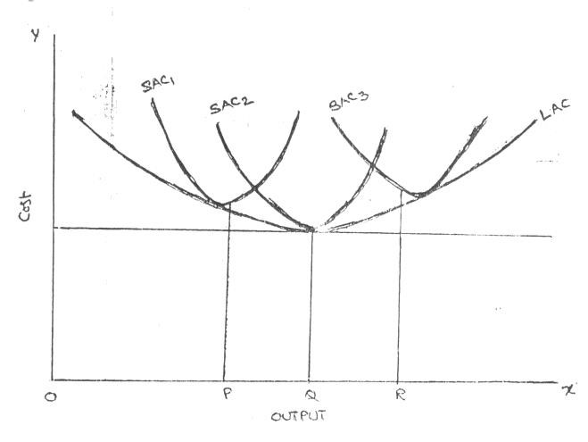
To draw on ‘LAC’ curve we have to start with a number of ‘SAC’ curves. In the above figure it is assumed that technologically there are only three sizes of plants – small, medium and large, ‘SAC’, for the small size, ‘SAC2’ for the medium size plant and ‘SAC3’ for the large size plant. If the firm wants to produce ‘OP’ units of output, it will choose the smallest plant. For an output beyond ‘OQ’ the firm wills optimum for medium size plant. It does not mean that the OQ production is not possible with small plant. Rather it implies that cost of production will be more with small plant compared to the medium plant.

For an output ‘OR’ the firm will choose the largest plant as the cost of production will be more with medium plant. Thus the firm has a series of ‘SAC’ curves. The ‘LCA’ curve drawn will be tangential to the entire family of ‘SAC’ curves i.e. the ‘LAC’ curve touches each ‘SAC’ curve at one point, and thus it is known as envelope curve. It is also known as planning curve as it serves as guide to the entrepreneur in his planning to expand the production in future. With the help of ‘LAC’ the firm determines the size of plant which yields the lowest average cost of producing a given volume of output it anticipates.

BREAKEVEN ANALYSIS

The study of cost-volume-profit relationship is often referred as BEA. The term BEA is interpreted in two senses. In its narrow sense, it is concerned with finding out BEP; BEP is the point at which total revenue is equal to total cost. It is the point of no profit, no loss.
In its broad determine the probable profit at any level of production.

Assumptions:

- All costs are classified into two – fixed and variable.
- Fixed costs remain constant at all levels of output.
- Variable costs vary proportionally with the volume of output.
- Selling price per unit remains constant in spite of competition or change in the volume of production.
- There will be no change in operating efficiency.
- There will be no change in the general price level.
- Volume of production is the only factor affecting the cost.
- Volume of sales and volume of production are equal. Hence there is no unsold stock.
- There is only one product or in the case of multiple products. Sales mix remains constant.

Merits:

- Information provided by the Break Even Chart can be understood more easily then those contained in the profit and Loss Account and the cost statement.
- Break Even Chart discloses the relationship between cost, volume and profit. It reveals how changes in profit. So, it helps management in decision-making.
- It is very useful for forecasting costs and profits long term planning and growth
- The chart discloses profits at various levels of production.
- It serves as a useful tool for cost control.
- It can also be used to study the comparative plant efficiencies of the industry.
- Analytical Break-even chart present the different elements, in the costs – direct material, direct labour, fixed and variable overheads.

Demerits:

- Break-even chart presents only cost volume profits. It ignores other considerations such as capital amount, marketing aspects and effect of government policy etc., which are necessary in decision making.
- It is assumed that sales, total cost and fixed cost can be represented as straight lines. In actual practice, this may not be so.
- It assumes that profit is a function of output. This is not always true. The firm may increase the profit without increasing its output.
- A major draw back of BEC is its inability to handle production and sale of multiple products.
- It is difficult to handle selling costs such as advertisement and sale promotion in BEC.
- It ignores economics of scale in production.
- Fixed costs do not remain constant in the long run.
- Semi-variable costs are completely ignored.
- It assumes production is equal to sale. It is not always true because generally there may be opening stock.
- When production increases variable cost per unit may not remain constant but may reduce on account of bulk buying etc.
- The assumption of static nature of business and economic activities is a well-known defect of BEC.

- Fixed cost
- Variable cost
- Contribution
- Margin of safety
- Angle of incidence
- Profit volume ratio
- Break-Even-Point

- Fixed cost: Expenses that do not vary with the volume of production are known as fixed expenses. Eg. Manager’s salary, rent and taxes, insurance etc. It should be noted that fixed changes are fixed only within a certain range of plant capacity. The concept of fixed overhead is most useful in formulating a price fixing policy. Fixed cost per unit is not fixed.
- Variable Cost: Expenses that vary almost in direct proportion to the volume of production of sales are called variable expenses. Eg. Electric power and fuel, packing materials consumable stores. It should be noted that variable cost per unit is fixed.
- Contribution: Contribution is the difference between sales and variable costs and it contributed towards fixed costs and profit. It helps in sales and pricing policies and measuring the profitability of different proposals. Contribution is a sure test to decide whether a product is worthwhile to be continued among different products.

Contribution = Sales – Variable cost Contribution = Fixed Cost + Profit.

- Margin of safety: Margin of safety is the excess of sales over the break even sales. It can be expressed in absolute sales amount or in percentage. It indicates the extent to which the sales can be reduced without resulting in loss. A large margin of safety indicates the soundness of the business. The formula for the margin of safety is:

Profit P. V. ratio
Present sales – Break even sales or
Margin of safety can be improved by taking the following steps.
- Increasing production
- Increasing selling price
- Reducing the fixed or the variable costs or both
- Substituting unprofitable product with profitable one.

- Angle of incidence: This is the angle between sales line and total cost line at the Break-even point. It indicates the profit earning capacity of the concern. Large angle of incidence indicates a high rate of profit; a small angle indicates a low rate of earnings. To improve this angle, contribution should be increased either by raising the selling price and/or by reducing variable cost. It also indicates as to what extent the output and sales price can be changed to attain a desired amount of profit.

- Profit Volume Ratio is usually called P. V. ratio. It is one of the most useful ratios for studying the profitability of business. The ratio of contribution to sales is the P/V ratio. It may be expressed in percentage. Therefore, every organization tries to improve the P. V. ratio of each product by reducing the variable cost per unit or by increasing the selling price per unit. The concept of P. V. ratio helps in determining break even-point, a desired amount of profit etc.

Contributi on
The formula is, X 100
Sales

7. Break – Even- Point: If we divide the term into three words, then it does not require further explanation.
Break-divide
Even-equal
Point-place or position
Break Even Point refers to the point where total cost is equal to total revenue. It is a point of no profit, no loss. This is also a minimum point of no profit, no loss. This is also a minimum point of production where total costs are recovered. If sales go up beyond the Break Even Point, organization makes a profit. If they come down, a loss is incurred.

Fixed Expenses Contributi on per unit Fixed expenses Contributi on
- Break Even point (Units) =
- Break Even point (In Rupees) = X sales

Simple problems
Problem1:

Find Break Even Point in Units and BEP sales through the follow
Fixed Cost=1, 50,000, Variable Cost=Rs. 15, Selling Price per unit =20/-

Solution: BEP Units = $\frac{Fixed Cost}{Selling Price Per unit-Variable Cost Per unit}$
BEP Units = $\frac{1,50,000}{20-15}$
BEP Units = 30,000
BEP Sales= BEP units X Selling Price per Unit
BEP Sales= 30,000 X 20
BEP Sales= 6, 00,000/-

Problem 2:
A company prepares a budget to produce 3, 00,000 units with fixed cost Rs. 15, 00,000/- Variable cost is Rs.10/- per unit Profit is 20% on Total Cost. Calculate BEP

Solution:
Total Units=3, 00,000
Fixed Cost =15, 00,000/-
Variable Cost= 3, 00,000 X 10 =30, 00,000
Profit = 20% on Total Cost
Total Cost = Fixed Cost + Variable Cost
Total Cost = 15, 00,000+30, 00,000
Total Cost=45, 00,000
Profit= 45, 00,000 X (20/100)
Profit=9, 00,000/-
Sales= Fixed Cost + Variable Cost + Profit
Sales=15, 00,000+ 30, 00,000 + 9, 00,000
Sales=54, 00,000/-
Selling Price per Unit = Total Sales / Total Produced Units
Selling Price per Unit = 54, 00,000 / 3, 00,000
Selling Price per Unit = 18/-
BEP Units = $\frac{Fixed Cost}{Selling Price Per unit-Variable Cost Per unit}$
BEP Units = $\frac{15,00,000}{18-10}$
BEP Units = 1, 87,500
BEP Sales = BEP Units X Selling Price per Unit
BEP Sales = 1, 87,500 X 18 = Rs. 33, 75,000/-

Problem: 3
From the following information you are required to calculate
- P.V Ratio 2) BEP Sales 3) Margin of Safety
Sales= Rs. 40,000/- Variable Cost = 20,000/- Fixed Cost = 16,000/
1). P.V Ratio: $P.V.Ratio=\frac{Sales-Variable Cost}{Sales}X100$

$$P.V.Ratio=\frac{40,000-20,000}{40,000}X100$$

$$P.V.Ratio=50\%$$

2). BEP Sales: $BEP Sales=\frac{Fixed Cost}{P.V.Ratio}$

$$BEP Sales=\frac{16,000}{0.5}$$

$$BEP Sales=32,000/-$$

3) Margin of Safety: $BEP Sales=Total Sales-BEP Sales$

$$BEP Sales=40,000-32,000$$

$$BEP Sales=8,000/-$$

Problem 4:
Determine P.V. Ratio and Fixed Cost and BEP Sales from the following information
Particulars | I period | II Period
Sales | 1,00,000 | 1,40,000
Profit | 4,000 | 12,000

1). P.V Ratio: $P.V.Ratio=\frac{Change in Profit}{Change in Sales}X100$

$$P.V.Ratio=\frac{8,000}{40,000}X100$$

$$P.V.Ratio=20\% or 0.2$$

II) Fixed Cost: For finding fixed cost take any period data as base.
$$Desire Sales=\frac{F+P}{P.V.Ratio}$$

$$1,00,000=\frac{F+4,000}{0.2}$$

$$1,00,000 X 0.2=F+4,000$$
$$F=20,000-4,000$$
$$F=16,000/-$$
II) BEP Sales: $BEP Sales=\frac{Fixed Cost}{P.V.Ratio}$

$$BEP Sales=\frac{16,000/-}{0.2}$$

BEP Sales = Rs. 80,000/-

Problem:5
The following figures of Sales and Profit of two periods are available in respect of firm

Particulars | I period | II Period
Sales | 10,00,000 | 12,00,000
Profit | 1,50,000 | 2,30,000
You are required to calculate
1. P.V ratio 2. BEP Sales 3.Sales required to earn profit of Rs. 20,000/- 4. Profit of estimated sales of Rs. 1,50,000/- 5. Margin of Safety at a profit of Rs. 50,000

1) P.V ratio: $P.V.Ratio=\frac{Change in Profit}{Change in Sales}X100$

$$P.V.Ratio=\frac{80,000}{2,00,000}X100$$

$$P.V.Ratio=40\% or 0.4$$
2) BEP Sales:
Fixed Cost: For finding fixed cost take any period data as base.
$$Desire Sales=\frac{F+P}{P.V.Ratio}$$

$$10,00,000=\frac{F+1,50,000}{0.4}$$

$$10,00,000 X 0.4=F+1,50,000$$
$$F=4,00,000-1,50,000$$
$$F=2,50,000/-$$

$$BEP Sales=\frac{Fixed Cost}{P.V.Ratio}$$

$$BEP Sales=\frac{2,50,000/-}{0.4}$$
BEP Sales = Rs. 6, 25,000/-

3. Sales required to earn profit of Rs. 2, 00,000/-
$$Desire Sales=\frac{F+P}{P.V.Ratio}$$

$$Desire Sales=\frac{6,25,000+2,00,000}{0.4}$$

$$Desire Sales=20,62,500$$

4. Profit of estimated sales of Rs. 50,00,000/-
$$Desire Sales=\frac{F+P}{P.V.Ratio}$$

$$50,00,000=\frac{6,25,000+P}{0.4}$$

$$50,00,000 X 0.4=6,25,000+P$$

$P=13,75,000$/-

5. Margin of Safety at a profit of Rs. 5,00,000/-
$$Margin of Safety=\frac{Profit}{P.V.Ratio}$$

$$Margin of Safety=\frac{5,00,000}{0.4}$$
$Margin of Safety=$12,50,000/-

Problem: 6
If sales are 10,000 units and selling price is Rs. 20/- per unit, variable coast Rs. 10/- per unit, fixed cost Rs. 80,000/-. Find out BEP and BEP Sales. Calculate profit earned. What should be the sales for earning a profit of Rs. 60,000/- (JNTU Apr./May 2004)

Solution: BEP Units = $\frac{Fixed Cost}{Selling Price Per unit-Variable Cost Per unit}$
BEP Units = $\frac{80,000}{20-10}$
BEP Units = 8,000 units
BEP Sales:
BEP Sales = BEP Units X Selling Price Per unit
BEP Sales= 8,000 X 20
BEP Sales=1,60,000/-
Profit earned:
Profit = Sales – Variable Cost – Fixed Cost
Profit= 2,00,000 – 1,00,000 - 80,000
Profit = 20,000/-
What should be the sales for earning a profit of Rs 60,000/-

$$Desire Sales=\frac{F+P}{P.V.Ratio}$$

$$Desire sales=\frac{80,000+60,000}{0.5}$$

$$Desire Sales=2,80,000/-$$
$P=13,75,000$/-
$$P.V.Ratio=\frac{Sales-Variable Cost}{Sales}X100$$

$$P.V.Ratio=\frac{20-10}{20}X100$$

$$P.V.Ratio=50\% or 0.5$$

UNIT – III BUSINESS ORGANISATIONS AND MARKETS

BUSINESS AND NEW ECONOMIC ENVIRONMENT

Imagine you want to do business. Which are you interested in? For example, you want to get into InfoTech industry. What can you do in this industry? Which one do you choose?
The following are the alternatives you have on hand:

- You can bye and sell
- You can set up a small/medium/large industry to manufacture
- You can set up a workshop to repair
- You can develop software
- You can design hardware
- You can be a consultant/trouble-shooter

If you choose any one or more of the above, you have chosen the line of activity. The next step for you is to decide whether.

- You want to be only owner (It means you what to be sole trader) or
- You want to take some more professionals as co-owners along with you (If means you what to from partnership with others as partners) or
- You want to be a global player by mobilizing large resources across the country/world
- You want to bring all like-minded people to share the benefits of the common enterprise (You want to promote a joint stock company) or
- You want to involve government in the IT business (here you want to suggest government to promote a public enterprise!)

To decide this, it is necessary to know how to evaluate each of these alternatives.

Factors affecting the choice of form of business organization

Before we choose a particular form of business organization, let us study what factors affect such a choice? The following are the factors affecting the choice of a business organization:

- Easy to start and easy to close: The form of business organization should be such that it should be easy to close. There should not be hassles or long procedures in the process of setting up business or closing the same.
- Division of labour: There should be possibility to divide the work among the available owners.
- Large amount of resources: Large volume of business requires large volume of resources. Some forms of business organization do not permit to raise larger resources. Select the one which permits to mobilize the large resources.
- Liability: The liability of the owners should be limited to the extent of money invested in business. It is better if their personal properties are not brought into business to make up the losses of the business.
- Secrecy: The form of business organization you select should be such that it should permit to take care of the business secrets. We know that century old business units are still surviving only because they could successfully guard their business secrets.
- Transfer of ownership: There should be simple procedures to transfer the ownership to the next legal heir.
- Ownership, Management and control: If ownership, management and control are in the hands of one or a small group of persons, communication will be effective and coordination will be easier. Where ownership, management and control are widely distributed, it calls for a high degree of professional’s skills to monitor the performance of the business.
- Continuity: The business should continue forever and ever irrespective of the uncertainties in future.
- Quick decision-making: Select such a form of business organization, which permits you to take decisions quickly and promptly. Delay in decisions may invalidate the relevance of the decisions.
- Personal contact with customer: Most of the times, customers give us clues to improve business. So choose such a form, which keeps you close to the customers.
- Flexibility: In times of rough weather, there should be enough flexibility to shift from one business to the other. The lesser the funds committed in a particular business, the better it is.
- Taxation: More profit means more tax. Choose such a form, which permits to pay low tax.

These are the parameters against which we can evaluate each of the available forms of business organizations.

SOLE TRADER

The sole trader is the simplest, oldest and natural form of business organization. It is also called sole proprietorship. ‘Sole’ means one. ‘Sole trader’ implies that there is only one trader who is the owner of the business.

It is a one-man form of organization wherein the trader assumes all the risk of ownership carrying out the business with his own capital, skill and intelligence. He is the boss for himself. He has total operational freedom. He is the owner, Manager and controller. He has total freedom and flexibility. Full control lies with him. He can take his own decisions. He can choose or drop a particular product or business based on its merits. He need not discuss this with anybody. He is responsible for himself. This form of organization is popular all over the world. Restaurants, Supermarkets, pan shops, medical shops, hosiery shops etc.

Features

- It is easy to start a business under this form and also easy to close. • He introduces his own capital. Sometimes, he may borrow, if necessary • He enjoys all the profits and in case of loss, he lone suffers.
- He has unlimited liability which implies that his liability extends to his personal properties in case of loss.
- He has a high degree of flexibility to shift from one business to the other.
- Business secretes can be guarded well
- There is no continuity. The business comes to a close with the death, illness or insanity of the sole trader. Unless, the legal heirs show interest to continue the business, the business cannot be restored.
- He has total operational freedom. He is the owner, manager and controller.
- He can be directly in touch with the customers.
- He can take decisions very fast and implement them promptly.
- Rates of tax, for example, income tax and so on are comparatively very low.

Advantages

The following are the advantages of the sole trader from of business organization:

- Easy to start and easy to close: Formation of a sole trader from of organization is relatively easy even closing the business is easy.
- Personal contact with customers directly: Based on the tastes and preferences of the customers the stocks can be maintained.
- Prompt decision-making: To improve the quality of services to the customers, he can take any decision and implement the same promptly. He is the boss and he is responsible for his business Decisions relating to growth or expansion can be made promptly.
- High degree of flexibility: Based on the profitability, the trader can decide to continue or change the business, if need be.
- Secrecy: Business secrets can well be maintained because there is only one trader.
- Low rate of taxation: The rate of income tax for sole traders is relatively very low.
- Direct motivation: If there are profits, all the profits belong to the trader himself. In other words. If he works more hard, he will get more profits. This is the direct motivating factor. At the same time, if he does not take active interest, he may stand to lose badly also.
- Total Control: The ownership, management and control are in the hands of the sole trader and hence it is easy to maintain the hold on business.
- Minimum interference from government: Except in matters relating to public interest, government does not interfere in the business matters of the sole trader. The sole trader is free to fix price for his products/services if he enjoys monopoly market.
- Transferability: The legal heirs of the sole trader may take the possession of the business.

Disadvantages

The following are the disadvantages of sole trader form:

- Unlimited liability: The liability of the sole trader is unlimited. It means that the sole trader has to bring his personal property to clear off the loans of his business. From the legal point of view, he is not different from his business.
- Limited amounts of capital: The resources a sole trader can mobilize cannot be very large and hence this naturally sets a limit for the scale of operations.
- No division of labour: All the work related to different functions such as marketing, production, finance, labour and so on has to be taken care of by the sole trader himself. There is nobody else to take his burden. Family members and relatives cannot show as much interest as the trader takes.
- Uncertainty: There is no continuity in the duration of the business. On the death, insanity of insolvency the business may be come to an end.
- Inadequate for growth and expansion: This from is suitable for only small size, one-man-show type of organizations. This may not really work out for growing and expanding organizations.
- Lack of specialization: The services of specialists such as accountants, market researchers, consultants and so on, are not within the reach of most of the sole traders.
- More competition: Because it is easy to set up a small business, there is a high degree of competition among the small businessmen and a few who are good in taking care of customer requirements along can service.
- Low bargaining power: The sole trader is the in the receiving end in terms of loans or supply of raw materials. He may have to compromise many times regarding the terms and conditions of purchase of materials or borrowing loans from the finance houses or banks.

PARTNERSHIP

Partnership is an improved from of sole trader in certain respects. Where there are likeminded persons with resources, they can come together to do the business and share the profits/losses of the business in an agreed ratio. Persons who have entered into such an agreement are individually called ‘partners’ and collectively called ‘firm’. The relationship among partners is called a partnership.

Indian Partnership Act, 1932 defines partnership as the relationship between two or more persons who agree to share the profits of the business carried on by all or any one of them acting for all.

Features

- Relationship: Partnership is a relationship among persons. It is relationship resulting out of an agreement.
- Two or more persons: There should be two or more number of persons.
- There should be a business: Business should be conducted.
- Agreement: Persons should agree to share the profits/losses of the business
- Carried on by all or any one of them acting for all: The business can be carried on by all or any one of the persons acting for all. This means that the business can be carried on by one person who is the agent for all other persons. Every partner is both an agent and a principal. Agent for other partners and principal for himself. All the partners are agents and the ‘partnership’ is their principal.

The following are the other features:

- Unlimited liability: The liability of the partners is unlimited. The partnership and partners, in the eye of law, and not different but one and the same. Hence, the partners have to bring their personal assets to clear the losses of the firm, if any.
- Number of partners: According to the Indian Partnership Act, the minimum number of partners should be two and the maximum number if restricted, as given below:
- 10 partners is case of banking business
- 20 in case of non-banking business
- Division of labour: Because there are more than two persons, the work can be divided among the partners based on their aptitude.
- Personal contact with customers: The partners can continuously be in touch with the customers to monitor their requirements.
- Flexibility: All the partners are likeminded persons and hence they can take any decision relating to business.

Partnership Deed

The written agreement among the partners is called ‘the partnership deed’. It contains the terms and conditions governing the working of partnership. The following are contents of the partnership deed.

- Names and addresses of the firm and partners
- Nature of the business proposed
- Duration
- Amount of capital of the partnership and the ratio for contribution by each of the partners.
- Their profit sharing ration (this is used for sharing losses also)
- Rate of interest charged on capital contributed, loans taken from the partnership and the amounts drawn, if any, by the partners from their respective capital balances.
- The amount of salary or commission payable to any partner
- Procedure to value good will of the firm at the time of admission of a new partner, retirement of death of a partner
- Allocation of responsibilities of the partners in the firm
- Procedure for dissolution of the firm
- Name of the arbitrator to whom the disputes, if any, can be referred to for settlement.
- Special rights, obligations and liabilities of partners(s), if any.

KIND OF PARTNERS

The following are the different kinds of partners:

- Active Partner: Active partner takes active part in the affairs of the partnership. He is also called working partner.
- Sleeping Partner: Sleeping partner contributes to capital but does not take part in the affairs of the partnership.
- Nominal Partner: Nominal partner is partner just for namesake. He neither contributes to capital nor takes part in the affairs of business. Normally, the nominal partners are those who have good business connections, and are well places in the society.
- Partner by Estoppels: Estoppels means behavior or conduct. Partner by estoppels gives an impression to outsiders that he is the partner in the firm. In fact be neither contributes to capital, nor takes any role in the affairs of the partnership.
- Partner by holding out: If partners declare a particular person (having social status) as partner and this person does not contradict even after he comes to know such declaration, he is called a partner by holding out and he is liable for the claims of third parties. However, the third parties should prove they entered into contract with the firm in the belief that he is the partner of the firm. Such a person is called partner by holding out.
- Minor Partner: Minor has a special status in the partnership. A minor can be admitted for the benefits of the firm. A minor is entitled to his share of profits of the firm. The liability of a minor partner is limited to the extent of his contribution of the capital of the firm.

Right of partners

Every partner has right

- To take part in the management of business
- To express his opinion
- Of access to and inspect and copy and book of accounts of the firm
- To share equally the profits of the firm in the absence of any specific agreement to the contrary
- To receive interest on capital at an agreed rate of interest from the profits of the firm
- To receive interest on loans, if any, extended to the firm.
- To be indemnified for any loss incurred by him in the conduct of the business
- To receive any money spent by him in the ordinary and proper conduct of the business of the firm.

Advantages

The following are the advantages of the partnership from:

- Easy to form: Once there is a group of like-minded persons and good business proposal, it is easy to start and register a partnership.
- Availability of larger amount of capital: More amount of capital can be raised from more number of partners.
- Division of labour: The different partners come with varied backgrounds and skills. This facilities division of labour.
- Flexibility: The partners are free to change their decisions, add or drop a particular product or start a new business or close the present one and so on.
- Personal contact with customers: There is scope to keep close monitoring with customers requirements by keeping one of the partners in charge of sales and marketing. Necessary changes can be initiated based on the merits of the proposals from the customers.
- Quick decisions and prompt action: If there is consensus among partners, it is enough to implement any decision and initiate prompt action. Sometimes, it may more time for the partners on strategic issues to reach consensus.
- The positive impact of unlimited liability: Every partner is always alert about his impending danger of unlimited liability. Hence he tries to do his best to bring profits for the partnership firm by making good use of all his contacts.

Disadvantages:

The following are the disadvantages of partnership:

- Formation of partnership is difficult: Only like-minded persons can start a partnership. It is sarcastically said,’ it is easy to find a life partner, but not a business partner’.
- Liability: The partners have joint and several liabilities beside unlimited liability. Joint and several liability puts additional burden on the partners, which means that even the personal properties of the partner or partners can be attached. Even when all but one partner become insolvent, the solvent partner has to bear the entire burden of business loss.
- Lack of harmony or cohesiveness: It is likely that partners may not, most often work as a group with cohesiveness. This result in mutual conflicts, an attitude of suspicion and crisis of confidence. Lack of harmony results in delay in decisions and paralyses the entire operations.
- Limited growth: The resources when compared to sole trader, a partnership may raise little more. But when compare to the other forms such as a company, resources raised in this form of organization are limited. Added to this, there is a restriction on the maximum number of partners.
- Instability: The partnership form is known for its instability. The firm may be dissolved on death, insolvency or insanity of any of the partners.
- Lack of Public confidence: Public and even the financial institutions look at the unregistered firm with a suspicious eye. Though registration of the firm under the Indian Partnership Act is a solution of such problem, this cannot revive public confidence into this form of organization overnight. The partnership can create confidence in other only with their performance.

JOINT STOCK COMPANY

The joint stock company emerges from the limitations of partnership such as joint and several liability, unlimited liability, limited resources and uncertain duration and so on. Normally, to take part in a business, it may need large money and we cannot foretell the fate of business. It is not literally possible to get into business with little money. Against this background, it is interesting to study the functioning of a joint stock company. The main principle of the joint stock company from is to provide opportunity to take part in business with a low investment as possible say Rs.1000. Joint Stock Company has been a boon for investors with moderate funds to invest.

The word ‘ company’ has a Latin origin, com means ‘ come together’, pany means ‘ bread’, joint stock company means, people come together to earn their livelihood by investing in the stock of company jointly.

Company Defined

Lord justice Lindley explained the concept of the joint stock company from of organization as ‘an association of many persons who contribute money or money’s worth to a common stock and employ it for a common purpose.

Features

This definition brings out the following features of the company:

- Artificial person: The Company has no form or shape. It is an artificial person created by law. It is intangible, invisible and existing only, in the eyes of law.
- Separate legal existence: it has an independence existence, it separate from its members. It can acquire the assets. It can borrow for the company. It can sue other if they are in default in payment of dues, breach of contract with it, if any. Similarly, outsiders for any claim can sue it. A shareholder is not liable for the acts of the company. Similarly, the shareholders cannot bind the company by their acts.
- Voluntary association of persons: The Company is an association of voluntary association of persons who want to carry on business for profit. To carry on business, they need capital. So they invest in the share capital of the company.
- Limited Liability: The shareholders have limited liability i.e., liability limited to the face value of the shares held by him. In other words, the liability of a shareholder is restricted to the extent of his contribution to the share capital of the company. The shareholder need not pay anything, even in times of loss for the company, other than his contribution to the share capital.
- Capital is divided into shares: The total capital is divided into a certain number of units. Each unit is called a share. The price of each share is priced so low that every investor would like to invest in the company. The companies promoted by promoters of good standing (i.e., known for their reputation in terms of reliability character and dynamism) are likely to attract huge resources.
- Transferability of shares: In the company form of organization, the shares can be transferred from one person to the other. A shareholder of a public company can
cell sell his holding of shares at his will. However, the shares of a private company cannot be transferred. A private company restricts the transferability of the shares.
- Common Seal: As the company is an artificial person created by law has no physical form, it cannot sign its name on a paper; so, it has a common seal on which its name is engraved. The common seal should affix every document or contract; otherwise the company is not bound by such a document or contract.
- Perpetual succession: ‘Members may comes and members may go, but the company continues for ever and ever’ A. company has uninterrupted existence because of the right given to the shareholders to transfer the shares.
- Ownership and Management separated: The shareholders are spread over the length and breadth of the country, and sometimes, they are from different parts of the world. To facilitate administration, the shareholders elect some among themselves or the promoters of the company as directors to a Board, which looks after the management of the business. The Board recruits the managers and employees at different levels in the management. Thus the management is separated from the owners.
- Winding up: Winding up refers to the putting an end to the company. Because law creates it, only law can put an end to it in special circumstances such as representation from creditors of financial institutions, or shareholders against the company that their interests are not safeguarded. The company is not affected by the death or insolvency of any of its members.
- The name of the company ends with ‘limited’: it is necessary that the name of the company ends with limited (Ltd.) to give an indication to the outsiders that they are dealing with the company with limited liability and they should be careful about the liability aspect of their transactions with the company.

Formation of Joint Stock company

There are two stages in the formation of a joint stock company. They are:

- To obtain Certificates of Incorporation
- To obtain certificate of commencement of Business

Certificate of Incorporation: The certificate of Incorporation is just like a ‘date of birth’ certificate. It certifies that a company with such and such a name is born on a particular day.
Certificate of commencement of Business: A private company need not obtain the certificate of commencement of business. It can start its commercial operations immediately after obtaining the certificate of Incorporation.

The persons who conceive the idea of starting a company and who organize the necessary initial resources are called promoters. The vision of the promoters forms the backbone for the company in the future to reckon with.

The promoters have to file the following documents, along with necessary fee, with a registrar of joint stock companies to obtain certificate of incorporation:

- Memorandum of Association: The Memorandum of Association is also called the charter of the company. It outlines the relations of the company with the outsiders. If furnishes all its details in six clause such as (ii) Name clause (II) situation clause (iii) objects clause (iv) Capital clause and (vi) subscription clause duly executed by its subscribers.
- Articles of association: Articles of Association furnishes the byelaws or internal rules government the internal conduct of the company.
- The list of names and address of the proposed directors and their willingness, in writing to act as such, in case of registration of a public company.
- A statutory declaration that all the legal requirements have been fulfilled. The declaration has to be duly signed by any one of the following: Company secretary in whole practice, the proposed director, legal solicitor, chartered accountant in whole time practice or advocate of High court.

The registrar of joint stock companies peruses and verifies whether all these documents are in order or not. If he is satisfied with the information furnished, he will register the documents and then issue a certificate of incorporation, if it is private company, it can start its business operation immediately after obtaining certificate of incorporation.

Advantages

The following are the advantages of a joint Stock Company

- Mobilization of larger resources: A joint stock company provides opportunity for the investors to invest, even small sums, in the capital of large companies. The facilities rising of larger resources.
- Separate legal entity: The Company has separate legal entity. It is registered under Indian Companies Act, 1956.
- Limited liability: The shareholder has limited liability in respect of the shares held by him. In no case, does his liability exceed more than the face value of the shares allotted to him.
- Transferability of shares: The shares can be transferred to others. However, the private company shares cannot be transferred.
- Liquidity of investments: By providing the transferability of shares, shares can be converted into cash.
- Inculcates the habit of savings and investments: Because the share face value is very low, this promotes the habit of saving among the common man and mobilizes the same towards investments in the company.
- Democracy in management: the shareholders elect the directors in a democratic way in the general body meetings. The shareholders are free to make any proposals, question the practice of the management, suggest the possible remedial measures, as they perceive, The directors respond to the issue raised by the shareholders and have to justify their actions.
- Economics of large scale production: Since the production is in the scale with large funds at
- Continued existence: The Company has perpetual succession. It has no natural end. It continues forever and ever unless law put an end to it.
- Institutional confidence: Financial Institutions prefer to deal with companies in view of their professionalism and financial strengths.
- Professional management: With the larger funds at its disposal, the Board of Directors recruits competent and professional managers to handle the affairs of the company in a professional manner.
- Growth and Expansion: With large resources and professional management, the company can earn good returns on its operations, build good amount of reserves and further consider the proposals for growth and expansion.

All that shines is not gold. The company from of organization is not without any disadvantages. The following are the disadvantages of joint stock companies.

Disadvantages

- Formation of company is a long drawn procedure: Promoting a joint stock company involves a long drawn procedure. It is expensive and involves large number of legal formalities.
- High degree of government interference: The government brings out a number of rules and regulations governing the internal conduct of the operations of a company such as meetings, voting, audit and so on, and any violation of these rules results into statutory lapses, punishable under the companies act.
- Inordinate delays in decision-making: As the size of the organization grows, the number of levels in organization also increases in the name of specialization. The more the number of levels, the more is the delay in decision-making. Sometimes, so-called professionals do not respond to the urgencies as required. It promotes delay in administration, which is referred to ‘red tape and bureaucracy’.
- Lack or initiative: In most of the cases, the employees of the company at different levels show slack in their personal initiative with the result, the opportunities once missed do not recur and the company loses the revenue.
- Lack of responsibility and commitment: In some cases, the managers at different levels are afraid to take risk and more worried about their jobs rather than the huge funds invested in the capital of the company lose the revenue.
- Lack of responsibility and commitment: In some cases, the managers at different levels are afraid to take risk and more worried about their jobs rather than the huge funds invested in the capital of the company. Where managers do not show up willingness to take responsibility, they cannot be considered as committed.
They will not be able to handle the business risks.

PUBLIC ENTERPRISES

Public enterprises occupy an important position in the Indian economy. Today, public enterprises provide the substance and heart of the economy. Its investment of over Rs.10,000 crore is in heavy and basic industry, and infrastructure like power, transport and communications. The concept of public enterprise in Indian dates back to the era of pre-independence.

Genesis of Public Enterprises

In consequence to declaration of its goal as socialistic pattern of society in 1954, the Government of India realized that it is through progressive extension of public enterprises only, the following aims of our five years plans can be fulfilled.

- Higher production
- Greater employment
- Economic equality, and
- Dispersal of economic power

The government found it necessary to revise its industrial policy in 1956 to give it a socialistic bent.

Need for Public Enterprises

The Industrial Policy Resolution 1956 states the need for promoting public enterprises as follows:

- To accelerate the rate of economic growth by planned development
- To speed up industrialization, particularly development of heavy industries and to expand public sector and to build up a large and growing cooperative sector.
- To increase infrastructure facilities
- To disperse the industries over different geographical areas for balanced regional development
- To increase the opportunities of gainful employment
- To help in raising the standards of living
- To reducing disparities in income and wealth (By preventing private monopolies and curbing concentration of economic power and vast industries in the hands of a small number of individuals)

Achievements of public Enterprises

The achievements of public enterprise are vast and varied. They are:

- Setting up a number of public enterprises in basic and key industries
- Generating considerably large employment opportunities in skilled, unskilled, supervisory and managerial cadres.
- Creating internal resources and contributing towards national exchequer for funds for development and welfare.
- Bringing about development activities in backward regions, through locations in different areas of the country.
- Assisting in the field of export promotion and conservation of foreign exchange.
- Creating viable infrastructure and bringing about rapid industrialization (ancillary industries developed around the public sector as its nucleus).
- Restricting the growth of private monopolies
- Stimulating diversified growth in private sector
- Taking over sick industrial units and putting them, in most of the vases, in order,
- Creating financial systems, through a powerful networking of financial institutions, development and promotional institutions, which has resulted in social control and social orientation of investment, credit and capital management systems.
- Benefiting the rural areas, priority sectors, small business in the fields of industry, finance, credit, services, trade, transport, consultancy and so on.

Let us see the different forms of public enterprise and their features now.

Forms of public enterprises

Public enterprises can be classified into three forms:

- Departmental undertaking
- Public corporation
- Government company

These are explained below

Departmental Undertaking

This is the earliest from of public enterprise. Under this form, the affairs of the public enterprise are carried out under the overall control of one of the departments of the government. The government department appoints a managing director (normally a civil servant) for the departmental undertaking. He will be given the executive authority to take necessary decisions. The departmental undertaking does not have a budget of its own. As and when it wants, it draws money from the government exchequer and when it has surplus money, it deposits it in the government exchequer. However, it is subject to budget, accounting and audit controls.

Examples for departmental undertakings are Railways, Department of Posts, All India Radio, Doordarshan, Defence undertakings like DRDL, DLRL, ordinance factories, and such.

Features

- Under the control of a government department: The departmental undertaking is not an independent organization. It has no separate existence. It is designed to work under close control of a government department. It is subject to direct ministerial control.
- More financial freedom: The departmental undertaking can draw funds from government account as per the needs and deposit back when convenient.
- Like any other government department: The departmental undertaking is almost similar to any other government department
- Budget, accounting and audit controls: The departmental undertaking has to follow guidelines (as applicable to the other government departments) underlying the budget preparation, maintenance of accounts, and getting the accounts audited internally and by external auditors.
- More a government organization, less a business organization . The set up of a departmental undertaking is more rigid, less flexible, slow in responding to market needs.

Advantages

- Effective control: Control is likely to be effective because it is directly under the Ministry.
- Responsible Executives: Normally the administration is entrusted to a senior civil servant. The administration will be organized and effective.
- Less scope for mystification of funds: Departmental undertaking does not draw any money more than is needed, that too subject to ministerial sanction and other controls. So chances for mis-utilisation are low.
- Adds to Government revenue: The revenue of the government is on the rise when the revenue of the departmental undertaking is deposited in the government account.

Disadvantages

- Decisions delayed: Control is centralized. This results in lower degree of flexibility. Officials in the lower levels cannot take initiative. Decisions cannot be fast and actions cannot be prompt.
- No incentive to maximize earnings: The departmental undertaking does not retain any surplus with it. So there is no inventive for maximizing the efficiency or earnings.
- Slow response to market conditions: Since there is no competition, there is no profit motive; there is no incentive to move swiftly to market needs.
- Redtapism and bureaucracy: The departmental undertakings are in the control of a civil servant and under the immediate supervision of a government department. Administration gets delayed substantially.
- Incidence of more taxes: At times, in case of losses, these are made up by the government funds only. To make up these, there may be a need for fresh taxes, which is undesirable.

Any business organization to be more successful needs to be more dynamic, flexible, and responsive to market conditions, fast in decision marking and prompt in actions. None of these qualities figure in the features of a departmental undertaking. It is true that departmental undertaking operates as a extension to the government. With the result, the government may miss certain business opportunities. So as not to miss business opportunities, the government has thought of another form of public enterprise, that is, Public corporation.

PUBLIC CORPORATION

Having released that the routing government administration would not be able to cope up with the demand of its business enterprises, the Government of India, in 1948, decided to organize some of its enterprises as statutory corporations. In pursuance of this, Industrial Finance Corporation, Employees’ State Insurance Corporation was set up in 1948.

Public corporation is a ‘right mix of public ownership, public accountability and business management for public ends’. The public corporation provides machinery, which is flexible, while at the same time retaining public control.

Definition

A public corporation is defined as a ‘body corporate create by an Act of Parliament or Legislature and notified by the name in the official gazette of the central or state government. It is a corporate entity having perpetual succession, and common seal with power to acquire, hold, dispose off property, sue and be sued by its name”.

Examples of a public corporation are Life Insurance Corporation of India, Unit Trust of India, Industrial Finance Corporation of India, Damodar Valley Corporation and others.

Features

- A body corporate: It has a separate legal existence. It is a separate company by itself. If can raise resources, buy and sell properties, by name sue and be sued.
- More freedom and day-to-day affairs: It is relatively free from any type of political interference. It enjoys administrative autonomy.
- Freedom regarding personnel: The employees of public corporation are not government civil servants. The corporation has absolute freedom to formulate its own personnel policies and procedures, and these are applicable to all the employees including directors.
- Perpetual succession: A statute in parliament or state legislature creates it. It continues forever and till a statue is passed to wind it up.
- Financial autonomy: Through the public corporation is fully owned government organization, and the initial finance are provided by the Government, it enjoys total financial autonomy, Its income and expenditure are not shown in the annual budget of the government, it enjoys total financial autonomy. Its income and expenditure are not shown in the annual budget of the government. However, for its freedom it
is restricted regarding capital expenditure beyond the laid down limits, and raising the capital through capital market.
- Commercial audit: Except in the case of banks and other financial institutions where chartered accountants are auditors, in all corporations, the audit is entrusted to the comptroller and auditor general of India.
- Run on commercial principles: As far as the discharge of functions, the corporation shall act as far as possible on sound business principles.

Advantages

- Independence, initiative and flexibility: The corporation has an autonomous set up. So it is independent, take necessary initiative to realize its goals, and it can be flexible in its decisions as required.
- Scope for Redtapism and bureaucracy minimized: The Corporation has its own policies and procedures. If necessary they can be simplified to eliminate redtapism and bureaucracy, if any.
- Public interest protected: The corporation can protect the public interest by making its policies more public friendly, Public interests are protected because every policy of the corporation is subject to ministerial directives and board parliamentary control.
- Employee friendly work environment: Corporation can design its own work culture and train its employees accordingly. It can provide better amenities and better terms of service to the employees and thereby secure greater productivity.
- Competitive prices: the corporation is a government organization and hence can afford with minimum margins of profit, It can offer its products and services at competitive prices.
- Economics of scale: By increasing the size of its operations, it can achieve economics of large-scale production.
- Public accountability: It is accountable to the Parliament or legislature; it has to submit its annual report on its working results.

Disadvantages

- Continued political interference: the autonomy is on paper only and in reality, the continued.
- Misuse of Power: In some cases, the greater autonomy leads to misuse of power. It takes time to unearth the impact of such misuse on the resources of the corporation. Cases of misuse of power defeat the very purpose of the public corporation.
- Burden for the government: Where the public corporation ignores the commercial principles and suffers losses, it is burdensome for the government to provide subsidies to make up the losses.

Government Company

Section 617 of the Indian Companies Act defines a government company as “any company in which not less than 51 percent of the paid up share capital” is held by the Central Government or by any State Government or Governments or partly by Central Government and partly by one or more of the state Governments and includes and company which is subsidiary of government company as thus defined”.

A government company is the right combination of operating flexibility of privately organized companies with the advantages of state regulation and control in public interest.

Government companies differ in the degree of control and their motive also.

Some government companies are promoted as
- industrial undertakings (such as Hindustan Machine Tools, Indian Telephone Industries, and so on)
- Promotional agencies (such as National Industrial Development Corporation, National Small Industries Corporation, and so on) to prepare feasibility reports for promoters who want to set up public or private companies.
- Agency to promote trade or commerce. For example, state trading corporation, Export Credit Guarantee Corporation and so such like.
- A company to take over the existing sick companies under private management (E.g. Hindustan Shipyard)
- A company established as a totally state enterprise to safeguard national interests such as Hindustan Aeronautics Ltd. And so on.
- Mixed ownership company in collaboration with a private consult to obtain technical know how and guidance for the management of its enterprises, e.g. Hindustan Cables)

Features

The following are the features of a government company:
- Like any other registered company: It is incorporated as a registered company under the Indian companies Act. 1956. Like any other company, the government company has separate legal existence. Common seal, perpetual succession, limited liability, and so on. The provisions of the Indian Companies Act apply for all matters relating to formation, administration and winding up. However, the government has a right to exempt the application of any provisions of the government companies.
- Shareholding: The majority of the share are held by the Government, Central or State, partly by the Central and State Government(s), in the name of the President of India, It is also common that the collaborators and allotted some shares for providing the transfer of technology.
- Directors are nominated: As the government is the owner of the entire or majority of the share capital of the company, it has freedom to nominate the directors to the Board. Government may consider the requirements of the company in terms of necessary specialization and appoints the directors accordingly.
- Administrative autonomy and financial freedom: A government company functions independently with full discretion and in the normal administration of affairs of the undertaking.
- Subject to ministerial control: Concerned minister may act as the immediate boss. It is because it is the government that nominates the directors, the minister issue directions for a company and he can call for information related to the progress and affairs of the company any time.

Advantages

- Formation is easy: There is no need for an Act in legislature or parliament to promote a government company. A Government company can be promoted as per the provisions of the companies Act. Which is relatively easier?
- Separate legal entity: It retains the advantages of public corporation such as autonomy, legal entity.
- Ability to compete: It is free from the rigid rules and regulations. It can smoothly function with all the necessary initiative and drive necessary to complete with any other private organization. It retains its independence in respect of large financial resources, recruitment of personnel, management of its affairs, and so on.
- Flexibility: A Government company is more flexible than a departmental undertaking or public corporation. Necessary changes can be initiated, which the framework of the company law. Government can, if necessary, change the provisions of the Companies Act. If found restricting the freedom of the government company. The form of Government Company is so flexible that it can be used for taking over sick units promoting strategic industries in the context of national security and interest.
- Quick decision and prompt actions: In view of the autonomy, the government company take decision quickly and ensure that the actions and initiated promptly.
- Private participation facilitated: Government company is the only from providing scope for private participation in the ownership. The facilities to take the best, necessary to conduct the affairs of business, from the private sector and also from the public sector.

Disadvantages

- Continued political and government interference: Government seldom leaves the government company to function on its own. Government is the major shareholder and it dictates its decisions to the Board. The Board of Directors gets these approved in the general body. There were a number of cases where the operational polices were influenced by the whims and fancies of the civil servants and the ministers.
- Higher degree of government control: The degree of government control is so high that the government company is reduced to mere adjuncts to the ministry and is, in majority of the cases, not treated better than the subordinate organization or offices of the government.
- Evades constitutional responsibility: A government company is creating by executive action of the government without the specific approval of the parliament or Legislature.
- Poor sense of attachment or commitment: The members of the Board of Management of government companies and from the ministerial departments in their ex-officio capacity. The lack the sense of attachment and do not reflect any degree of commitment to lead the company in a competitive environment.
- Divided loyalties: The employees are mostly drawn from the regular government departments for a defined period. After this period, they go back to their government departments and hence their divided loyalty dilutes their interest towards their job in the government company.
- Flexibility on paper: The powers of the directors are to be approved by the concerned Ministry, particularly the power relating to borrowing, increase in the capital, appointment of top officials, entering into contracts for large orders and restrictions on capital expenditure. The government companies are rarely allowed to exercise their flexibility and independence.

MARKET

Market is a place where buyer and seller meet, goods and services are offered for the sale and transfer of ownership occurs. A market may be also defined as the demand made by a certain group of potential buyers for a good or service. The former one is a narrow concept and later one, a broader concept. Economists describe a market as a collection of buyers and sellers who transact over a particular product or product class (the housing market, the clothing market, the grain market etc.). For business purpose we define a market as people or organizations with wants (needs) to satisfy, money to spend, and the willingness to spend it. Broadly, market represents the structure and nature of buyers and sellers for a commodity/service and the process by which the price of the commodity or service is established. In this sense, we are referring to the structure of competition and the process of price determination for a commodity or service. The determination of price for a commodity or service depends upon the structure of the market for that commodity or service (i.e., competitive structure of the market). Hence the understanding on the market structure and the nature of competition are a pre-requisite in price determination.

Different Market Structures

Market structure describes the competitive environment in the market for any good or service. A market consists of all firms and individuals who are willing and able to buy or sell a particular product. This includes firms and individuals currently engaged in buying and selling a particular product, as well as potential entrants.

The determination of price is affected by the competitive structure of the market. This is because the firm operates in a market and not in isolation. In marking decisions concerning economic variables it is affected, as are all institutions in society by its environment.

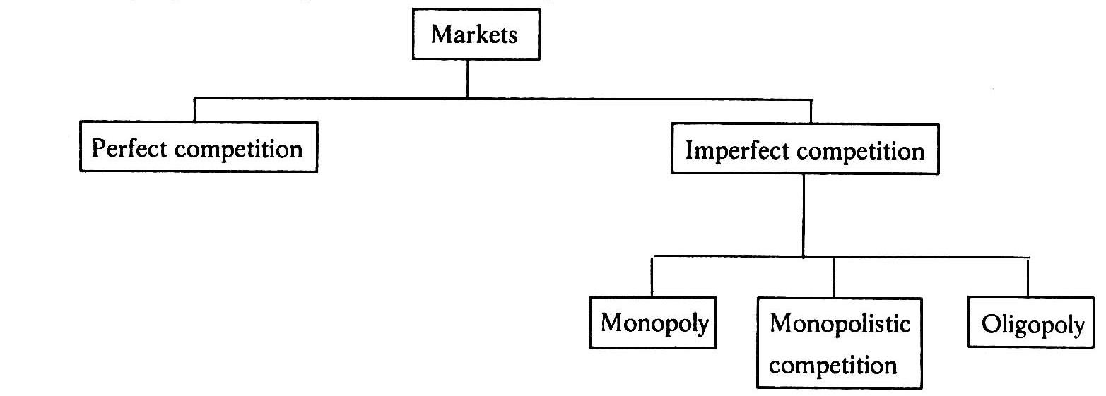

Perfect Competition

Perfect competition refers to a market structure where competition among the sellers and buyers prevails in its most perfect form. In a perfectly competitive market, a single market price prevails for the commodity, which is determined by the forces of total demand and total supply in the market.

Characteristics of Perfect Competition

The following features characterize a perfectly competitive market:

- A large number of buyers and sellers: The number of buyers and sellers is large and the share of each one of them in the market is so small that none has any influence on the market price.
- Homogeneous product: The product of each seller is totally undifferentiated from those of the others.
- Free entry and exit: Any buyer and seller is free to enter or leave the market of the commodity.
- Perfect knowledge: All buyers and sellers have perfect knowledge about the market for the commodity.
- Indifference: No buyer has a preference to buy from a particular seller and no seller to sell to a particular buyer.
- Non-existence of transport costs: Perfectly competitive market also assumes the non-existence of transport costs.
- Perfect mobility of factors of production: Factors of production must be in a position to move freely into or out of industry and from one firm to the other.

Under such a market no single buyer or seller plays a significant role in price determination. One the other hand all of them jointly determine the price. The price is determined in the industry, which is composed of all the buyers and seller for the commodity. The demand curve facing the industry is the sum of all consumers’ demands at various prices. The industry supply curve is the sum of all sellers’ supplies at various prices.

Pure competition and perfect competition

The term perfect competition is used in a wider sense. Pure competition has only limited assumptions. When the assumptions, that large number of buyers and sellers, homogeneous products, free entry and exit are satisfied, there exists pure competition. Competition becomes perfect only when all the assumptions (features) are satisfied.
Generally pure competition can be seen in agricultural products.

Equilibrium of a firm and industry under perfect competition

Equilibrium is a position where the firm has no incentive either to expand or contrast its output. The firm is said to be in equilibrium when it earn maximum profit. There are two conditions for attaining equilibrium by a firm. They are:

Marginal cost is an additional cost incurred by a firm for producing and additional unit of output. Marginal revenue is the additional revenue accrued to a firm when it sells one additional unit of output. A firm increases its output so long as its marginal cost becomes equal to marginal revenue. When marginal cost is more than marginal revenue, the firm reduces output as its costs exceed the revenue. It is only at the point where marginal cost is equal to marginal revenue, and then the firm attains equilibrium. Secondly, the marginal cost curve must cut the marginal revenue curve from below. If marginal cost curve cuts the marginal revenue curve from above, the firm is having the scope to increase its output as the marginal cost curve slopes downwards. It is only with the upward sloping marginal cost curve, there the firm attains equilibrium. The reason is that the marginal cost curve when rising cuts the marginal revenue curve from below.

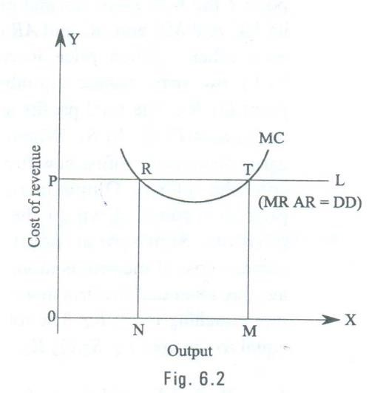

The equilibrium of a perfectly competitive firm may be explained with the help of the fig.
6.2.

In the given fig. PL and MC represent the Price line and Marginal cost curve. PL also represents Marginal revenue, Average revenue and demand. As Marginal revenue, Average revenue and demand are the same in perfect competition, all are equal to the price line. Marginal cost curve is U- shaped curve cutting MR curve at R and T. At point R marginal cost becomes equal to marginal revenue. But MC curve cuts the MR curve fro above. So this is not the equilibrium position. The downward sloping marginal cost curve indicates that the firm can reduce its cost of production by increasing output. As the firm expands its output, it will reach equilibrium at point T. At this point, on price line PL; the two conditions of equilibrium are satisfied. Here the marginal cost and marginal revenue of the firm remain equal. The firm is producing maximum output and is in equilibrium at this stage. If the firm continues its output beyond this stage, its marginal cost exceeds marginal revenue resulting in losses. As the firm has no idea of expanding or contracting its size of out, the firm is said to be in equilibrium at point T.

Pricing under perfect competition

The price or value of a commodity under perfect competition is determined by the demand for and the supply of that commodity.

Under perfect competition there is large number of sellers trading in a homogeneous product. Each firm supplies only very small portion of the market demand. No single buyer or seller is powerful enough to influence the price. The demand of all consumers and the supply of all firms together determine the price. The individual seller is only a price taker and not a price maker. An individual firm has no price policy of it’s own. Thus, the main problem of a firm in a perfectly competitive market is not to determine the price of its product but to adjust its output to the given price, So that the profit is maximum. Marshall however gives great importance to the time element for the determination of price. He divided the time periods on the basis of supply and ignored the forces of demand. He classified the time into four periods to determine the price as follows.

- Very short period or Market period
- Short period
- Long period
- Very long period or secular period

Very short period: It is the period in which the supply is more or less fixed because the time available to the firm to adjust the supply of the commodity to its changed demand is extremely short; say a single day or a few days. The price determined in this period is known as Market Price.

Short Period: In this period, the time available to firms to adjust the supply of the commodity to its changed demand is, of course, greater than that in the market period. In this period altering the variable factors like raw materials, labour, etc can change supply.
During this period new firms cannot enter into the industry.

Long period: In this period, a sufficiently long time is available to the firms to adjust the supply of the commodity fully to the changed demand. In this period not only variable factors of production but also fixed factors of production can be changed. In this period new firms can also enter the industry. The price determined in this period is known as long run normal price.

Secular Period: In this period, a very long time is available to adjust the supply fully to change in demand. This is very long period consisting of a number of decades. As the period is very long it is difficult to lay down principles determining the price.

Price Determination in the market period

The price determined in very short period is known as Market price. Market price is determined by the equilibrium between demand and supply in a market period. The nature of the commodity determines the nature of supply curve in a market period. Under this period goods are classified in to (a) Perishable goods and (b) Non-perishable goods.

Perishable Goods: In the very short period, the supply of perishable goods like fish, milk vegetables etc. cannot be increased. And it cannot be decreased also. As a result the supply curve under very short period will be parallel to the Y-axis or Vertical to X-axis. Supply is perfectly inelastic. The price determination of perishable goods in very short period may be shown with the help of the following fig. 6.5

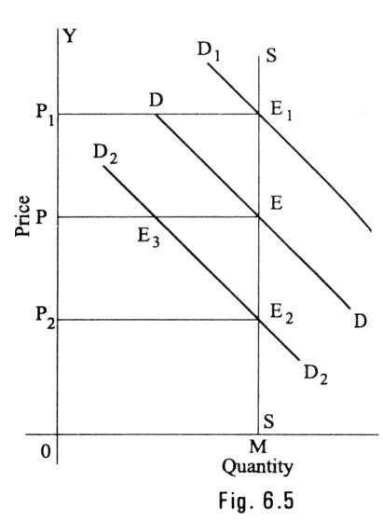

In this figure quantity is represented along X-axis and price is represented along Y-axis. MS is the very short period supply curve of perishable goods. DD is demand curve. It intersects supply curve at E. The price is OP. The quantity exchanged is OM. D1 D1 represents increased demand. This curve cuts the supply curve at E1. Even at the new equilibrium, supply is OM only. But price increases to OP1. So, when demand increases, the price will increase but not the supply. If demand decreases new demand curve will be D2 D2. This curve cuts the supply curve at E2. Even at this new equilibrium, the supply is OM only. But price falls to OP2. Hence in very short period, given the supply, it is the change in demand that influences price. The price determined in a very short period is called Market Price.

Non-perishable goods: In the very short period, the supply of non-perishable goods like cloth, pen, watches etc. cannot be increased. But if price falls, preserving some stock can decrease their supply. If price falls too much, the whole stock will be held back from the market and carried over to the next market period. The price below, which the seller will refuse to sell, is called Reserve Price.

The Price determination of non-perishable goods in very short period may be shown with the help of the following fig 6.6.

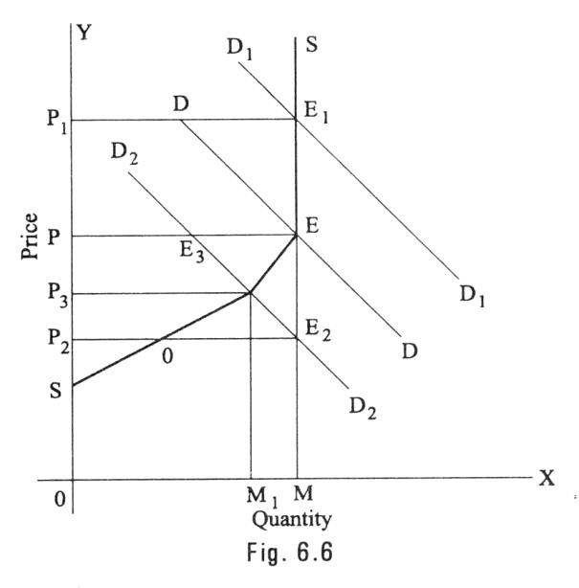

In the given figure quantity is shown on X-axis and the price on Y-axis. SES is the supply curve. It slopes upward up to the point E. From E it becomes a vertical straight line. This is because the quantity existing with sellers is OM, the maximum amount they have is thus OM. Till OM quantity (i.e., point E) the supply curve sloped upward. At the point S, nothing is offered for sale.

It means that the seller with hold the entire stock if the price is OS. OS is thus the reserve price. As the price rises, supply increases up to point E. At OP price (Point E), the entire stock is offered for sale.

Suppose demand increases, the DD curve shift upward. It becomes D1D1 price raises to OP1. If demand decreases, the demand curve becomes D2D2. It intersects the supply curve at E3. The price will fall to OP3. We find that at OS price, supply is zero. It is the reserve price.

Price Determination in the short period

Short period is a period in which supply can be increased by altering the variable factors. In this period fixed costs will remain constant. The supply is increased when price rises and vice versa. So the supply curve slopes upwards from left to right.

The price in short period may be explained with the help of a diagram.

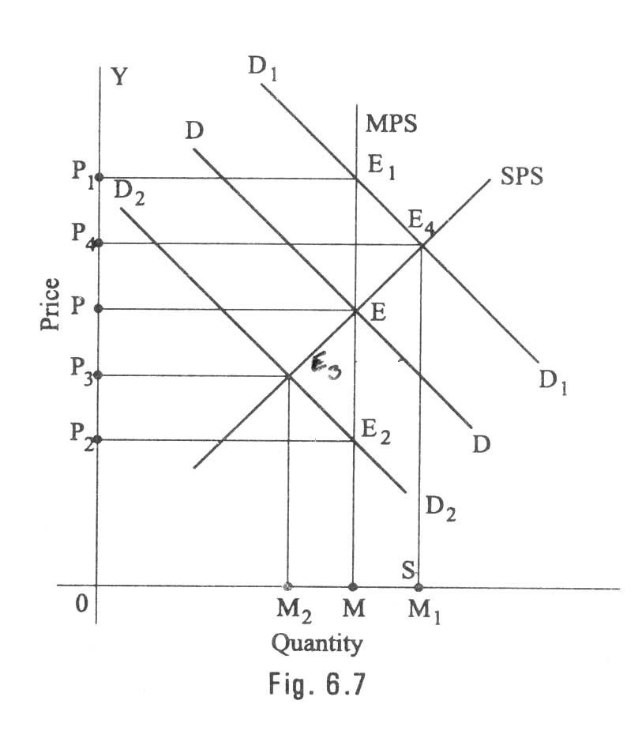
In the given diagram MPS is the market period supply curve. DD is the initial demand curve. It intersects MPS curve at E. The price is OP and out put OM. Suppose demand increases, the demand curve shifts upwards and becomes D1D1. In the very short period, supply remains fixed on OM. The new demand curve D1D1 intersects MPS at E1. The price will rise to OP1. This is what happen in the very short-period.

As the price rises from OP to OP1, firms expand output. As firms can vary some factors but not all, the law of variable proportions operates. This results in new short-run supply curve SPS. It interests D1 D1 curve at E4. The price will fall from OP1 to OP4.

It the demand decreases, DD curve shifts downward and becomes D2D2. It interests MPS curve at E2. The price will fall to OP2. This is what happens in market period. In the short period, the supply curve is SPS. D2D2 curve interests SPS curve at E3. The short period price is higher than the market period price.

Price determination in the long period (Normal Price)

Market price may fluctuate due to a sudden change either on the supply side or on the demand side. A big arrival of milk may decrease the price of that production in the market period. Similarly, a sudden cold wave may raise the price of woolen garments. This type of temporary change in supply and demand may cause changes in market price. In the absence of such disturbing causes, the price tends to come back to a certain level. Marshall called this level is normal price level. In the words of Marshall Normal value (Price) of a commodity is that which economics force would tend to bring about in the long period.

In order to describe how long run normal price is determined, it is useful to refer to the market period as short period also. The market period is so short that no adjustment in the output can be made. Here cost of production has no influence on price. A short period is sufficient only to allow the firms to make only limited output adjustment. In the long period, supply conditions are fully sufficient to meet the changes in demand. In the long period, all factors are alterable and the new firms may enter into or old firms leave the; industry.

In the long period all costs are variable costs. So supply will be increased only when price is equal to average cost.

Hence, in long period normal price will be equal to minimum average cost of the industry. Will this price be more or less than the short period normal price? The answer depends on the stage of returns to which the industry is subject. There are three stages of return on the stage of returns to which the industry is subject. There are three stages of returns.

- Increasing returns or decreasing costs.
- Constant Returns or Constant costs.
- Diminishing returns or increasing costs.

- Determination of long period normal price in decreasing cost industry:

At this stage, average cost falls due to an increase in the output. So, the supply curve at this stage will slope downwards from left to right. The long period Normal price determination at this stage can be explained with the help of a diagram.

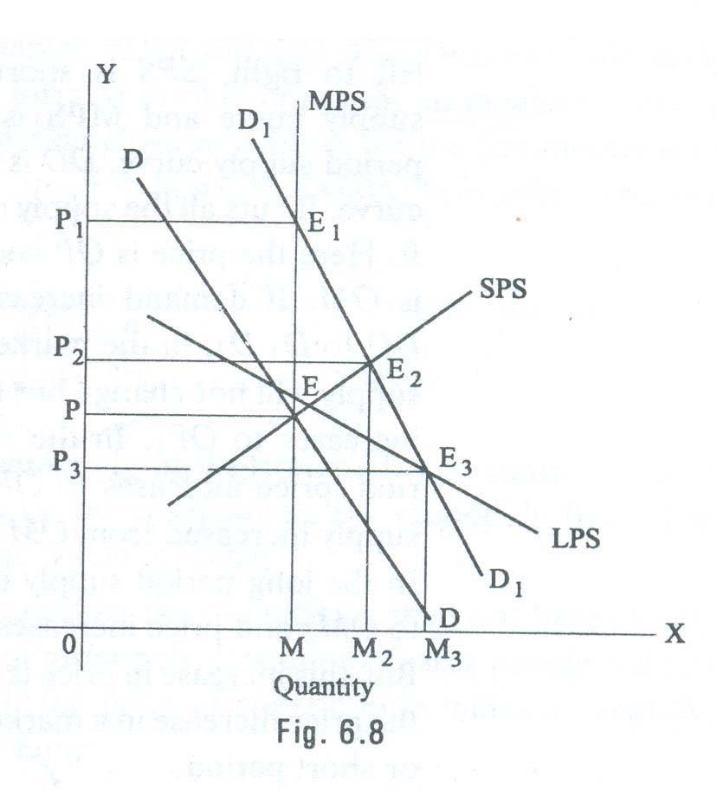
In the diagram, MPS represents market period supply curve. DD is demand curve. DD cuts LPS, SPS and MPS at point E. At point E the supply is OM and the price is OP. If demand increases from DD to D1D1 market price increases to OP1. In the short period it is OP2. In the long period supply increases considerably to OM3. So price has fallen to OP3, which is less than the price of market period.

- Determination of Long Period Normal Price in Constant Cost Industry:

In this case average cost does not change even though the output
increases. Hence long period supply curve is horizontal to X-axis. The determination of long period normal price can be explained with the help of the diagram. In the fig. 6.9, LPS is horizontal to X-axis. MPS represents market period supply curve, and SPS represents short period supply curve. At point ‘E’ the output is OM and price is OP. If demand increases from DD to D1D1 market price increases to OP1. In the short period, supply increases and hence the price will be OP2. In the long run supply is adjusted fully to meet increased demand. The price remains constant at OP because costs are constant at OP and market is perfect market.

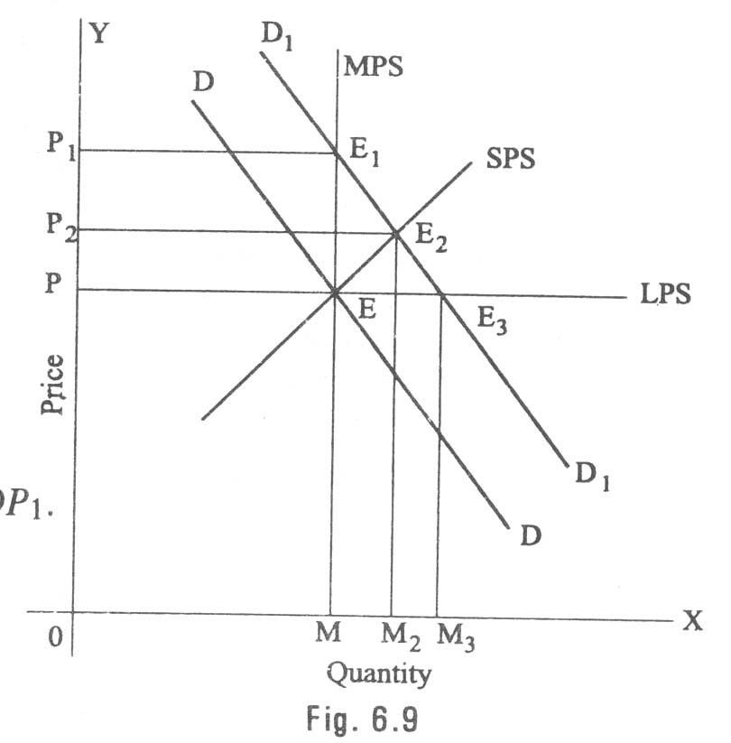
- Determination of long period normal price in increase cost industry:

If the industry is subject to increasing costs (diminishing returns) the supply curve slopes upwards from left to right like an ordinary supply curve. The determination of long period normal price in increasing cost industry can be explained with the help of the following diagram. In the diagram LPS represents long period supply curve. The industry is subject to diminishing return or increasing costs. So, LPS slopes upwards from left to right. SPS is short period supply curve and MPS is market period supply curve. DD is demand curve. It cuts all the supply curves at E. Here the price is OP and output is OM. If demand increases from DD to D1D1 in the market period, supply will not change but the price increases to OP1. In the short period, price increase but the price increases to OP1. In the short period, price increases to OP2 as the supply increased from OM to OM2. In the long period supply increases to OM3 and price increases to OP3. But this increase in price is less than the price increase in a market period or short period.
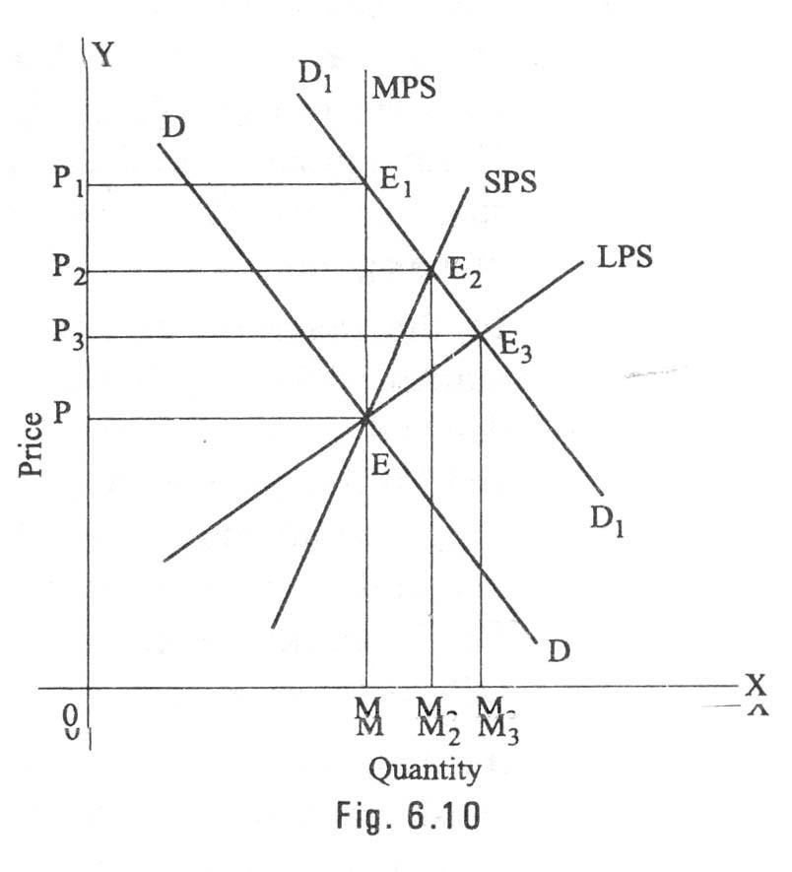

Monopoly

The word monopoly is made up of two syllables, Mono and poly. Mono means single while poly implies selling. Thus monopoly is a form of market organization in which there is only one seller of the commodity. There are no close substitutes for the commodity sold by the seller. Pure monopoly is a market situation in which a single firm sells a product for which there is no good substitute.

Features of monopoly

The following are the features of monopoly.

- Single person or a firm: A single person or a firm controls the total supply of the commodity. There will be no competition for monopoly firm. The monopolist firm is the only firm in the whole industry.
- No close substitute: The goods sold by the monopolist shall not have closely competition substitutes. Even if price of monopoly product increase people will not go in far substitute. For example: If the price of electric bulb increase slightly, consumer will not go in for kerosene lamp.
- Large number of Buyers: Under monopoly, there may be a large number of buyers in the market who compete among themselves.
- Price Maker: Since the monopolist controls the whole supply of a commodity, he is a price-maker, and then he can alter the price.
- Supply and Price: The monopolist can fix either the supply or the price. He cannot fix both. If he charges a very high price, he can sell a small amount. If he wants to sell more, he has to charge a low price. He cannot sell as much as he wishes for any price he pleases.
- Downward Sloping Demand Curve: The demand curve (average revenue curve) of monopolist slopes downward from left to right. It means that he can sell more only by lowering price.

Types of Monopoly

Monopoly may be classified into various types. The different types of monopolies are explained below:

- Legal Monopoly: If monopoly arises on account of legal support or as a matter of legal privilege, it is called Legal Monopoly. Ex. Patent rights, special brands, trade means, copyright etc.
- Voluntary Monopoly: To get the advantages of monopoly some private firms come together voluntarily to control the supply of a commodity. These are called voluntary monopolies. Generally, these monopolies arise with industrial combinations. These voluntary monopolies are of three kinds (a) cartel (b) trust (c) holding company. It may be called artificial monopoly.
- Government Monopoly: Sometimes the government will take the responsibility of supplying a commodity and avoid private interference. Ex. Water, electricity. These monopolies, created to satisfy social wants, are formed on social considerations. These are also called Social Monopolies.
- Private Monopoly: If the total supply of a good is produced by a single private person or firm, it is called private monopoly. Hindustan Lever Ltd. Is having the monopoly power to produce Lux Soap.
- Limited Monopoly: if the monopolist is having limited power in fixing the price of his product, it is called as ‘Limited Monopoly’. It may be due to the fear of distant substitutes or government intervention or the entry of rivals firms.
- Unlimited Monopoly: If the monopolist is having unlimited power in fixing the price of his good or service, it is called unlimited monopoly. Ex. A doctor in a village.
- Single Price Monopoly: When the monopolist charges same price for all units of his product, it is called single price monopoly. Ex. Tata Company charges the same price to all the Tata Indiaca Cars of the same model.
- Discriminating Monopoly: When a Monopolist charges different prices to different consumers for the same product, it is called discriminating monopoly. A doctor may take Rs.20 from a rich man and only Rs.2 from a poor man for the same treatment.
- Natural Monopoly: Sometimes monopoly may arise due to scarcity of natural resources. Nature provides raw materials only in some places. The owner of the place will become monopolist. For Ex. Diamond mine in South Africa.

Pricing under Monopoly

Monopoly refers to a market situation where there is only one seller. He has complete control over the supply of a commodity. He is therefore in a position to fix any price. Under monopoly there is no distinction between a firm and an industry. This is because the entire industry consists of a single firm.

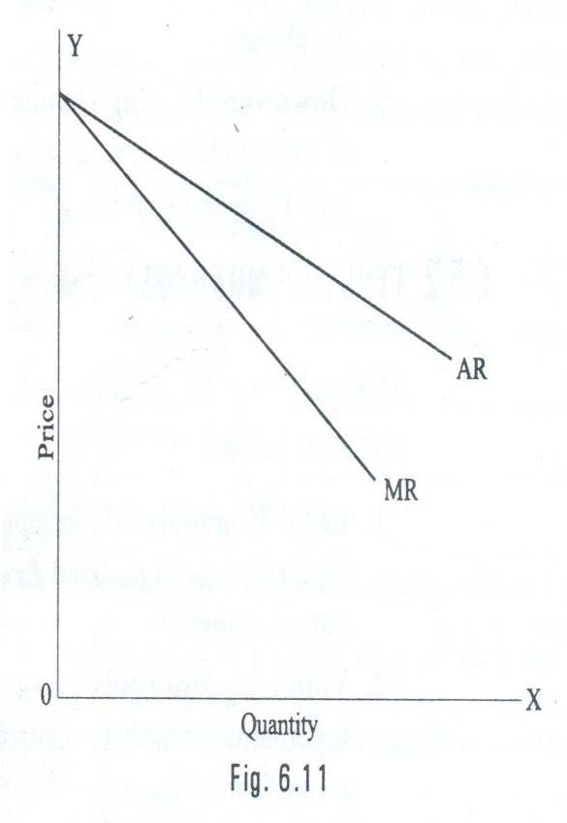

Being the sole producer, the monopolist has complete control over the supply of the commodity. He has also the power to influence the market price. He can raise the price by reducing his output and lower the price by increasing his output. Thus he is a price-maker. He can fix the price to his maximum advantages. But he cannot fix both the supply and the price, simultaneously. He can do one thing at a time. If the fixes the price, his output will be determined by the market demand for his commodity. On the other hand, if he fixes the output to be sold, its market will determine the price for the commodity. Thus his decision to fix either the price or the output is determined by the market demand.

The market demand curve of the monopolist (the average revenue curve) is downward sloping. Its corresponding marginal revenue curve is also downward sloping. But the marginal revenue curve lies below the average revenue curve as shown in the figure. The monopolist faces the down-sloping demand curve because to sell more output, he must reduce the price of his product. The firm’s demand curve and industry’s demand curve are one and the same. The average cost and marginal cost curve are U shaped curve.
Marginal cost falls and rises steeply when compared to average cost.

Price output determination (Equilibrium Point)

The monopolistic firm attains equilibrium when its marginal cost becomes equal to the marginal revenue. The monopolist always desires to make maximum profits. He makes maximum profits when MC=MR. He does not increasing his output if his revenue exceeds his costs. But when the costs exceed the revenue, the monopolist firm incur loses. Hence the monopolist curtails his production. He produces up to that point where additional cost is equal to the additional revenue (MR=MC). Thus point is called equilibrium point. The price output determination under monopoly may be explained with the help of a diagram.

In the diagram 6.12 the quantity supplied or demanded is shown along X-axis. The cost or revenue is shown along Y-axis. AC and MC are the average cost and marginal cost curves respectively. AR and MR curves slope downwards from left to right. AC and MC and U shaped curves. The monopolistic firm attains equilibrium when its marginal cost is equal to marginal revenue (MC=MR). Under monopoly, the MC curve may cut the MR curve from below or from a side. In the diagram, the above condition is satisfied at point E. At point E, MC=MR. The firm is in equilibrium. The equilibrium output is OM.

The above diagram (Average revenue) = MQ or OP
Average cost = MR
Profit per unit = Average Revenue-Average cost=MQ-MR=QR
Total Profit = QRXSR=PQRS
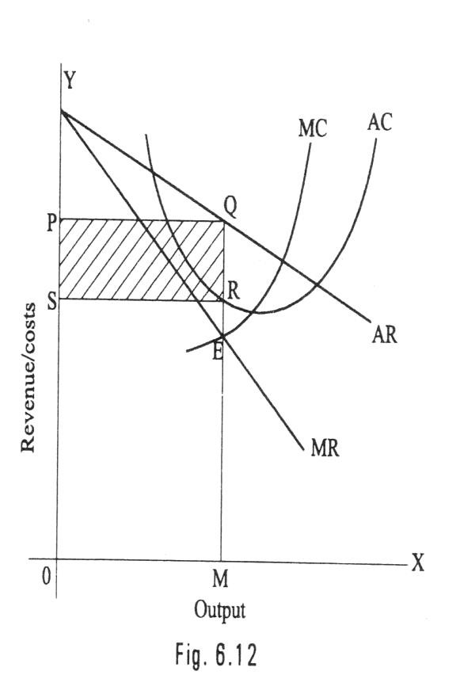

The area PQRS resents the maximum profit earned by the monopoly firm.

But it is not always possible for a monopolist to earn super-normal profits. If the demand and cost situations are not favorable, the monopolist may realize short run losses.

Through the monopolist is a price marker, due to weak demand and high costs; he suffers a loss equal to PABC.

If AR > AC -> Abnormal or super normal profits.
If AR = AC -> Normal Profit
If AR < AC -> Loss

In the long run the firm has time to adjust his plant size or to use existing plant so as to maximize profits.

Monopolistic competition

Perfect competition and pure monopoly are rate phenomena in the real world. Instead, almost every market seems to exhibit characteristics of both perfect competition and monopoly. Hence in the real world it is the state of imperfect competition lying between these two extreme limits that work. Edward. H. Chamberlain developed the theory of monopolistic competition, which presents a more realistic picture of the actual market structure and the nature of competition.

Characteristics of Monopolistic Competition

The important characteristics of monopolistic competition are:

- Existence of Many firms: Industry consists of a large number of sellers, each one of whom does not feel dependent upon others. Every firm acts independently without bothering about the reactions of its rivals. The size is so large that an individual firm has only a relatively small part in the total market, so that each firm has very limited control over the price of the product. As the number is relatively large it is difficult for these firms to determine its price- output policies without considering the possible reactions of the rival forms. A monopolistically competitive firm follows an independent price policy.

- Product Differentiation: Product differentiation means that products are different in some ways, but not altogether so. The products are not identical but the same time they will not be entirely different from each other. IT really means that there are various monopolist firms competing with each other. An example of monopolistic competition and product differentiation is the toothpaste produced by various firms. The product of each firm is different from that of its rivals in one or more respects. Different toothpastes like Colgate, Close-up, Forehans, Cibaca, etc., provide an example of monopolistic competition. These products are relatively close substitute for each other but not perfect substitutes. Consumers have definite preferences for the particular verities or brands of products offered for sale by various sellers. Advertisement, packing, trademarks, brand names etc. help differentiation of products even if they are physically identical.
- Large Number of Buyers: There are large number buyers in the market. But the buyers have their own brand preferences. So the sellers are able to exercise a certain degree of monopoly over them. Each seller has to plan various incentive schemes to retain the customers who patronize his products.
- Free Entry and Exist of Firms: As in the perfect competition, in the monopolistic competition too, there is freedom of entry and exit. That is, there is no barrier as found under monopoly.
- Selling costs: Since the products are close substitute much effort is needed to retain the existing consumers and to create new demand. So each firm has to spend a lot on selling cost, which includes cost on advertising and other sale promotion activities.
- Imperfect Knowledge: Imperfect knowledge about the product leads to monopolistic competition. If the buyers are fully aware of the quality of the product they cannot be influenced much by advertisement or other sales promotion techniques. But in the business world we can see that thought the quality of certain products is the same, effective advertisement and sales promotion techniques make certain brands monopolistic. For examples, effective dealer service backed by advertisement-helped popularization of some brands through the quality of almost all the cement available in the market remains the same.
- The Group: Under perfect competition the term industry refers to all collection of firms producing a homogenous product. But under monopolistic competition the products of various firms are not identical through they are close substitutes. Prof. Chamberlin called the collection of firms producing close substitute products as a group.

Price – Output Determination under Monopolistic Competition

Since under monopolistic competition different firms produce different varieties of products, different prices for them will be determined in the market depending upon the demand and cost conditions. Each firm will set the price and output of its own product.
Here also the profit will be maximized when marginal revenue is equal to marginal cost.

Short-run equilibrium of the firm:
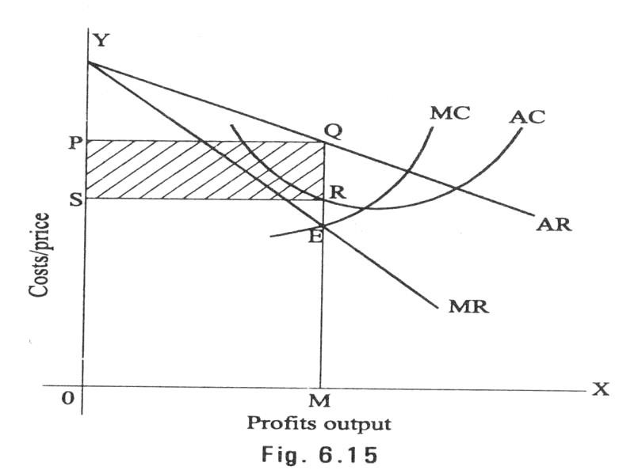
In the short-run the firm is in equilibrium when marginal Revenue = Marginal Cost. In Fig 6.15 AR is the average revenue curve. NMR marginal revenue curve, SMC short-run marginal cost curve, SAC short-run average cost curve, MR and SMC interest at point E where output in OM and price MQ (i.e. OP). Thus the equilibrium output or the maximum profit output is OM and the price MQ or OP. When the price (average revenue) is above average cost a firm will be making supernormal profit. From the figure it can be seen that AR is above AC in the equilibrium point. As AR is above AC, this firm is making abnormal profits in the short-run. The abnormal profit per unit is QR, i.e., the difference between AR and AC at equilibrium point and the total supernormal profit is OR X OM. This total abnormal profits is represented by the rectangle PQRS. As the demand curve here is highly elastic, the excess price over marginal cost is rather low. But in monopoly the demand curve is inelastic. So the gap between price and marginal cost will be rather large.

If the demand and cost conditions are less favorable the monopolistically competitive firm may incur loss in the short-run fig 6.16 Illustrates this. A firm incurs loss when the price is less than the average cost of production. MQ is the average cost and OS (i.e. MR) is the price per unit at equilibrium output OM. QR is the loss per unit. The total loss at an output OM is OR X OM. The rectangle PQRS represents the total loses in the short run.

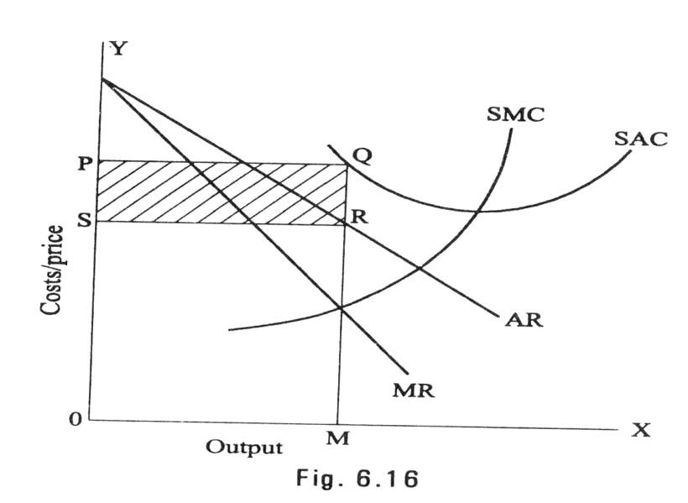

Long – Run Equilibrium of the Firm:

A monopolistically competitive firm will be long – run equilibrium at the output level where marginal cost equal to marginal revenue. Monopolistically competitive firm in the long run attains equilibrium where MC=MR and AC=AR Fig 6.17 shows this trend.
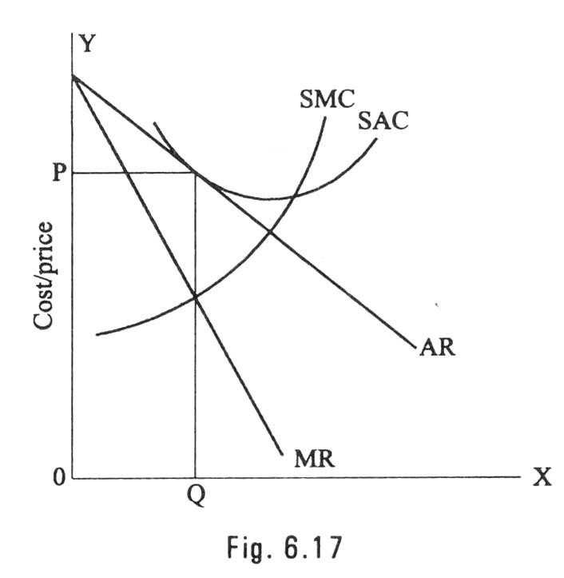

Oligopoly

The term oligopoly is derived from two Greek words, oligos meaning a few, and pollen meaning to sell. Oligopoly is the form of imperfect competition where there are a few firms in the market, producing either a homogeneous product or producing products, which are close but not perfect substitute of each other.

Characteristics of Oligopoly

The main features of oligopoly are:

- Few Firms: There are only a few firms in the industry. Each firm contributes a sizeable share of the total market. Any decision taken by one firm influence the actions of other firms in the industry. The various firms in the industry compete with each other.
- Interdependence: As there are only very few firms, any steps taken by one firm to increase sales, by reducing price or by changing product design or by increasing advertisement expenditure will naturally affect the sales of other firms in the industry. An immediate retaliatory action can be anticipated from the other firms in the industry every time when one firm takes such a decision. He has to take this into account when he takes decisions. So the decisions of all the firms in the industry are interdependent.
- Indeterminate Demand Curve: The interdependence of the firms makes their demand curve indeterminate. When one firm reduces price other firms also will make a cut in their prices. So he firm cannot be certain about the demand for its product. Thus the demand curve facing an oligopolistic firm loses its definiteness and thus is indeterminate as it constantly changes due to the reactions of the rival firms.
- Advertising and selling costs: Advertising plays a greater role in the oligopoly market when compared to other market systems. According to Prof. William J. Banumol “it is only oligopoly that advertising comes fully into its own”. A huge expenditure on advertising and sales promotion techniques is needed both to retain the present market share and to increase it. So Banumol concludes “under oligopoly, advertising can become a life-and-death matter where a firm which fails to keep up with the advertising budget of its competitors may find its customers drifting off to rival products.”
- Price Rigidity: In the oligopoly market price remain rigid. If one firm reduced price it is with the intention of attracting the customers of other firms in the industry. In order to retain their consumers they will also reduce price. Thus the pricing decision of one firm results in a loss to all the firms in the industry. If one firm increases price. Other firms will remain silent there by allowing that firm to lost its customers. Hence, no firm will be ready to change the prevailing price. It causes price rigidity in the oligopoly market.

OTHER MARKET STRUCTURES

Duopoly

Duopoly refers to a market situation in which there are only two sellers. As there are only two sellers any decision taken by one seller will have reaction from the other Eg. CocaCola and Pepsi. Usually these two sellers may agree to co-operate each other and share the market equally between them, So that they can avoid harmful competition.

The duopoly price, in the long run, may be a monopoly price or competitive price, or it may settle at any level between the monopoly price and competitive price. In the short period, duopoly price may even fall below the level competitive price with the both the firms earning less than even the normal price.

Monopsony

Mrs. Joan Robinson was the first writer to use the term monopsony to refer to market, which there is a single buyer. Monoposony is a single buyer or a purchasing agency, which buys the show, or nearly whole of a commodity or service produced. It may be created when all consumers of a commodity are organized together and/or when only one consumer requires that commodity which no one else requires.

Bilateral Monopoly

A bilateral monopoly is a market situation in which a single seller (Monopoly) faces a single buyer (Monoposony). It is a market of monopoly-monoposy.

Oligopsony

Oligopsony is a market situation in which there will be a few buyers and many sellers. As the sellers are more and buyers are few, the price of product will be comparatively low but not as low as under monopoly.

PRICING METHODS

The micro – economic principle of profit maximization suggests pricing by the marginal analysis. That is by equating MR to MC. However the pricing methods followed by the firms in practice around the world rarely follow this procedure. This is for two reasons; uncertainty with regard to demand and cost function and the deviation from the objective of short run profit maximization.

It was seen that there is no unique theory of firm behavior. While profit certainly on important variable for which every firm cares. Maximization of short – run profit is not a popular objective of a firm today. At the most firms seek maximum profit in the long run. If so the problem is dynamic and its solution requires accurate knowledge of demand and cost conditions over time. Which is impossible to come by?

In view of these problems economic prices are a rare phenomenon. Instead, firms set prices for their products through several alternative means. The important pricing methods followed in practice are shown in the chart.

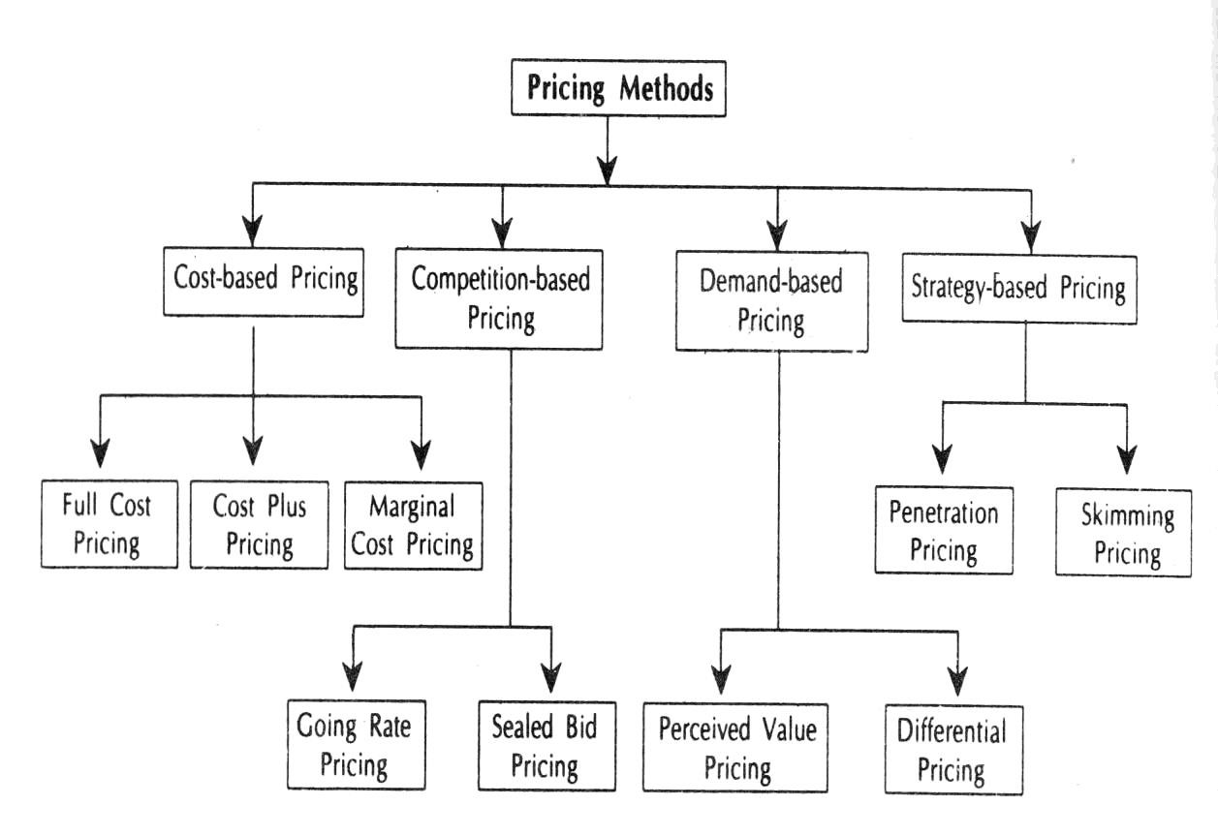
Cost Based Pricing

There are three versions of the cost – based pricing. Full – cost or break even pricing, cost plus pricing and the marginal cost pricing. Under the first version, price just equals the average (total) cost. In the second version, some mark-up is added to the average cost in arriving at the price. In the last version, price is set equal to the marginal cost. While all these methods appear to be easy and straight forward, they are in fact associated with a number of difficulties. Even through difficulties are there, the cost- oriented pricing is quite popular today.

The cost – based pricing has several strengths as well as limitations. The advantages are its simplicity, acceptability and consistency with the target rate of return on investment and the price stability in general. The limitations are difficulties in getting accurate estimates of cost (particularly of the future cost rather than the historic cost) Volatile nature of the variable cost and its ignoring of the demand side of the market etc.

Competition based pricing

Some commodities are priced according to the competition in their markets. Thus we have the going rate method of price and the sealed bid pricing technique. Under the former a firm prices its new product according to the prevailing prices of comparable products in the market. If the product is new in the country, then its import cost – inclusive of the costs of certificates, insurance, and freight and customs duty, is used as the basis for pricing, Incidentally, the price is not necessarily equal to the import cost, but to the firm is either new in the country, or is a close substitute or complimentary to some other products, the prices of hitherto existing bands or / and of the related goods are taken in to a account while deciding its price. Thus, when television was first manufactures in India, its import cost must have been a guiding force in its price determination. Similarly, when

maruti car was first manufactured in India, it must have taken into account the prices of existing cars, price of petrol, price of car accessories, etc. Needless to say, the going rate price could be below or above the average cost and it could even be an economic price.

The sealed bid pricing method is quite popular in the case of construction activities and in the disposition of used produces. In this method the prospective seller (buyers) are asked to quote their prices through a sealed cover, all the offers are opened at a preannounce time in the presence of all the competitors, and the one who quoted the least is awarded the contract (purchase / sale deed). As it sound, this method is totally competition based and if the competitors unit by any change, the buyers (seller) may have to pay (receive) an exorbitantly high (too low) price, thus there is a great degree of risk attached to this method of pricing.

Demand Based Pricing

The demand – based pricing and strategy – based pricing are quite related. The seller knows rather well that the demand for its product is a decreasing function of the price its sets for product. Thus if seller wishes to sell more he must reduce the price of his product, and if he wants a good price for his product, he could sell only a limited quantity of his good. Demand oriented pricing rules imply establishment of prices in accordance with consumer preference and perceptions and the intensity of demand.

Two general types demand oriented pricing rules can be identified.

i. Perceived value pricing and ii. Differential pricing

Perceived value pricing considers the buyer’s perception of the value of the product ad the basis of pricing. Here the pricing rule is that the firm must develop procedures for measuring the relative value of the product as perceived by consumers. Differential pricing is nothing but price discrimination. In involves selling a product or service for different prices in different market segments. Price differentiation depends on geographical location of the consumers, type of consumer, purchasing quantity, season, time of the service etc. E.g. Telephone charges, APSRTC charges.

Strategy based pricing (new product pricing)

A firm which products a new product, if it is also new to industry, can earn very good profits it if handles marketing carefully, because of the uniqueness of the product. The price fixed for the new product must keep the competitors away. Earn good profits for the firm over the life of the product and must help to get the product accepted. The company can select either skimming pricing or penetration pricing.

While there are some firms, which follow the strategy of price penetration, there are some others who opt for price – skimming. Under the former, firms sell their new product at a low price in the beginning in order to catch the attention of consumers, once the product image and credibility is established, the seller slowly starts jacking up the price to reap good profits in future. Under this strategy, a firm might well sell its product below the cost of production and thus runs into losses to start with but eventually it recovers all its losses and even makes good overall profits. The Rin washing soap perhaps falls into this category. This soap was sold at a rather low price in the beginning and the firm even distributed free samples. Today, it is quite an expensive brand and yet it is selling very well. Under the price – skimming strategy, the new product is priced high in the beginning, and its price is reduced gradually as it faces a dearth of buyers such a strategy may be beneficial for products, which are fancy, but of poor quality and / or of insignificant use over a period of time.

A prudent producer follows a good mix of the various pricing methods rather than adapting any once of them. This is because no method is perfect and every method has certain good features further a firm might adopt one method at one time and another method at some other accession.

UNIT- IV

CAPITAL AND CAPITAL BUDGETING

Introduction

Finance is the prerequisite to commence and vary on business. It is rightly said to be the lifeblood of the business. No growth and expansion of business can take place without sufficient finance. It shows that no business activity is possible without finance. This is why; every business has to make plans regarding acquisition and utilization of funds.

However efficient a firm may be in terms of production as well as marketing if it ignores the proper management of flow of funds it certainly lands in financial crunch and the very survival of the firm would be at a stake.

Function of finance

According to B. O. Wheeler, Financial Management is concerned with the acquisition and utiliasation of capital funds in meeting the financial needs and overall objectives of a business enterprise. Thus the primary function of finance is to acquire capital funds and put them for proper utilization, with which the firm’s objectives are fulfilled. The firm should be able to procure sufficient funds on reasonable terms and conditions and should exercise proper control in applying them in order to earn a good rate of return, which in turn allows the firm to reward the sources of funds reasonably, and leaves the firm with good surplus to grow further. These activities viz. financing, investing and dividend payment are not sequential they are performed simultaneously and continuously. Thus, the Financial Management can be broken down in to three major decisions or functions of finance. They are: (i) the investment decision, (ii) the financing decision and (iii) the dividend policy decision.

Investment Decision

The investment decision relates to the selection of assets in which funds will be invested by a firm. The assets as per their duration of benefits, can be categorized into two groups: (i) long-term assets which yield a return over a period of time in future (ii) short-term or current assents which in the normal course of business are convertible into cash usually with in a year. Accordingly, the asset selection decision of a firm is of two types. The investment in long-term assets is popularly known as capital budgeting and in short-term assets, working capital management.

- Capital budgeting: Capital budgeting – the long – term investment decision – is probably the most crucial financial decision of a firm. It relates to the selection of an assent or investment proposal or course of action that benefits are likely to be available in future over the lifetime of the project.

The long-term investment may relate to acquisition of new asset or replacement of old assets. Whether an asset will be accepted or not will depend upon the relative benefits and returns associated with it. The measurement of the worth of the investment proposals is, therefore, a major element in the capital budgeting exercise. The second element of the capital budgeting decision is the analysis of risk and uncertainty as the benefits from the investment proposals pertain the future, which is uncertain. They have to be estimated under various assumptions and thus there is an element of risk involved in the exercise. The return from the capital budgeting decision should, therefore, be evaluated in relation to the risk associated with it.

The third and final element is the ascertainment of a certain norm or standard against which the benefits are to be judged. The norm is known by different names such as cut-off rate, hurdle rate, required rate, minimum rate of return and so on. This standard is broadly expressed in terms of the cost of capital is, thus, another major aspect of the capital; budgeting decision. In brief, the main elements of the capital budgeting decision are: (i) The total assets and their composition (ii) The business risk complexion of the firm, and (iii) concept and measurement of the cost of capital.

- Working Capital Management: Working capital management is concerned with the management of the current assets. As we know, the short-term survival is a pre-requisite to long-term success. The major thrust of working capital management is the trade-off between profitability and risk (liquidity), which are inversely related to each other. If a firm does not have adequate working capital it may not have the ability to meet its current obligations and thus invite the risk of bankrupt. One the other hand if the current assets are too large the firm will be loosing the opportunity of making a good return and thus may not serve the requirements of suppliers of funds. Thus, the profitability and liquidity are the two major dimensions of working capital management. In addition, the individual current assets should be efficiently managed so that neither inadequate nor unnecessary funds are locked up.

Finance Decision

The second major decision involved in financial management is the financing decision, which is concerned with the financing – mix or capital structure of leverage. The term capital structure refers to the combination of debt (fixed interest sources of financing) and equity capital (variable – dividend securities/source of funds). The financing decision of a firm relates to the choice of the proportion of these sources to finance the investment requirements. A higher proportion of debt implies a higher return to the shareholders and also the higher financial risk and vice versa. A proper balance between debt and equity is a must to ensure a trade – off between risk and return to the shareholders. A capital structure with a reasonable proportion of debt and equity capital is called the optimum capital structure.

The second aspect of the financing decision is the determination of an appropriate capital structure, which will result, is maximum return to the shareholders and in turn maximizes the worth of the firm. Thus, the financing decision covers two inter-related aspects: (a) capital structure theory, and (b) capital structure decision.

Dividend Policy decision

The third major decision of financial management is relating to dividend policy. The firm has two alternatives with regard to management of profits of a firm. They can be either distributed to the shareholder in the form of dividends or they can be retained in the business or even distribute some portion and retain the remaining. The course of action to be followed is a significant element in the dividend decision. The dividend pay out ratio i. e. the proportion of net profits to be paid out to the shareholders should be in tune with the investment opportunities available within the firm. The second major aspect of the dividend decision is the study of factors determining dividend policy of a firm in practice.

WORKING CAPITAL ANALYSIS

Finance is required for two purpose viz. for it establishment and to carry out the day-today operations of a business. Funds are required to purchase the fixed assets such as plant, machinery, land, building, furniture, etc, on long-term basis. Investments in these assets represent that part of firm’s capital, which is blocked on a permanent of fixed basis and is called fixed capital. Funds are also needed for short-term purposes such as the purchase of raw materials, payment of wages and other day-to-day expenses, etc. and these funds are known as working capital. In simple words working capital refers that part of the firm’s capital, which is required for financing short term or current assets such as cash, marketable securities, debtors and inventories. The investment in these current assets keeps revolving and being constantly converted into cash and which in turn financed to acquire current assets. Thus the working capital is also known as revolving or circulating capital or short-term capital.

Concept of working capital

There are two concepts of working capital:

- Gross working capital
- Net working capital

Gross working capital:
In the broader sense, the term working capital refers to the gross working capital. The notion of the gross working capital refers to the capital invested in total current assets of the enterprise. Current assets are those assets, which in the ordinary course of business, can be converted into cash within a short period, normally one accounting year.

Examples of current assets:

- Cash in hand and bank balance
- Bills receivables or Accounts Receivables 3. Sundry Debtors (less provision for bad debts)
- Short-term loans and advances.
- Inventories of stocks, such as:
  - Raw materials
  - Work – in process
  - Stores and spares
  - Finished goods
- Temporary Investments of surplus funds.
- Prepaid Expenses
- Accrued Incomes etc.

Net working capital:
In a narrow sense, the term working capital refers to the net working capital. Networking capital represents the excess of current assets over current liabilities.

Current liabilities are those liabilities, which are intend to be paid in the ordinary course of business within a short period, normally one accounting year out of the current assets or the income of the business. Net working capital may be positive or negative. When the current assets exceed the current liabilities net working capital is positive and the negative net working capital results when the liabilities are more then the current assets.

Examples of current liabilities:

- Bills payable
- Sundry Creditors or Accounts Payable.
- Accrued or Outstanding Expanses.
- Short term loans, advances and deposits.
- Dividends payable
- Bank overdraft
- Provision for taxation etc.

Classification or kinds of working capital

Working capital may be classified in two ways:

- On the basis of concept.
- On the basis of time permanency

On the basis of concept, working capital is classified as gross working capital and net working capital is discussed earlier. This classification is important from the point of view of the financial manager. On the basis of time, working capital may be classified as:

- Permanent or fixed working capital
- Temporary of variable working capital

- Permanent or fixed working capital: There is always a minimum level of current assets, which is continuously required by the enterprise to carry out its normal business operations and this minimum is known as permanent of fixed working capital. For example, every firm has to maintain a minimum level of raw materials, work in process; finished goods and cash balance to run the business operations smoothly and profitably. This minimum level of current assets is permanently blocked in current assets. As the business grows, the requirement of permanent working capital also increases due to the increases in current assets. The permanent working capital can further be classified into regular working capital and reserve working capital. Regular working capital is the minimum amount of working capital required to ensure circulation of current assets from cash to inventories, from inventories to receivables and from receivable to cash and so on. Reserve working capital is the excess amount over the requirement for regular working capital which may be provided for contingencies that may arise at unstated period such as strikes, rise in prices, depression etc.
- Temporary or variable working capital: Temporary or variable working capital is the amount of working capital, which is required to meet the seasonal demands and some special exigencies. Thus the variable working capital can be further classified into seasonal working capital and special working capital. While seasonal working capital is required to meet certain seasonal demands, the special working capital is that part of working capital which is required to meet special exigencies such as launching of extensive marketing campaigns, for conducting research etc.

Temporary working capital differs from permanent working capital in the sense that it is required for short periods and cannot be permanently employed gainfully in the business. Figures given below illustrate the different between permanent and temporary working capital.

Importance of working capital

Working capital is refereed to be the lifeblood and nerve center of a business. Working capital is as essential to maintain the smooth functioning of a business as blood circulation in a human body. No business can run successfully with out an adequate amount of working capital. The main advantages of maintaining adequate amount of working capital are as follows:

- Solvency of the business: Adequate working capital helps in maintaining solvency of the business by providing uninterrupted flow of production.
- Good will: Sufficient working capital enables a business concern to make prompt payment and hence helps in creating and maintaining good will.
- Easy loans: A concern having adequate working capital, high solvency and good credit standing can arrange loans from banks and others on easy and favorable terms.
- Cash Discounts: Adequate working capital also enables a concern to avail cash discounts on the purchases and hence it reduces costs.
- Regular supply of raw materials: Sufficient working capital ensures regular supply of raw materials and continuous production.
- Regular payments of salaries wages and other day to day commitments: A company which has ample working capital can make regular payment of salaries, wages and other day to day commitments which raises the morale of its employees, increases their efficiency, reduces wastage and cost and enhances production and profits.
- Exploitation of favorable market conditions: The concerns with adequate working capital only can exploit favorable market conditions such as purchasing its requirements in bulk when the prices are lower.
- Ability to face crisis: Adequate working capital enables a concern to face business crisis in emergencies.
- Quick and regular return on Investments: Every investor wants a quick and regular return on his investment. Sufficiency of working capital enables a concern to pay quick and regular dividends to its investors, as there may not be much pressure to plough back profits. This gains the confidence of its investors and creates a favorable market to raise additional funds in the future.
- High morale: Adequacy of working capital creates an environment of security, confidence, and high morale and creates overall efficiency in a business. Every business concern should have adequate working capital to run its business operations. It should have neither redundant excess working capital nor inadequate shortage of working capital. Both, excess as well as short working capital positions are bad for any business. However, out of the two, it is the inadequacy of working capital which is more dangerous from the point of view of the firm.

The need or objectives of working capital

The need for working capital arises mainly due to the time gap between production and realization of cash. The process of production and sale cannot be done instantaneously and hence the firm needs to hold the current assets to fill-up the time gaps. There are time gaps in purchase of raw materials and production; production and sales: and sales and realization of cash. The working capital is needed mainly for the following purposes:

- For the purchase of raw materials.
- To pay wages, salaries and other day-to-day expenses and overhead cost such as fuel, power and office expenses, etc.
- To meet the selling expenses such as packing, advertising, etc.
- To provide credit facilities to the customers and
- To maintain the inventories of raw materials, work-in-progress, stores and spares and finishes stock etc.

Generally, the level of working capital needed depends upon the time gap (known as operating cycle) and the size of operations. Greater the size of the business unit generally, larger will be the requirements of working capital. The amount of working capital needed also goes on increasing with the growth and expansion of business. Similarly, the larger the operating cycle, the larger the requirement for working capital. There are many other factors, which influence the need of working capital in a business, and these are discussed below in the following pages.

Factors determining the working capital requirements

There are a large number of factors such as the nature and size of business, the character of their operations, the length of production cycle, the rate of stock turnover and the state of economic situation etc. that decode requirement of working capital. These factors have different importance and influence on firm differently. In general following factors generally influence the working capital requirements.

- Nature or character of business: The working capital requirements of a firm basically depend upon the nature of its business. Public utility undertakings like electricity, water supply and railways need very limited working capital as their sales are on cash and are engaged in provision of services only. On the other hand, trading firms require more investment in inventories, receivables and cash and such they need large amount of working capital. The manufacturing undertakings also require sizable working capital.
- Size of business or scale of operations: The working capital requirements of a concern are directly influenced by the size of its business, which may be measured in terms of scale of operations. Greater the size of a business unit, generally, larger will be the requirements of working capital. However, in some cases, even a
smaller concern may need more working capital due to high overhead charges, inefficient use of available resources and other economic disadvantages of small size.
- Production policy: If the demand for a given product is subject to wide fluctuations due to seasonal variations, the requirements of working capital, in such cases, depend upon the production policy. The production could be kept either steady by accumulating inventories during stack periods with a view to meet high demand during the peck season or the production could be curtailed during the slack season and increased during the peak season. If the policy is to keep the production steady by accumulating inventories it will require higher working capital.
- Manufacturing process/Length of production cycle: In manufacturing business, the requirements of working capital will be in direct proportion to the length of manufacturing process. Longer the process period of manufacture, larger is the amount of working capital required, as the raw materials and other supplies have to be carried for a longer period.
- Seasonal variations: If the raw material availability is seasonal, they have to be bought in bulk during the season to ensure an uninterrupted material for the production. A huge amount is, thus, blocked in the form of material, inventories during such season, which give rise to more working capital requirements.
Generally, during the busy season, a firm requires larger working capital then in the slack season.
- Working capital cycle: In a manufacturing concern, the working capital cycle starts with the purchase of raw material and ends with the realization of cash from the sale of finished products. This cycle involves purchase of raw materials and stores, its conversion into stocks of finished goods through work–in progress with progressive increment of labour and service costs, conversion of finished stock into sales, debtors and receivables and ultimately realization of cash. This cycle continues again from cash to purchase of raw materials and so on. In general the longer the operating cycle, the larger the requirement of working capital.
- Credit policy: The credit policy of a concern in its dealings with debtors and creditors influences considerably the requirements of working capital. A concern that purchases its requirements on credit requires lesser amount of working capital compared to the firm, which buys on cash. On the other hand, a concern allowing credit to its customers shall need larger amount of working capital compared to a firm selling only on cash.
- Business cycles: Business cycle refers to alternate expansion and contraction in general business activity. In a period of boom, i.e., when the business is prosperous, there is a need for larger amount of working capital due to increase in sales. On the contrary, in the times of depression, i.e., when there is a down swing of the cycle, the business contracts, sales decline, difficulties are faced in collection from debtors and firms may have to hold large amount of working capital.
- Rate of growth of business: The working capital requirements of a concern increase with the growth and expansion of its business activities. The retained profits may provide for a part of working capital but the fast growing concerns need larger amount of working capital than the amount of undistributed profits.

SOURCE OF FINANCE

Incase of proprietorship business, the individual proprietor generally invests his own savings to start with, and may borrow money on his personal security or the security of his assets from others. Similarly, the capital of a partnership from consists partly of funds contributed by the partners and partly of borrowed funds. But the company from of organization enables the promoters to raise necessary funds from the public who may contribute capital and become members (share holders) of the company. In course of its business, the company can raise loans directly from banks and financial institutions or by issue of securities (debentures) to the public. Besides, profits earned may also be reinvested instead of being distributed as dividend to the shareholders.

Thus for any business enterprise, there are two sources of finance, viz, funds contributed by owners and funds available from loans and credits. In other words the financial resources of a business may be own funds and borrowed funds.

Owner funds or ownership capital:

The ownership capital is also known as ‘risk capital’ because every business runs the risk of loss or low profits, and it is the owner who bears this risk. In the event of low profits they do not have adequate return on their investment. If losses continue the owners may be unable to recover even their original investment. However, in times of prosperity and in the case of a flourishing business the high level of profits earned accrues entirely to the owners of the business. Thus, after paying interest on loans at a fixed rate, the owners may enjoy a much higher rate of return on their investment. Owners contribute risk capital also in the hope that the value of the firm will appreciate as a result of higher earnings and growth in the size of the firm.

The second characteristic of this source of finance is that ownership capital remains permanently invested in the business. It is not refundable like loans or borrowed capital. Hence a large part of it is generally used for a acquiring long – lived fixed assets and to finance a part of the working capital which is permanently required to hold a minimum level of stock of raw materials, a minimum amount of cash, etc.

Another characteristic of ownership capital related to the management of business. It is on the basis of their contribution to equity capital that owners can exercise their right of control over the management of the firm. Managers cannot ignore the owners in the conduct of business affairs. The sole proprietor directly controls his own business. In a partnership firm, the active partner will take part in the management of business. A company is managed by directors who are elected by the members (shareholders).

Merits:

Arising out of its characteristics, the advantages of ownership capital may be briefly stated as follows:

- It provides risk capital
- It is a source of permanent capital
- It is the basis on which owners ‘acquire their right of control over management
- It does not require security of assets to be offered to raise ownership capital

Limitations:

There are also certain limitations of ownership capital as a source of finance. These are:

The amount of capital, which may be raised as owners fund depends on the number of persons, prepared to take the risks involved. In a partnership confer, a few persons cannot provide ownership capital beyond a certain limit and this limitation is more so in case of proprietary form of organization.

A joint stock company can raise large amount by issuing shares to the public. Bus it leads to an increased number of people having ownership interest and right of control over management. This may reduce the original investors’ power of control over management. Being a permanent source of capital, ownership funds are not refundable as long as the company is in existence, even when the funds remain idle.

A company may find it difficult to raise additional ownership capital unless it has high profit-earning capacity or growth prospects. Issue of additional shares is also subject to so many legal and procedural restrictions.

Borrowed funds and borrowed capital: It includes all funds available by way of loans or credit. Business firms raise loans for specified periods at fixed rates of interest. Thus borrowed funds may serve the purpose of long-term, medium-term or short-term finance. The borrowing is generally at against the security of assets from banks and financial institutions. A company to borrow the funds can also issue various types of debentures.

Interest on such borrowed funds is payable at half yearly or yearly but the principal amount is being repaid only at the end of the period of loan. These interest and principal payments have to be met even if the earnings are low or there is loss. Lenders and creditors do not have any right of control over the management of the borrowing firm. But they can sue the firm in a law court if there is default in payment, interest or principal back.

Merits:

From the business point of view, borrowed capital has several merits.
- It does not affect the owner’s control over management.
- Interest is treated as an expense, so it can be charged against income and amount of tax payable thereby reduced.
- The amount of borrowing and its timing can be adjusted according to convenience and needs, and
- It involves a fixed rate of interest to be paid even when profits are very high, thus owners may enjoy a much higher rate of return on investment then the lenders.

Limitations:

There are certain limitations, too in case of borrowed capacity. Payment of interest and repayment of loans cannot be avoided even if there is a loss. Default in meeting these obligations may create problems for the business and result in decline of its credit worthiness. Continuing default may even lead to insolvency of firm.

Secondly, it requires adequate security to be offered against loans. Moreover, high rates of interest may be charged if the firm’s ability to repay the loan in uncertain.

Source of Company Finance

Based upon the time, the financial resources may be classified into (1) sources of long term (2) sources of short – term finance. Some of these sources also serve the purpose of medium – term finance.

- The source of long – term finance are:
  - Issue of shares
  - Issue debentures
  - Loan from financial institutions
  - Retained profits and
  - Public deposits

- Sources of Short-term Finance are:

  - Trade credit
  - Bank loans and advances and
  - Short-term loans from finance companies.

Sources of Long Term Finance

- Issue of Shares: The amount of capital decided to be raised from members of the public is divided into units of equal value. These units are known as share and the aggregate values of shares are known as share capital of the company. Those who subscribe to the share capital become members of the company and are called shareholders. They are the owners of the company. Hence shares are also described as ownership securities.
- Issue of Preference Shares: Preference share have three distinct characteristics. Preference shareholders have the right to claim dividend at a fixed rate, which is decided according to the terms of issue of shares. Moreover, the preference dividend is to be paid first out of the net profit. The balance, it any, can be distributed among other shareholders that is, equity shareholders. However, payment of dividend is not legally compulsory. Only when dividend is declared, preference shareholders have a prior claim over equity shareholders.

Preference shareholders also have the preferential right of claiming repayment of capital in the event of winding up of the company. Preference capital has to be repaid out of assets after meeting the loan obligations and claims of creditors but before any amount is repaid to equity shareholders.

Holders of preference shares enjoy certain privileges, which cannot be claimed by the equity shareholders. That is why; they cannot directly take part in matters, which may be discussed at the general meeting of shareholders, or in the election of directors.

Depending upon the terms of conditions of issue, different types of preference shares may be issued by a company to raises funds. Preference shares may be issued as:

  - Cumulative or Non-cumulative
  - Participating or Non-participating
  - Redeemable or Non-redeemable, or as
  - Convertible or non-convertible preference shares.
In the case of cumulative preference shares, the dividend unpaid if any in previous years gets accumulated until that is paid. No cumulative preference shares have any such provision.

Participatory shareholders are entitled to a further share in the surplus profits after a reasonable divided has been paid to equity shareholders. Non-participating preference shares do not enjoy such right. Redeemable preference shares are those, which are repaid after a specified period, where as the irredeemable preference shares are not repaid. However, the company can also redeem these shares after a specified period by giving notice as per the terms of issue. Convertible preference shows are those, which are entitled to be converted into equity shares after a specified period.

Merits:

Many companies due to the following reasons prefer issue of preference shares as a source of finance.

- It helps to enlarge the sources of funds.
- Some financial institutions and individuals prefer to invest in preference shares due to the assurance of a fixed return.
- Dividend is payable only when there are profits.
- If does not affect the equity shareholders’ control over management

Limitations:

The limitations of preference shares relates to some of its main features:

- Dividend paid cannot be charged to the company’s income as an expense; hence there is no tax saving as in the case of interest on loans.
- Even through payment of dividend is not legally compulsory, if it is not paid or arrears accumulate there is an adverse effect on the company’s credit.
- Issue of preference share does not attract many investors, as the return is generally limited and not exceed the rates of interest on loan. On the other than, there is a risk of no dividend being paid in the event of falling income.

- Issue of Equity Shares: The most important source of raising long-term capital for a company is the issue of equity shares. In the case of equity shares there is no promise to shareholders a fixed dividend. But if the company is successful and the level profits are high, equity shareholders enjoy very high returns on their investment. This feature is very attractive to many investors even through they run the risk of having no return if the profits are inadequate or there is loss. They have the right of control over the management of the company and their liability is limited to the value of shares held by them.

From the above it can be said that equity shares have three distinct characteristics:
  - The holders of equity shares are the primary risk bearers. It is the issue of equity shares that mainly provides ‘risk capital’, unlike borrowed capital. Even compared with preference capital, equity shareholders are to bear ultimate risk.
  - Equity shares enable much higher return sot be earned by shareholders during prosperity because after meeting the preference dividend and interest on borrowed capital at a fixed rate, the entire surplus of profit goes to equity shareholders only.
  - Holders of equity shares have the right of control over the company. Directors are elected on the vote of equity shareholders.

Merits:

From the company’ point of view; there are several merits of issuing equity shares to raise long-term finance.

  - It is a source of permanent capital without any commitment of a fixed return to the shareholders. The return on capital depends ultimately on the profitability of business.
  - It facilities a higher rate of return to be earned with the help borrowed funds. This is possible due to two reasons. Loans carry a relatively lower rate of interest than the average rate of return on total capital. Secondly, there is tax saving as interest paid can be charged to income as a expense before tax calculation.
  - Assets are not required to give as security for raising equity capital. Thus additional funds can be raised as loan against the security of assets.

Limitations:

Although there are several advantages of issuing equity shares to raise long-term capital.

  - The risks of fluctuating returns due to changes in the level of earnings of the company do not attract many people to subscribe to equity capital.
  - The value of shares in the market also fluctuate with changes in business conditions, this is another risk, which many investors want to avoid.

- Issue of Debentures:
When a company decides to raise loans from the public, the amount of loan is dividend into units of equal. These units are known as debentures. A debenture is the instrument or certificate issued by a company to acknowledge its debt. Those who invest money in debentures are known as ‘debenture holders’. They are creditors of the company. Debentures are therefore called ‘creditor ship’ securities. The value of each debentures is generally fixed in multiplies of 10 like Rs. 100 or Rs. 500, or Rs. 1000.

Debentures carry a fixed rate of interest, and generally are repayable after a certain period, which is specified at the time of issue. Depending upon the terms and conditions of issue there are different types of debentures. There are:

  - Secured or unsecured Debentures and
  - Convertible of Non convertible Debentures.

It debentures are issued on the security of all or some specific assets of the company, they are known as secured debentures. The assets are mortgaged in favor of the debenture holders. Debentures, which are not secured by a charge or mortgage of any assets, are called unsecured debentures. The holders of these debentures are treated as ordinary creditors.

Sometimes under the terms of issue debenture holders are given an option to covert their debentures into equity shares after a specified period. Or the terms of issue may lay down that the whole or part of the debentures will be automatically converted into equity shares of a specified price after a certain period. Such debentures are known as convertible debentures. If there is no mention of conversion at the time of issue, the debentures are regarded as non-convertible debentures.

Merits:
Debentures issue is a widely used method of raising long-term finance by companies, due to the following reasons.

- Interest payable on Debentures can be fixed at low rates than rate of return on equity shares. Thus Debentures issue is a cheaper source of finance.
- Interest paid can be deducted from income tax purpose; there by the amount of tax payable is reduced.
- Funds raised for the issue of debentures may be used in business to earn a much higher rate of return then the rate of interest. As a result the equity shareholders earn more.
- Another advantage of debenture issue is that funds are available from investors who are not entitled to have any control over the management of the company.
- Companies often find it convenient to raise debenture capital from financial institutions, which prefer to invest in debentures rather than in shares. This is due to the assurance of a fixed return and repayment after a specified period.

Limitations:
Debenture issue as a source of finance has certain limitations too.

- It involves a fixed commitment to pay interest regularly even when the company has low earnings or incurring losses.
- Debentures issue may not be possible beyond a certain limit due to the inadequacy of assets to be offered as security.

Methods of Issuing Securities: The firm after deciding the amount to be raised and the type of securities to be issued, must adopt suitable methods to offer the securities to potential investors. There are for common methods followed by companies for the purpose.

When securities are offered to the general public a document known as Prospectus, or a notice, circular or advertisement is issued inviting the public to subscribe to the securities offered thereby all particulars about the company and the securities offered are made to the public. Brokers are appointed and one or more banks are authorized to collect subscription.

Some times the entire issue is subscribed by an organization known as Issue House, which in turn sells the securities to the public at a suitable time.

The company may negotiate with large investors of financial institutions who agree to take over the securities. This is known as ‘Private Placement’ of securities.

When an exiting company decides to raise funds by issue of equity shares, it is required under law to offer the new shares to the existing shareholders. This is described as right issue of equity shares. But if the existing shareholders decline, the new shares can be offered to the public.

3. Loans from financial Institutions:

Government with the main object of promoting industrial development has set up a number of financial institutions. These institutions play an important role as sources of company finance. Besides they also assist companies to raise funds from other sources.

These institutions provide medium and long-term finance to industrial enterprises at a reason able rate of interest. Thus companies may obtain direct loan from the financial institutions for expansion or modernization of existing manufacturing units or for starting a new unit.

Often, the financial institutions subscribe to the industrial debenture issue of companies some of the institutions (ICICI) and (IDBI) also subscribe to the share issued by companies.

All such institutions also underwrite the public issue of shares and debentures by companies. Underwriting is an agreement to take over the securities to the extent there is no public response to the issue. They may guarantee loans, which may be raised by companies from other sources.

Loans in foreign currency may also be granted for the import of machinery and equipment wherever necessary from these institutions, which stand guarantee for re-payments. Apart from the national level institutions mentioned above, there are a number of similar institutions set up in different states of India. The state-level financial institutions are known as State Financial Corporation, State Industrial Development Corporations, State Industrial Investment Corporation and the like. The objectives of these institutions are similar to those of the national-level institutions. But they are mainly concerned with the development of medium and small-scale industrial units. Thus, smaller companies depend on state level institutions as a source of medium and long-term finance for the expansion and modernization of their enterprise.

4. Retained Profits:

Successful companies do not distribute the whole of their profits as dividend to shareholders but reinvest a part of the profits. The amount of profit reinvested in the business of a company is known as retained profit. It is shown as reserve in the accounts. The surplus profits retained and reinvested may be regarded as an internal source of finance. Hence, this method of financing is known as self-financing. It is also called sloughing back of profits.

Since profits belong to the shareholders, the amount of retained profit is treated as ownership fund. It serves the purpose of medium and long-term finance. The total amount of ownership capital of a company can be determined by adding the share capital and accumulated reserves.

Merits:

This source of finance is considered to be better than other sources for the following reasons.

- As an internal source, it is more dependable than external sources. It is not necessary to consider investor’s preference.
- Use of retained profit does not involve any cost to be incurred for raising the funds. Expenses on prospectus, advertising, etc, can be avoided.
- There is no fixed commitment to pay dividend on the profits reinvested. It is a part of risk capital like equity share capital.
- Control over the management of the company remains unaffected, as there is no addition to the number of shareholder.
- It does not require the security of assets, which can be used for raising additional funds in the form of loan.

Limitations:

However, there are certain limitations on the part of retained profit.

- Only well established companies can be avail of this sources of finance. Even for such companies retained profits cannot be used to an unlimited extent.
- Accumulation of reserves often attract competition in the market,
- With the increased earnings, shareholders expect a high rate of dividend to be paid.
- Growth of companies through internal financing may attract government restrictions as it leads to concentration of economic power.

- Public Deposits:

An important source of medium – term finance which companies make use of is public deposits. This requires advertisement to be issued inviting the general public of deposits. This requires advertisement to be issued inviting the general public to deposit their savings with the company. The period of deposit may extend up to three yeas. The rate of interest offered is generally higher than the interest on bank deposits. Against the deposit, the company mentioning the amount, rate of interest, time of repayment and such other information issues a receipt.

Since the public deposits are unsecured loans, profitable companies enjoying public confidence only can be able to attract public deposits. Even for such companies there are rules prescribed by government limited its use.

Sources of Short Term Finance

The major sources of short-term finance are discussed below:

- Trade credit: Trade credit is a common source of short-term finance available to all companies. It refers to the amount payable to the suppliers of raw materials, goods etc. after an agreed period, which is generally less than a year. It is customary for all business firms to allow credit facility to their customers in trade business. Thus, it is an automatic source of finance. With the increase in production and corresponding purchases, the amount due to the creditors also increases. Thereby part of the funds required for increased production is financed by the creditors. The more important advantages of trade credit as a source of short-term finance are the following:

It is readily available according to the prevailing customs. There are no special efforts to be made to avail of it. Trade credit is a flexible source of finance. It can be easily adjusted to the changing needs for purchases.

Where there is an open account for any creditor failure to pay the amounts on time due to temporary difficulties does not involve any serious consequence Creditors often adjust the time of payment in view of continued dealings. It is an economical source of finance.

However, the liability on account of trade credit cannot be neglected. Payment has to be made regularly. If the company is required to accept a bill of exchange or to issue a promissory note against the credit, payment must be made on the maturity of the bill or note. It is a legal commitment and must be honored; otherwise legal action will follow to recover the dues.

- Bank loans and advances: Money advanced or granted as loan by commercial banks is known as bank credit. Companies generally secure bank credit to meet their current operating expenses. The most common forms are cash credit and overdraft facilities. Under the cash credit arrangement the maximum limit of credit is fixed in advance on the security of goods and materials in stock or against the personal security of directors. The total amount drawn is not to exceed the limit fixed. Interest is charged on the amount actually drawn and outstanding. During the period of credit, the company can draw, repay and again draw amounts with in the maximum limit. In the case of overdraft, the company is allowed to overdraw its current account up to the sanctioned limit. This facility is also allowed either against personal security or the security of assets. Interest is charged on the amount actually overdrawn, not on the sanctioned limit.

The advantage of bank credit as a source of short-term finance is that the amount can be adjusted according to the changing needs of finance. The rate of interest on bank credit is fairly high. But the burden is no excessive because it is used for short periods and is compensated by profitable use of the funds.

Commercial banks also advance money by discounting bills of exchange. A company having sold goods on credit may draw bills of exchange on the customers for their acceptance. A bill is an order in writing requiring the customer to pay the specified amount after a certain period (say 60 days or 90 days). After acceptance of the bill, the company can drawn the amount as an advance from many commercial banks on payment of a discount. The amount of discount, which is equal to the interest for the period of the bill, and the balance, is available to the company. Bill discounting is thus another source of short-term finance available from the commercial banks.

- Short term loans from finance companies: Short-term funds may be available from finance companies on the security of assets. Some finance companies also provide funds according to the value of bills receivable or amount due from the customers of the borrowing company, which they take over.

CAPITAL BUDGETING

Capital Budgeting: Capital budgeting is the process of making investment decision in long-term assets or courses of action. Capital expenditure incurred today is expected to bring its benefits over a period of time. These expenditures are related to the acquisition & improvement of fixes assets.

Capital budgeting is the planning of expenditure and the benefit, which spread over a number of years. It is the process of deciding whether or not to invest in a particular project, as the investment possibilities may not be rewarding. The manager has to choose a project, which gives a rate of return, which is more than the cost of financing the project. For this the manager has to evaluate the worth of the projects in-terms of cost and benefits. The benefits are the expected cash inflows from the project, which are discounted against a standard, generally the cost of capital.
Capital Budgeting Process:

The capital budgeting process involves generation of investment, proposal estimation of cash-flows for the proposals, evaluation of cash-flows, selection of projects based on acceptance criterion and finally the continues revaluation of investment after their acceptance the steps involved in capital budgeting process are as follows.

- Project generation
- Project evaluation
- Project selection
- Project execution

- Project generation: In the project generation, the company has to identify the proposal to be undertaken depending upon its future plans of activity. After identification of the proposals they can be grouped according to the following categories:

    - Replacement of equipment: In this case the existing outdated equipment and machinery may be replaced by purchasing new and modern equipment.
    - Expansion: The Company can go for increasing additional capacity in the existing product line by purchasing additional equipment.
    - Diversification: The Company can diversify its product line by way of producing various products and entering into different markets. For this purpose, It has to acquire the fixed assets to enable producing new products.
    - Research and Development: Where the company can go for installation of research and development suing by incurring heavy expenditure with a view to innovate new methods of production new products etc.,

- Project evaluation: In involves two steps.

    - Estimation of benefits and costs: These must be measured in terms of cash flows. Benefits to be received are measured in terms of cash flows. Benefits to be received are measured in terms of cash in flows, and costs to be incurred are measured in terms of cash flows.
    - Selection of an appropriate criterion to judge the desirability of the project.

- Project selection: There is no standard administrative procedure for approving the investment decisions. The screening and selection procedure would differ from firm to firm. Due to lot of importance of capital budgeting decision, the final approval of the project may generally rest on the top management of the company. However the proposals are scrutinized at multiple levels. Some times top management may delegate authority to approve certain types of investment proposals. The top management may do so by limiting the amount of cash out lay. Prescribing the selection criteria and holding the lower management levels accountable for the results.

- Project Execution: In the project execution the top management or the project execution committee is responsible for effective utilization of funds allocated for the projects. It must see that the funds are spent in accordance with the appropriation made in the capital budgeting plan. The funds for the purpose of the project execution must be spent only after obtaining the approval of the finance controller. Further to have an effective cont. It is necessary to prepare monthly budget reports to show clearly the total amount appropriated, amount spent and to amount unspent.

Capital budgeting Techniques:

The capital budgeting appraisal methods are techniques of evaluation of investment proposal will help the company to decide upon the desirability of an investment proposal depending upon their; relative income generating capacity and rank them in order of their desirability. These methods provide the company a set of norms on the basis of which either it has to accept or reject the investment proposal. The most widely accepted techniques used in estimating the cost-returns of investment projects can be grouped under two categories.

  - Traditional methods
  - Discounted Cash flow methods

1. Traditional methods

These methods are based on the principles to determine the desirability of an investment project on the basis of its useful life and expected returns. These methods depend upon the accounting information available from the books of accounts of the company. These will not take into account the concept of ‘time value of money’, which is a significant factor to determine the desirability of a project in terms of present value.

A. Pay-back period method: It is the most popular and widely recognized traditional method of evaluating the investment proposals. It can be defined, as ‘the number of years required to recover the original cash out lay invested in a project’.

According to Weston & Brigham, “The pay back period is the number of years it takes the firm to recover its original investment by net returns before depreciation, but after taxes”.

According to James. C. Vanhorne, “The payback period is the number of years required to recover initial cash investment.

The pay back period is also called payout or payoff period. This period is calculated by dividing the cost of the project by the annual earnings after tax but before depreciation under this method the projects are ranked on the basis of the length of the payback period. A project with the shortest payback period will be given the highest rank and taken as the best investment. The shorter the payback period, the less risky the investment is the formula for payback period is

Cash outlay (or) original cost of project
Pay-back period = -------------------------------------------
Annual cash inflow
Merits:
- It is one of the earliest methods of evaluating the investment projects.
- It is simple to understand and to compute.
- It dose not involve any cost for computation of the payback period
- It is one of the widely used methods in small scale industry sector
- It can be computed on the basis of accounting information available from the books.

Demerits:
- This method fails to take into account the cash flows received by the company after the pay back period.
- It doesn’t take into account the interest factor involved in an investment outlay.
- It doesn’t take into account the interest factor involved in an investment outlay.
- It is not consistent with the objective of maximizing the market value of the company’s share.
- It fails to consider the pattern of cash inflows i. e., the magnitude and timing of cash in flows.

B. Accounting (or) Average rate of return method (ARR):

It is an accounting method, which uses the accounting information repeated by the financial statements to measure the probability of an investment proposal. It can be determine by dividing the average income after taxes by the average investment i.e., the average book value after depreciation.

According to ‘Soloman’, accounting rate of return on an investment can be calculated as the ratio of accounting net income to the initial investment, i.e.,

Average net income after taxes
ARR= ----]--------------------------------- X 100
Average Investment
Total Income after Taxes
Average net income after taxes = -----------------------------
No. Of Years
Total Investment
Average investment = ----------------------
2

On the basis of this method, the company can select all those projects who’s ARR is higher than the minimum rate established by the company. It can reject the projects with an ARR lower than the expected rate of return. This method can also help the management to rank the proposal on the basis of ARR. A highest rank will be given to a project with highest ARR, where as a lowest rank to a project with lowest ARR.

Merits:

- It is very simple to understand and calculate.
- It can be readily computed with the help of the available accounting data.
- It uses the entire stream of earning to calculate the ARR.

Demerits:

- It is not based on cash flows generated by a project.
- This method does not consider the objective of wealth maximization
- IT ignores the length of the projects useful life.
- It does not take into account the fact that the profits can be re-invested.

II: Discounted cash flow methods:

The traditional method does not take into consideration the time value of money. They give equal weight age to the present and future flow of incomes. The DCF methods are based on the concept that a rupee earned today is more worth than a rupee earned tomorrow. These methods take into consideration the profitability and also time value of money.

A. Net present value method (NPV)

The NPV takes into consideration the time value of money. The cash flows of different years and valued differently and made comparable in terms of present values for this the net cash inflows of various period are discounted using required rate of return which is predetermined.

According to Ezra Solomon, “It is a present value of future returns, discounted at the required rate of return minus the present value of the cost of the investment.”

NPV is the difference between the present value of cash inflows of a project and the initial cost of the project.

According the NPV technique, only one project will be selected whose NPV is positive or above zero. If a project(s) NPV is less than ‘Zero’. It gives negative NPV hence. It must be rejected. If there are more than one project with positive NPV’s the project is selected whose NPV is the highest.
The formula for NPV is

NPV= Present value of cash inflows – investment.
C1 C2 C3 Cn

NPV = ------ + ------- + -------- + -------
(1+K)
Co- investment
C1, C2, C3… Cn= cash inflows in different years.
K= Cost of the Capital (or) Discounting rate D= Years.

Merits:

- It recognizes the time value of money.
- It is based on the entire cash flows generated during the useful life of the asset.
- It is consistent with the objective of maximization of wealth of the owners.
- The ranking of projects is independent of the discount rate used for determining the present value.

Demerits:

- It is different to understand and use.
- The NPV is calculated by using the cost of capital as a discount rate. But the concept of cost of capital. If self is difficult to understood and determine.
- It does not give solutions when the comparable projects are involved in different amounts of investment.
- It does not give correct answer to a question whether alternative projects or limited funds are available with unequal lines.

B. Internal Rate of Return Method (IRR)

The IRR for an investment proposal is that discount rate which equates the present value of cash inflows with the present value of cash out flows of an investment. The IRR is also known as cutoff or handle rate. It is usually the concern’s cost of capital.

According to Weston and Brigham “The internal rate is the interest rate that equates the present value of the expected future receipts to the cost of the investment outlay.

When compared the IRR with the required rate of return (RRR), if the IRR is more than RRR then the project is accepted else rejected. In case of more than one project with IRR more than RRR, the one, which gives the highest IRR, is selected.

The IRR is not a predetermine rate, rather it is to be trial and error method. It implies that one has to start with a discounting rate to calculate the present value of cash inflows. If the obtained present value is higher than the initial cost of the project one has to try with a higher rate. Like wise if the present value of expected cash inflows obtained is lower than the present value of cash flow. Lower rate is to be taken up. The process is continued till the net present value becomes Zero. As this discount rate is determined internally, this method is called internal rate of return method.

P1 - Q
IRR = L+ --------- X D
P1 –P2

L- Lower discount rate
P1 - Present value of cash inflows at lower rate.
P2 - Present value of cash inflows at higher rate.
Q- Actual investment
D- Difference in Discount rates.

Merits:
- It consider the time value of money
- It takes into account the cash flows over the entire useful life of the asset.
- It has a psychological appear to the user because when the highest rate of return projects are selected, it satisfies the investors in terms of the rate of return an capital
- It always suggests accepting to projects with maximum rate of return.
- It is inconformity with the firm’s objective of maximum owner’s welfare.

Demerits:

- It is very difficult to understand and use.
- It involves a very complicated computational work.
- It may not give unique answer in all situations.

C. Probability Index Method (PI)

The method is also called benefit cost ration. This method is obtained cloth a slight modification of the NPV method. In case of NPV the present value of cash out flows are profitability index (PI), the present value of cash inflows are divide by the present value of cash out flows, while NPV is a absolute measure, the PI is a relative measure.

It the PI is more than one (>1), the proposal is accepted else rejected. If there are more than one investment proposal with the more than one PI the one with the highest PI will be selected. This method is more useful incase of projects with different cash outlays cash outlays and hence is superior to the NPV method.

The formula for PI is

Present Value of Future Cash Inflow
Probability index = ----------------------------------------
Investment

Merits:
- It requires less computational work then IRR method
- It helps to accept / reject investment proposal on the basis of value of the index.
- It is useful to rank the proposals on the basis of the highest/lowest value of the index.
- It is useful to tank the proposals on the basis of the highest/lowest value of the index.
- It takes into consideration the entire stream of cash flows generated during the useful life of the asset.

Demerits:

- It is some what difficult to understand
- Some people may feel no limitation for index number due to several limitation involved in their competitions
- It is very difficult to understand the analytical part of the decision on the basis of probability index.

UNIT - V

INTRODUCTION TO FINANCIAL ACCOUNTING

CONCEPTS

Synopsis:

- Introduction
- Book-keeping and Accounting
- Function of an Accountant
- Users of Accounting
- Advantages of Accounting
- Limitations of Accounting
- Basic Accounting concepts

1. INTRODUCITON

As you are aware, every trader generally starts business for purpose of earning profit. While establishing business, he brings own capital, borrows money from relatives, friends, outsiders or financial institutions. Then he purchases machinery, plant , furniture, raw materials and other assets. He starts buying and selling of goods, paying for salaries, rent and other expenses, depositing and withdrawing cash from bank. Like this he undertakes innumerable transactions in business. Observe the following transactions of small trader for one week during the month of July, 1998.

1998 Rs.
July 24 | Purchase of goods from Sree Ram | 12,000
July 25 | Goods sold for cash | 5,000
July 25 | Sold gods to Syam on credit | 8,000
July 26 | Advertising expenses | 5,200
July 27 | Stationary expenses | 600
July 27 | Withdrawal for personal use | 2,500
July 28 | Rent paid through cheque | 1,000
July 31 | Salaries paid | 9,000
July 31 | Received cash from Syam | 5,000

The number of transactions in an organization depends upon the size of the organization. In small organizations, the transactions generally will be in thousand and in big organizations they may be in lakhs. As such it is humanly impossible to remember all these transactions. Further, it may not by possible to find out the final result of the business without recording and analyzing these transactions.

Accounting came into practice as an aid to human memory by maintaining a systematic record of business transactions.

1.1 History of Accounting:
Accounting is as old as civilization itself. From the ancient relics of Babylon, it can be will proved that accounting did exist as long as 2600 B.C. However, in modern form accounting based on the principles of Double Entry System came into existence in 17th Century. Fra Luka Paciolo, a Fransiscan monk and mathematician published a book De computic et scripturies in 1494 at Venice in Italyl. This book was translated into English in 1543. In this book he covered a brief section on ‘book-keeping’.

1.2 Origin of Accounting in India:
Accounting was practiced in India thousand years ago and there is a clear evidence for this. In his famous book Arthashastra Kautilya dealt with not only politics and economics but also the art of proper keeping of accounts. However, the accounting on modern lines was introduced in India after 1850 with the formation joint stock companies in India.
Accounting in India is now a fast developing discipline. The two premier
Accounting Institutes in India viz., chartered Accountants of India and the Institute of Cost and Works Accountants of India are making continuous and substantial contributions. The international Accounts Standards Committee (IASC) was established as on 29th June. In India the ‘Accounting Standards Board (ASB) is formulating ‘Accounting Standards’ on the lines of standards framed by International Accounting Standards Committee.

2. BOOK-KEEPING AND ACCOUNTING

According to G.A. Lee the accounting system has two stages.
- The making of routine records in the prescribed from and according to set rules of all events with affect the financial state of the organization; and
- The summarization from time to time of the information contained in the records, its presentation in a significant form to interested parties and its interpretation as an aid to decision making by these parties.
First stage is called Book-Keeping and the second one is Accounting.

Book – Keeping: Book – Keeping involves the chronological recording of financial transactions in a set of books in a systematic manner.
Accounting: Accounting is concerned with the maintenance of accounts giving stress to the design of the system of records, the preparation of reports based on the recorded date and the interpretation of the reports.

Distinction between Book – Keeping and Accountancy

Thus, the terms, book-keeping and accounting are very closely related, through there is a subtle difference as mentioned below.
- Object : The object of book-keeping is to prepare original books of Accounts. It is restricted to journal, subsidiary book and ledge accounts only. On the other hand, the main object of accounting is to record analyse and interpret the business transactions.
- Level of Work: Book-keeping is restricted to level of work. Clerical work is mainly involved in it. Accountancy on the other hand, is concerned with all level of management.
- Principles of Accountancy: In Book-keeping Accounting concepts and conventions will be followed by all without any difference. On the other hand, various firms follow various methods of reporting and interpretation in accounting.
3. Final Result: In Book-Keeping it is not possible to know the final result of business every year,

2.1 Meaning of Accounting
Thus, book-keeping is an art of recording the business transactions in the books of original entry and the ledges. Accountancy begins where Book-keeping ends.
Accountancy means the compiliation of accounts in such a way that one is in a position to know the state of affairs of the business. The work of an accountant is to analyse, interpret and review the accounts and draw conclusion with a view to guide the management in chalking out the future policy of the business.

2.2 Definition of Accounting:

Smith and Ashburne: “Accounting is a means of measuring and reporting the results of economic activities.”
R.N. Anthony: “Accounting system is a means of collecting summarizing, analyzing and reporting in monetary terms, the information about the business.
American Institute of Certified Public Accountants (AICPA): “The art of recording, classifying and summarizing in a significant manner and in terms of money transactions and events, which are in part at least, of a financial character and interpreting the results thereof.”
Thus, accounting is an art of identifying, recording, summarizing and interpreting business transactions of financial nature. Hence accounting is the Language of Business.

2.3 Branches of Accounting:
The important branches of accounting are:
  - Financial Accounting: The purpose of Accounting is to ascertain the financial results i.e. profit or loass in the operations during a specific period. It is also aimed at knowing the financial position, i.e. assets, liabilities and equity position at the end of the period. It also provides other relevant information to the management as a basic for decision-making for planning and controlling the operations of the business.
  - Cost Accounting: The purpose of this branch of accounting is to ascertain the cost of a product / operation / project and the costs incurred for carrying out various activities. It also assist the management in controlling the costs. The necessary data and information are gatherr4ed form financial and other sources.
  - Management Accounting : Its aim to assist the management in taking correct policy decision and to evaluate the impact of its decisions and actions. The data required for this purpose are drawn accounting and cost-accounting.
  - Inflation Accounting : It is concerned with the adjustment in the values of assest and of profit in light of changes in the price level. In a way it is concerned with the overcoming of limitations that arise in financial statements
on account of the cost assumption (i.e recording of the assets at their historical or original cost) and the assumption of stable monetary unit.
  - Human Resource Accounting : It is a branch of accounting which seeks to report and emphasize the importance of human resources in a company’s earning process and total assets. It is concerned with the process of identifying and measuring data about human resources and communicating this information to interested parties. In simple words, it is accounting for people as organizational resources.

3. FUNCTIONS OF AN ACCOUNTANT
The job of an accountant involves the following types of accounting works :
- Designing Work : It includes the designing of the accounting system, basis for identification and classification of financial transactions and events, forms, methods, procedures, etc.
- Recording Work : The financial transactions are identified, classified and recorded in appropriate books of accounts according to principles. This is “Book Keeping”. The recording of transactions tends to be mechanical and repetitive.
- Summarizing Work : The recorded transactions are summarized into significant form according to generally accepted accounting principles. The work includes the preparation of profit and loss account, balance sheet. This phase is called ‘preparation of final accounts’
- Analysis and Interpretation Work: The financial statements are analysed by using ratio analysis, break-even analysis, funds flow and cash flow analysis.
- Reporting Work: The summarized statements along with analysis and interpretation are communicated to the interested parties or whoever has the right to receive them. For Ex. Share holders. In addition, the accou8nting departments has to prepare and send regular reports so as to assist the management in decision making. This is ‘Reporting’.
- Preparation of Budget : The management must be able to reasonably estimate the future requirements and opportunities. As an aid to this process, the accountant has to prepare budgets, like cash budget, capital budget, purchase budget, sales budget etc. this is ‘Budgeting’.
- Taxation Work : The accountant has to prepare various statements and returns pertaining to income-tax, sales-tax, excise or customs duties etc., and file the returns with the authorities concerned.
- Auditing : It involves a critical review and verification of the books of accounts statements and reports with a view to verifying their accuracy. This is
‘Auditing’

This is what the accountant or the accounting department does. A person may be placed in any part of Accounting Department or MIS (Management Information System) Department or in small organization, the same person may have to attend to all this work.

4. USERS OF ACCOUNTING INFORMATION

Different categories of users need different kinds of information for making decisions. The users of accounting can be divided in two board groups (1). Internal users and (2). External users.

4.1 Internal Users:
Managers : These are the persons who manage the business, i.e. management at he top, middle and lower levels. Their requirements of information are different because they make different types of decisions.
Accounting reports are important to managers for evaluating the results of their decisions. In additions to external financial statements, managers need detailed internal reports either branch division or department or product-wise. Accounting reports for managers are prepared much more frequently than external reports.
Accounting information also helps the managers in appraising the performance of subordinates. As such Accounting is termed as “ the eyes and ears of management.”

4.2 External Users :
- Investors : Those who are interested in buying the shares of company are naturally interested in the financial statements to know how safe the investment already made is and how safe the proposed investments will be.

- Creditors : Lenders are interested to know whether their load, principal and interest, will be paid when due. Suppliers and other creditors are also interested to know the ability of the firm to pay their dues in time.

- Workers : In our country, workers are entitled to payment of bonus which depends on the size of profit earned. Hence, they would like to be satisfied that he bonus being paid to them is correct. This knowledge also helps them in conducting negotiations for wages.

- Customers : They are also concerned with the stability and profitability of the enterprise. They may be interested in knowing the financial strength of the company to rent it for further decisions relating to purchase of goods.

- Government: Governments all over the world are using financial statements for compiling statistics concerning business which, in turn, helps in compiling national accounts. The financial statements are useful for tax authorities for calculating taxes.

- Public : The public at large interested in the functioning of the enterprises because it may make a substantial contribution to the local economy in many ways including the number of people employed and their patronage to local suppliers.

- Researchers: The financial statements, being a mirror of business conditions, is of great interest to scholars undertaking research in accounting theory as well as business affairs and practices.

5. ADVANTAGES FROM ACCOUNTING

The role of accounting has changed from that of a mere record keeping during the 1st decade of 20th century of the present stage, which it is accepted as information system and decision making activity. The following are the advantages of accounting.

- Provides for systematic records: Since all the financial transactions are recorded in the books, one need not rely on memory. Any information required is readily available from these records.
- Facilitates the preparation of financial statements: Profit and loss accountant and balance sheet can be easily prepared with the help of the information in the records. This enables the trader to know the net result of business operations (i.e. profit / loss) during the accounting period and the financial position of the business at the end of the accounting period.
- Provides control over assets: Book-keeping provides information regarding cash in had, cash at bank, stock of goods, accounts receivables from various parties and the amounts invested in various other assets. As the trader knows the values of the assets he will have control over them.
- Provides the required information: Interested parties such as owners, lenders, creditors etc., get necessary information at frequent intervals.
- Comparative study: One can compare the present performance of the organization with that of its past. This enables the managers to draw useful conclusion and make proper decisions.
- Less Scope for fraud or theft: It is difficult to conceal fraud or theft etc., because of the balancing of the books of accounts periodically. As the work is divided among many persons, there will be check and counter check.
- Tax matters: Properly maintained book-keeping records will help in the settlement of all tax matters with the tax authorities.
- Ascertaining Value of Business: The accounting records will help in ascertaining the correct value of the business. This helps in the event of sale or purchase of a business.
- Documentary evidence: Accounting records can also be used as an evidence in the court to substantiate the claim of the business. These records are based on documentary proof. Every entry is supported by authentic vouchers. As such, Courts accept these records as evidence.
- Helpful to management: Accounting is useful to the management in various ways. It enables the management to asses the achievement of its performance. The weakness of the business can be identified and corrective measures can be applied to remove them with the helps accounting.

6. LIMITATIONS OF ACCOUNTING

The following are the limitations of accounting.
- Does not record all events: Only the transactions of a financial character will be recorded under book-keeping. So it does not reveal a complete picture about the quality of human resources, locational advantage, business contacts etc.
- Does not reflect current values: The data available under book-keeping is historical in nature. So they do not reflect current values. For instance, we record the value of stock at cost price or market price, which ever is less. In case of, building, machinery etc., we adopt historical cost as the basis. Infact, the current values of buildings, plant and machinery may be much more than what is recorded in the balance sheet.
- Estimates based on Personal Judgment: The estimate used for determining the values of various items may not be correct. For example, debtor are estimated in terms of collectibility, inventories are based on marketability, and fixed assets are based on useful working life. These estimates are based on personal judgment and hence sometimes may not be correct.
- Inadequate information on costs and Profits: Book-keeping only provides information about the overall profitability of the business. No information is given about the cost and profitability of different activities of products or divisions.

7. BASIC ACCOUNTING CONCEPTS

Accounting has been evolved over a period of several centuries. During this period, certain rules and conventions have been adopted. They serve as guidelines in identifying the events and transactions to be accounted for measuring, recording, summarizing and reporting them to the interested parties. These rules and conventions are termed as Generally Accepted Accounting Principles. These principles are also referred as standards, assumptions, concepts, conventions doctrines, etc. Thus, the accounting concepts are the fundamental ideas or basic assumptions underlying the theory and practice of financial accounting. They are the broad working rules for all accounting activities developed and accepted by the accounting profession.
Basic accounting concepts may be classified into two broad categories.
- Concept to be observed at the time of recording transactions.(Recording Stage).
- Concept to be observed at the time of preparing the financial accounts (Reporting Stage)

FINAL ACCOUNTS

INTRODUCTION: The main object of any Business is to make profit. Every trader generally starts business for the purpose of earning profit. While establishing Business, he brings his own capital, borrows money from relatives, friends, outsiders or financial institutions, then purchases machinery, plant, furniture, raw materials and other assets. He starts buying and selling of goods, paying for salaries, rent and other expenses, depositing and withdrawing cash from Bank. Like this he undertakes innumerable transactions in Business.
The number of Business transactions in an organization depends up on the size of the organization. In small organizations the transactions generally will be in thousands and in big organizations they may be in lacks. As such it is humanly impossible to remember all these transactions. Further it may not be possible to find out the final result of the Business with out recording and analyzing these transactions.
Accounting came in practice as an aid to human memory by maintaining a systematic record of Business transactions.

BOOK KEEPING AND ACCOUNTING:
According to G.A.Lee the Accounting system has two stages. First stage is Book keeping and the second stage is accounting.

[A]. BOOK KEEPING:
Book keeping involves the chronological recording of financial transactions in a set of books in a systematic manner

“Book keeping is the system of recording Business transactions for the purpose of providing reliable information to the owners and managers about the state and prospect of the Business concepts”.

Thus Book keeping is an art of recording business transactions in the books of original entry and the ledges.

[B]. ACCOUNTING: Accounting begins where the Bookkeeping ends
- SMITH AND ASHBUNNE: Accounting means “measuring and reporting the results of economic activities”.
- R.N ANTHONY: Accounting is a system of “collecting, summarizing, Analyzing and reporting in monster terms, the information about the Business”.
- ICPA: Recording, classifying and summarizing is a significant manner and in terms of money transactions and events, which are in part at least, of a financial character and interpreting the results there.

Thus accounting is an art of recording, classifying, summarizing and interpreting business transactions of financial nature. Hence accounting is the “Language of Business”.

ADVANTAGE OF ACCOUNTING

The following are the advantages of Accounting…………

  - PROVIDES FOR SYSTEMATIC RECORDS: Since all the financial transactions are recorded in the books, one need not rely on memory. Any information required is readily available from these records.

  - FACILITATES THE PRPARATION OF FINANCIAL STATEMENTS: Profit and Loss account and balance sheet can be easily prepared with the help of the information in the records. This enables the trader to know the net result of Business operations (i.e. profit/loss) during the accounting period and the financial position of the business at the end of the accounting period.

  - PROVIDES CONTROL OVER ASSETS: Book keeping provides information regarding cash in hand, cash at hand, stack of goods, accounts receivable from various parties and the amounts invested in various other assets. As the trader knows the values of the assets he will have control over them.

  - PROVIES THE REQUIRED INFORMATION: Interested parties such as owners, lenders, creditors etc, get necessary information at frequent intervals.

  - COMPARITIVE STUDY: One can compare present performance of the organization with that of its past. This enables the managers to draw useful conclusions and make proper decisions.

  - LESS SCOPE FOR FRAUD OR THEFT: It is difficult to conceal fraud or theft etc. because of the balancing of the books of accounts periodically. As the work is divided among many persons, there will be check and counter check.

  - TAX MALTERS: Properly maintained Book keeping records will help in the settlement of all tax matters with the tax authorities.

  - ASCERTAINING VALUE OF BUSINESS: The accounting records will help in ascertaining the correct value of the Business. This helps in the event of sale or purchase of a business.

  - DOCUMENTARY EVIDENCE: Accounting records can also be used as evidence in the court of substantial the claim of the Business. Thus records are based on documentary proof. Authentic vouchers support every entry. As such, courts accept these records as evidence.

10.HELPFUL TO MANAGEMENT: Accounting is useful to the management in various ways. It enables the management to assess the achievement of its performance. The weaknesses of the business can be identified and corrective measures can be applied to remove them with the help of accounting.

LIMITATIONS OF ACCOUNTING

The following are the limitations of accounting…………..

1.DOES NOT RECORD ALL EVENTS: Only the transactions of a financial character will be recorded under book keeping. So it does not reveal a complete picture about the quality of human resources, locational advantages, business contacts etc.

2.DOES NOT REFLECT CURRENT VLAUES: The data available under book keeping is historical in nature. So they do not reflect current values. For instance we record the values of stock at cost price or market price, which ever is less. In case of building, machinery etc., we adapt historical case as the basis. Infact, the current values of Buildings, plant and machinery may be much more than what is recorded in the balance sheet.

- ESTIMATES BASED ON PERSONAL JUDGEMENT: The estimates used for determining the values of various items may not be correct. For example, debtors are estimated in terms of collectibles, inventories are based on marketability and fixed assets are based on useful working life. These estimates are based on personal judgment and hence sometimes may not be correct.

- INADEQUATE INFORMATION ON COSTS AND PROFITS: Book keeping only provides information about over all profitability of the business. No information is given about the cost and profitability of different activities of products or divisions.

BASIC ACCOUNTING CONCEPTS

Accounting is a system evolved to achieve a set of objectives. In order to achieve the goals, we need a set of rules or guidelines. These guidelines are termed here as “BASIC ACCOUNTING ONCEPTS”. The term concept means an idea or thought. Basic accounting concepts are the fundamental ideas or basic assumptions underlying the theory and profit of FINANCIAL ACCOUNTING. These concepts help in bringing about uniformity in the practice of accounting. In accountancy following concepts are quite popular.
- BUSINESS ENTITY CONEPT: In this concept “Business is treated as separate from the proprietor”. All the
Transactions recorded in the book of Business and not in the books of proprietor. The proprietor is also treated as a creditor for the Business.

- GOING CONCERN CONCEPT: This concept relates with the long life of Business. The assumption is that business will continue to exist for unlimited period unless it is dissolved due to some reasons or the other.

- MONEY MEASUREMENT CONCEPT: In this concept “Only those transactions are recorded in accounting which can be expressed in terms of money, those transactions which can not be expressed in terms of money are not recorded in the books of accounting”.

- COST CONCEPT: Accounting to this concept, can asset is recorded at its cost in the books of account. i.e., the price, which is paid at the time of acquiring it. In balance sheet, these assets appear not at cost price every year, but depreciation is deducted and they appear at the amount, which is cost, less classification.

- ACCOUNTING PERIOD CONCEPT: every Businessman wants to know the result of his investment and efforts after a certain period. Usually one-year period is regarded as an ideal for this purpose. This period is called Accounting Period. It depends on the nature of the business and object of the proprietor of business.

- DUAL ASCEPT CONCEPT: According to this concept “Every business transactions has two aspects”, one is the receiving benefit aspect another one is giving benefit aspect. The receiving benefit aspect is termed as
“DEBIT”, where as the giving benefit aspect is termed as “CREDIT”. Therefore, for every debit, there will be corresponding credit.

- MATCHING COST CONCEPT: According to this concept “The expenses incurred during an accounting period, e.g., if revenue is recognized on all goods sold during a period, cost of those good sole should also Be charged to that period.

- REALISATION CONCEPT: According to this concept revenue is recognized when a sale is made. Sale is
Considered to be made at the point when the property in goods posses to the buyer and he becomes legally liable to pay.

ACCOUNTING CONVENTIONS

Accounting is based on some customs or usages. Naturally accountants here to adopt that usage or custom.
They are termed as convert conventions in accounting. The following are some of the important accounting conventions.

1.FULL DISCLOSURE: According to this convention accounting reports should disclose fully and fairly the information. They purport to represent. They should be prepared honestly and sufficiently disclose information which is if material interest to proprietors, present and potential creditors and investors. The companies ACT, 1956 makes it compulsory to provide all the information in the prescribed form.

2.MATERIALITY: Under this convention the trader records important factor about the commercial activities. In the form of financial statements if any unimportant information is to be given for the sake of clarity it will be given as footnotes.

3.CONSISTENCY: It means that accounting method adopted should not be changed from year to year. It means that there should be consistent in the methods or principles followed. Or else the results of a year
Cannot be conveniently compared with that of another.

4. CONSERVATISM: This convention warns the trader not to take unrealized income in to account. That is why the practice of valuing stock at cost or market price, which ever is lower is in vague. This is the policy of “playing safe”; it takes in to consideration all prospective losses but leaves all prospective profits.

KEY WORDS IN BOOK-KEEPING

1. TRANSACTIONS: Any sale or purchase of goods of services is called the transaction.
Transactions are two types.
[a]. cash transaction: cash transaction is one where cash receipt or payment is involved in the exchange.
[b]. Credit transaction: Credit transaction will not have cash, either received or paid, for something given or received respectively.

2.GOODS: Fill those things which a firm purchases for resale are called goods.

3.PURCHASES: Purchases means purchase of goods, unless it is stated otherwise it also represents the
Goods purchased.

4.SALES: Sales means sale of goods, unless it is stated otherwise it also represents these goods sold.

5.EXPENSES: Payments for the purchase of goods as services are known as expenses.

6.REVENUE: Revenue is the amount realized or receivable from the sale of goods or services.

7.ASSETS: The valuable things owned by the business are known as assets. These are the properties
Owned by the business.

8.LIABILITIES: Liabilities are the obligations or debts payable by the enterprise in future in the term
Of money or goods.

9. DEBTORS: Debtors means a person who owes money to the trader.

10.CREDITORS: A creditor is a person to whom something is owned by the business.

11.DRAWINGS: cash or goods withdrawn by the proprietor from the Business for his personal or Household is termed to as “drawing”.
12.RESERVE: An amount set aside out of profits or other surplus and designed to meet contingencies.

13.ACCOUNT: A summarized statements of transactions relating to a particular person, thing,
Expense or income.

14.DISCOUNT: There are two types of discounts..
- cash discount: An allowable made to encourage frame payment or before the expiration of the period allowed for credit.
- Trade discount: A deduction from the gross or catalogue price allowed to traders who buys them for resale.

CLASSIFICATION OF BUSINESS TRANSACTIONS

All business transactions are classified into three categories:
1.Those relating to persons
2.Those relating to property(Assets)
3.Those relating to income & expenses
Thus, three classes of accounts are maintained for recording all business transactions. They are:
1.Personal accounts
2.Real accounts
3.Nominal accounts

1.Personal Accounts :Accounts which are transactions with persons are called “Personal Accounts” .
A separate account is kept on the name of each person for recording the benefits received from ,or given to the person in the course of dealings with him.
E.g.: Krishna’s A/C, Gopal’s A/C, SBI A/C, Nagarjuna Finanace Ltd.A/C, ObulReddy & Sons A/C , HMT Ltd. A/C, Capital A/C, Drawings A/C etc.

2.Real Accounts: The accounts relating to properties or assets are known as “Real Accounts” .Every business needs assets such as machinery , furniture etc, for running its activities .A separate account is maintained for each asset owned by the business . E.g.: cash A/C, furniture A/C, building A/C, machinery A/C etc.

3.NominalAccounts:Accounts relating to expenses, losses, incomes and gains are known as “Nominal Accounts”. A separate account is maintained for each item of expenses, losses, income or gain.
E.g.: Salaries A/C, stationery A/C, wages A/C, postage A/C, commission A/C, interest A/C, purchases A/C, rent A/C, discount A/C, commission received A/C, interest received A/C, rent received A/C, discount received A/C.

Before recording a transaction, it is necessary to find out which of the accounts is to be debited and which is to be credited. The following three different rules have been laid down for the three classes of accounts….

1.Personal Accounts: The account of the person receiving benefit (receiver) is to be debited and the account of the person giving the benefit (given) is to be credited.

Rule: “Debit----The Receiver Credit---The Giver”

2.Real Accounts: When an asset is coming into the business, account of that asset is to be debited .When an asset is going out of the business, the account of that asset is to be credited.

Rule: “Debit----What comes in

Credit---What goes out”

3. Nominal Accounts: When an expense is incurred or loss encountered, the account representing the expense or loss is to be debited . When any income is earned or gain made, the account representing the income of gain is to be credited.

Rule: “Debit----All expenses and losses

Credit---All incomes and gains”

JOURNAL

The first step in accounting therefore is the record of all the transactions in the books of original entry viz., Journal and then posting into ledges.

JOURNAL: The word Journal is derived from the Latin word ‘journ’ which means a day. Therefore, journal means a ‘day Book’ in day-to-day business transactions are recorded in chronological order.

Journal is treated as the book of original entry or first entry or prime entry. All the business transactions are recorded in this book before they are posted in the ledges. The journal is a complete and chronological(in order of dates) record of business transactions. It is recorded in a systematic manner. The process of recording a transaction in the journal is called “JOURNALISING”. The entries made in the book are called “Journal Entries”.

The proforma of Journal is given below.

Date | Particulars | L.F.  no | Debit RS. | Credit RS.
1998 Jan 1 | Purchases account to cash account(being goods  purchased for cash) |  | 10,000/- | 10,000/-

LEDGER

All the transactions in a journal are recorded in a chronological order. After a certain period, if we want to know whether a particular account is showing a debit or credit balance it becomes very difficult. So, the ledger is designed to accommodate the various accounts maintained the trader. It contains the final or permanent record of all the transactions in duly classified form. “A ledger is a book which contains various accounts.” The process of transferring entries from journal to ledger is called “POSTING”.

Posting is the process of entering in the ledger the entries given in the journal. Posting into ledger is done periodically, may be weekly or fortnightly as per the convenience of the business. The following are the guidelines for posting transactions in the ledger.

- After the completion of Journal entries only posting is to be made in the ledger.
- For each item in the Journal a separate account is to be opened. Further, for each new item a new account is to be opened.
- Depending upon the number of transactions space for each account is to be determined in the ledger.
- For each account there must be a name. This should be written in the top of the table. At the end of the name, the word “Account” is to be added.
- The debit side of the Journal entry is to be posted on the debit side of the account, by starting with “TO”.
- The credit side of the Journal entry is to be posted on the debit side of the account, by starting with “BY”.

Proforma for ledger: LEDGER BOOK

Particulars account

Date | Particulars | Lfno | Amount | Date | Particulars | Lfno | amount

sales account

Date | Particulars | Lfno | Amount | Date | Particulars | Lfno | amount

cash account

Date | Particulars | Lfno | Amount | Date | Particulars | Lfno | amount

TRAIL BALANCE

The first step in the preparation of final accounts is the preparation of trail balance. In the double entry system of book keeping, there will be credit for every debit and there will not be any debit without credit. When this principle is followed in writing journal entries, the total amount of all debits is equal to the total amount all credits.

A trail balance is a statement of debit and credit balances. It is prepared on a particular date with the object of checking the accuracy of the books of accounts. It indicates that all the transactions for a particular period have been duly entered in the book, properly posted and balanced. The trail balance doesn’t include stock in hand at the end of the period. All adjustments required to be done at the end of the period including closing stock are generally given under the trail balance.

DEFINITIONS: SPICER AND POGLAR :A trail balance is a list of all the balances standing on the ledger accounts and cash book of a concern at any given date. J.R.BATLIBOI:

A trail balance is a statement of debit and credit balances extracted from the ledger with a view to test the arithmetical accuracy of the books.

Thus a trail balance is a list of balances of the ledger accounts’ and cash book of a business concern at any given date.

PROFORMA FOR TRAIL BALANCE:
Trail balance for MR…………………………………… as on …………
NO | NAME OF ACCOUNT  (PARTICULARS) | DEBIT  AMOUNT(RS.) | CREDIT  AMOUNT(RS.)

Trail Balance

Specimen of trial balance

1 | Capital | Credit | Loan
2 | Opening stock | Debit | Asset
3 | Purchases | Debit | Expense
4 | Sales | Credit | Gain
5 | Returns inwards | Debit | Loss
6 | Returns outwards | Debit | Gain
7 | Wages | Debit | Expense
8 | Freight | Debit | Expense
9 | Transport expenses | Debit | Expense
10 | Royalities on production | Debit | Expense
11 | Gas, fuel | Debit | Expense
12 | Discount received | Credit | Revenue
13 | Discount allowed | Debit | Loss
14 | Bas debts | Debit | Loss
15 | Dab debts reserve | Credit | Gain
16 | Commission received | Credit | Revenue
17 | Repairs | Debit | Expense
18 | Rent | Debit | Expense
19 | Salaries | Debit | Expense
20 | Loan Taken | Credit | Loan
21 | Interest received | Credit | Revenue
22 | Interest paid | Debit | Expense
23 | Insurance | Debit | Expense
24 | Carriage outwards | Debit | Expense
25 | Advertisements | Debit | Expense
26 | Petty expenses | Debit | Expense
27 | Trade expenses | Debit | Expense
28 | Petty receipts | Credit | Revenue
29 | Income tax | Debit | Drawings
30 | Office expenses | Debit | Expense
31 | Customs duty | Debit | Expense
32 | Sales tax | Debit | Expense
33 | Provision for discount on debtors | Debit | Liability
34 | Provision for discount on creditors | Debit | Asset
35 | Debtors | Debit | Asset
36 | Creditors | Credit | Liability
37 | Goodwill | Debit | Asset
38 | Plant, machinery | Debit | Asset
39 | Land, buildings | Debit | Asset
40 | Furniture, fittings | Debit | Asset
41 | Investments | Debit | Asset
42 | Cash in hand | Debit | Asset
43 | Cash at bank | Debit | Asset
44 | Reserve fund | Credit | Liability
45 | Loan advances | Debit | Asset
46 | Horse, carts | Debit | Asset
47 | Excise duty | Debit | Expense
48 | General reserve | Credit | Liability
49 | Provision for depreciation | Credit | Liability
50 | Bills receivable | Debit | Asset
51 | Bills payable | Credit | Liability
52 | Depreciation | Debit | Loss
53 | Bank overdraft | Credit | Liability
54 | Outstanding salaries | Credit | Liability
55 | Prepaid insurance | Debit | Asset
56 | Bad debt reserve | Credit | Revenue
57 | Patents & Trademarks | Debit | Asset
58 | Motor vehicle | Debit | Asset
59 | Outstanding rent | Credit | Revenue

FINAL ACCOUNTS

In every business, the business man is interested in knowing whether the business has resulted in profit or loss and what the financial position of the business is at a given time. In brief, he wants to know (i)The profitability of the business and (ii) The soundness of the business.
The trader can ascertain this by preparing the final accounts. The final accounts are prepared from the trial balance. Hence the trial balance is said to be the link between the ledger accounts and the final accounts. The final accounts of a firm can be divided into two stages. The first stage is preparing the trading and profit and loss account and the second stage is preparing the balance sheet.

TRADING ACCOUNT
The first step in the preparation of final account is the preparation of trading account. The main purpose of preparing the trading account is to ascertain gross profit or gross loss as a result of buying and selling the goods.
Trading account of MR……………………. for the year ended ……………………

Particulars | Amount | Particulars | Amount
To opening stock  To purchases xxxx  Less: returns xx  To carriage inwards  To wages  To freight  To customs duty, octroi  To gas, fuel, coal,  Water  To factory expenses  To other man. Expenses  To productive expenses  To gross profit c/d | Xxxx  Xxxx  Xxxx  Xxxx  Xxxx  Xxxx  Xxxx  Xxxx  Xxxx  Xxxx  Xxxx | By sales xxxx  Less: returns xxx  By closing stock | Xxxx  Xxxx
 |  | By sales xxxx  Less: returns xxx  By closing stock | Xxxx
 | Xxxx | By sales xxxx  Less: returns xxx  By closing stock | Xxxx

Finally, a ledger may be defined as a summary statement of all the transactions relating to a person , asset, expense or income which have taken place during a given period of time.
The up-to-date state of any account can be easily known by referring to the ledger.

PROFIT AND LOSS ACCOUNT

The business man is always interested in knowing his net income or net profit.Net profit represents the excess of gross profit plus the other revenue incomes over administrative, sales, Financial and other expenses. The debit side of profit and loss account shows the expenses and the credit side the incomes. If the total of the credit side is more, it will be the net profit. And if the debit side is more, it will be net loss.

PROFIT AND LOSS A/C OF MR…………………….FOR THE YEAR ENDED…………
PARTICULARS | AMOUNT | PARTICULARS | AMOUNT
TO office salaries  TO rent,rates,taxes  TO Printing and stationery  TO Legal charges  Audit fee  TO Insurance  TO General expenses  TO Advertisements  TO Bad debts  TO Carriage outwards  TO Repairs  TO Depreciation  TO interest paid  TO Interest on capital  TO Interest on loans  TO Discount allowed  TO Commission  TO Net profit-------→  (transferred to capital a/c) | Xxxxxx  Xxxxx  Xxxxx  Xxxx  Xxxx  Xxxx  Xxxxx  Xxxx  Xxxx  Xxxx  Xxxxx  Xxxxx  Xxxxx  Xxxx  Xxxxx  Xxxxx  Xxxxx | By gross profit b/d  Interest received  Discount received  Commission received  Income from  investments Dividend on shares Miscellaneous investments Rent received | Xxxxx  Xxxxx  Xxxx  Xxxxx  Xxxx  Xxxx  xxxx
 | xxxxxx |  | Xxxxxx

BALANCE SHEET

The second point of final accounts is the preparation of balance sheet. It is prepared often in the trading and profit, loss accounts have been compiled and closed. A balance sheet may be considered as a statement of the financial position of the concern at a given date.

DEFINITION: A balance sheet is an item wise list of assets, liabilities and proprietorship of a business at a certain state.

J.R.botliboi: A balance sheet is a statement with a view to measure exact financial position of a business at a particular date.

Thus, Balance sheet is defined as a statement which sets out the assets and liabilities of a business firm and which serves to as certain the financial position of the same on any particular date. On the left-hand side of this statement, the liabilities and the capital are shown. On the right-hand side all the assets are shown. Therefore, the two sides of the balance sheet should be equal. Otherwise, there is an error somewhere.

BALANCE SHEET OF ………………………… AS ON …………………………………….
Liabilities and capital | Amount | Assets | Amount
Creditors  Bills payable  Bank overdraft  Loans  Mortgage  Reserve fund Capital xxxxxx Add:  Net Profit xxxx  ------- xxxxxxx  --------  Less:  Drawings xxxx  --------- | Xxxx  Xxxx  Xxxx  Xxxx  Xxxx  Xxxx  Xxxx | Cash in hand  Cash at bank  Bills receivable  Debtors  Closing stock  Investments  Furniture and fittings  Plats&machinery  Land & buildings  Patents, tm  ,copyrights  Goodwill  Prepaid expenses  Outstanding incomes | Xxxx  Xxxx  Xxxx  Xxxx  Xxxx  Xxxx  Xxxx  Xxxx  Xxxx  Xxxx  Xxxx  Xxxx  Xxxx
 | XXXX |  | XXXX

Advantages: The following are the advantages of final balance .
- It helps in checking the arithmetical accuracy of books of accounts.
- It helps in the preparation of financial statements.
- It helps in detecting errors.
- It serves as an instrument for carrying out the job of rectification of entries.
- It is possible to find out the balances of various accounts at one place.

FINAL ACCOUNTS -- ADJUSTMENTS

We know that business is a going concern. It has to be carried on indefinitely. At the end of every accounting year. The trader prepares the trading and profit and loss account and balance sheet. While preparing these financial statements, sometimes the trader may come across certain problems .The expenses of the current year may be still payable or the expenses of the next year have been prepaid during the current year. In the same way, the income of the current year still receivable and the income of the next year have been received during the current year. Without these adjustments, the profit figures arrived at or the financial position of the concern may not be correct. As such these adjustments are to be made while preparing the final accounts.

The adjustments to be made to final accounts will be given under the Trial Balance. While making the adjustment in the final accounts, the student should remember that “every adjustment is to be made in the final accounts twice i.e. once in trading, profit and loss account and later in balance sheet generally”. The following are some of the important adjustments to be made at the time of preparing of final accounts:-

1. CLOSING STOCK :-

(i)If closing stock is given in Trail Balance: It should be shown only in the balance sheet “Assets Side”.

(ii)If closing stock is given as adjustment :

  - First, it should be posted at the credit side of “Trading Account”.
  - Next, shown at the asset side of the “Balance Sheet”.

2.OUTSTANDING EXPENSES :-

(i)If outstanding expenses given in Trail Balance: It should be only on the liability side of Balance Sheet.

(ii)If outstanding expenses given as adjustment :
- First, it should be added to the concerned expense at the debit side of profit and loss account or Trading Account.
- Next, it should be added at the liabilities side of the
Balance Sheet.

3.PREAPID EXPENSES :-

(i)If prepaid expenses given in Trial Balance: It should be shown only in assets side of the Balance Sheet.
(ii)If prepaid expense given as adjustment :

- First, it should be deducted from the concerned expenses at the debit side of profit and loss account or Trading Account.
- Next, it should be shown at the assets side of the Balance Sheet.

4.INCOME EARNED BUT NOT RECEIVED [OR] OUTSTANDING INCOME [OR] ACCURED INCOME :-

(i)If incomes given in Trial Balance: It should be shown only on the assets side of the Balance Sheet.

(ii)If incomes outstanding given as adjustment:

- First, it should be added to the concerned income at the credit side of profit and loss account.
- Next, it should be shown at the assets side of the Balance sheet.

5. INCOME RECEIVED IN ADVANCE: UNEARNED INCOME:-
(i)If unearned incomes given in Trail Balance : It should be shown only on the liabilities side of the Balance Sheet.

(ii)If unearned income given as adjustment :
- First, it should be deducted from the concerned income in the credit side of the profit and loss account.
- Secondly, it should be shown in the liabilities side of the Balance Sheet.

6.DEPRECIATION:-

(i)If Depreciation given in Trail Balance: It should be shown only on the debit side of the profit and loss account.

(ii)If Depreciation given as adjustment
- First, it should be shown on the debit side of the profit and loss account.
- Secondly, it should be deduced from the concerned asset in the Balance sheet assets side.

7.INTEREST ON LOAN [OR] CAPITAL :-
(i)If interest on loan (or) capital given in Trail balance :It should be shown only on debit side of the profit and loss account.

(ii)If interest on loan (or)capital given as adjustment :

  - First, it should be shown on debit side of the profit and loss account.
  - Secondly, it should added to the loan or capital in
the liabilities side of the Balance Sheet.

8.BAD DEBTS:-

(i)If bad debts given in Trail balance :It should be shown on the debit side of the profit and loss account.

(ii)If bad debts given as adjustment:
- First, it should be shown on the debit side of the profit and loss account.
- Secondly, it should be deducted from debtors in the assets side of the Balance Sheet.

9.INTEREST ON DRAWINGS :-

(i)If interest on drawings given in Trail balance: It should be shown on the credit side of the profit and loss account.

(ii)If interest on drawings given as adjustments :
- First, it should be shown on the credit side of the profit and loss account.
- Secondly, it should be deducted from capital on liabilities side of the Balance Sheet.

10.INTEREST ON INVESTMENTS :-

(i)If interest on the investments given in Trail balance :It should be shown on the credit side of the profit and loss account.

(ii)If interest on investments given as adjustments :

- First, it should be shown on the credit side of the profit and loss account.
- Secondly, it should be added to the investments on assets side of the Balance Sheet.

Note: Problems to be solved on final accounts

SUBSIDIARY BOOKS

In a small business concern, the numbers of transactions are limited. These transactions are first recorded in the journal as and when they take place. Subsequently, these transactions are posted in the appropriate accounts of the ledger. Therefore, the journal is known as “Book Of Original Entry” or “Book of Prime Entry” while the ledger is known as main book of accounts.

On the other hand, the transactions in big concern are numerous and sometimes even run into thousands and lakhs. It is inconvenient and time wasting process if all the transactions are going to be managed with a journal.

Therefore, a convenient device is made. Smaller account books known as subsidiary books or subsidiary journals are disturbed to various sections of the business house. As and when transactions take place, they are recorded in these subsidiary books simultaneously without delay. The original journal (which is known as Journal Proper) is used only occasionally to record those transactions which cannot be recorded in any of the subsidiary books.

TYPES OF SUBSIDIARY BOOKS:-- Subsidiary books are divided into eight types. They are,
1.Purchases Book
2.Sales Book
3.Purchase Returns Book
4.Sales Returns Book
5.Cash Book
6.Bills Receivable Book
7.Bills Payable Book
8.Journal Proper

- PURCHASES BOOK :- This book records all credit purchases only. Purchase of goods for cash and purchase of assets for cash. Credit will not be recorded in this book. Purchases book is otherwise called Purchases Day Book, Purchases Journal or Purchases Register.

- SALES BOOK :-This book is used to record credit sales only. Goods are sold for cash and sale of assets for cash or credit will not be recorded in this book. This book is otherwise called Sales Day Book, Sales Journal or Sales Register.

3.PURCHASE RETURNS BOOK :- This book is used to record the particulars of goods returned to the suppliers .This book is otherwise called Returns Outward Book.

4.SALES RETURNS BOOK :- This book is used to record the particulars of goods returned by the customers. This book is otherwise called Returns Inward Book.

5.CASH BOOK :- All cash transactions , receipts and payments are recorded in this book.
Cash includes cheques, money orders etc.

6.BILLS REECEIVABLE BOOK :- This book is used to record all the bills and promissory notes are received from the customers.

7.BILLS PAYABLE BOOK :- This book is used to record all the bills or promissory notes accepted to the suppliers.

8.JOURNAL PROPER :- This is used to record all the transactions that cannot be recorded in any of the above mentioned subsidiary books.

FORMAT FOR PURCHASE BOOK

Date | Name of supplier | Invoice  No | Lf no | Details | Amount(Rs.)

FORMAT FOR SALES BOOK

Date | Name of customer | Invoice  No | Lf no | Details | Amount(Rs.)

FORMAT FOR PURCHASE RETURNS BOOK

Date | Name of supplier | Debit note No | Lf no | Details | Amount(Rs.)

FORMAT FOR SALES RETURNS BOOK
Date | Name of supplier | Credit note No | Lf no | Details | Amount(Rs.)

CASH BOOK

Cash book plays an important role in accounting. Whether transactions made are in the form of cash or credit, final statement will be in the form of receipt or payment of cash.
So, every transaction finds place in the cash book finally.

Cash book is a principal book as well as the subsidiary book. It is a book of original entry since the transactions are recorded for the first time from the source of documents. It is a ledger in a sense it is designed in the form of cash account and records cash receipts on the debit side and the cash payments on the credit side. Thus, a cash book fulfils the functions of both a ledger account and a journal.

Cash book is divided into two sides. Receipt side (debit side) and payment side (credit side). The method of recording cash sample is very simple. All cash receipts will be posted on the debit side and all the payments will be recorded on the credit side.

Types of cash book: cash book may be of the following types according to the needs of the business.

- Simple cash book
- Double column or two column cash book
- Three column cash book
- Petty cash book

SINGLE COLUMN CASH BOOK: The simple cash book is a record of only cash transactions. The model of the cash book is given below.

CASH BOOK
Date | Partic ulars | Lf no | Amount | Date | Particulars | Lf no | Amo  unt

TWO COLUMN CASH BOOK: This book has two columns on each side one for discount and the other for cash. Discount column on debit side represents loss being discount allowed to customers. Similarly, discount column on credit side represents gain being discount received.

Discount may be two types.

(i)Trade discount
(ii)cash discount

TRADE DISCOUNT: when a retailer purchases goods from the wholesaler, he allows some discount on the catalogue price. This discount is called as Trade discount. Trade discount is adjusted in the invoice and the net amount is recorded in the purchase book. As such it will not appear in the book of accounts.

CASH DISCOUNT: When the goods are purchased on credit, payment will be made in the future as agreed by the parties. If the amount is paid early as promptly a discount by a way of incentive will be allowed by the seller to the buyer. This discount is called as cash discount. So cash discount is the discount allowed by the seller to encourage prompt payment from the buyer. Cash discount is entered in the discount column of the cash book. The discount recorded in the debit side of the cash book is discount allowed. The discount recorded in the credit side of the cash book is discount received.

CASH DISCOUNT COLUMN CASH BOOK

Date | particulars | Lf no | Disc. Allo  wed | cash | Date | Particulars | Lf  No | Disc  Recei Ved. | cash

PETTY CASH BOOK: We have seen that all the cash receipts and payments will be recorded in the cash book. But in the case of big concerns if all transactions like postage, cleaning charges, etc., are recorded in the cash book, the cash book becomes bulky and un wieldy. So, all petty disbursement of cash is recorded in a separate cash book called petty cash book.

Note: Problems to be solved on subsidiary books

UNIT - VIII FINANCIAL ANALYSIS THROUGH RATIOS

Ratio Analysis

Absolute figures are valuable but they standing alone convey no meaning unless compared with another. Accounting ratio show inter-relationships which exist among various accounting data. When relationships among various accounting data supplied by financial statements are worked out, they are known as accounting ratios.

Accounting ratios can be expressed in various ways such as:
- a pure ratio says ratio of current assets to current liabilities is 2:1 or
- a rate say current assets are two times of current liabilities or
- a percentage say current assets are 200% of current liabilities.

Each method of expression has a distinct advantage over the other the analyst will selected that mode which will best suit his convenience and purpose.

Uses or Advantages or Importance of Ratio Analysis

Ratio Analysis stands for the process of determining and presenting the relationship of items and groups of items in the financial statements. It is an important technique of financial analysis. It is a way by which financial stability and health of a concern can be judged. The following are the main uses of Ratio analysis:

- Useful in financial position analysis: Accounting reveals the financial position of the concern. This helps banks, insurance companies and other financial institution in lending and making investment decisions.
- Useful in simplifying accounting figures: Accounting ratios simplify, summaries and systematic the accounting figures in order to make them more understandable and in lucid form.

- Useful in assessing the operational efficiency: Accounting ratios helps to have an idea of the working of a concern. The efficiency of the firm becomes evident when analysis is based on accounting ratio. This helps the management to assess financial requirements and the capabilities of various business units.

- Useful in forecasting purposes: If accounting ratios are calculated for number of years, then a trend is established. This trend helps in setting up future plans and forecasting.

- Useful in locating the weak spots of the business: Accounting ratios are of great assistance in locating the weak spots in the business even through the overall performance may be efficient.

- Useful in comparison of performance: Managers are usually interested to know which department performance is good and for that he compare one department with the another department of the same firm. Ratios also help him to make any change in the organisation structure.

Limitations of Ratio Analysis: These limitations should be kept in mind while making use of ratio analyses for interpreting the financial statements. The following are the main limitations of ratio analysis.

- False results if based on incorrect accounting data: Accounting ratios can be correct only if the data (on which they are based) is correct. Sometimes, the information given in the financial statements is affected by window dressing, i. e. showing position better than what actually is.
- No idea of probable happenings in future: Ratios are an attempt to make an analysis of the past financial statements; so they are historical documents. Now-adays keeping in view the complexities of the business, it is important to have an idea of the probable happenings in future.
- Variation in accounting methods: The two firms’ results are comparable with the help of accounting ratios only if they follow the some accounting methods or bases. Comparison will become difficult if the two concerns follow the different methods of providing depreciation or valuing stock.
- Price level change: Change in price levels make comparison for various years difficult.
- Only one method of analysis: Ratio analysis is only a beginning and gives just a fraction of information needed for decision-making so, to have a comprehensive analysis of financial statements, ratios should be used along with other methods of analysis.
- No common standards: It is very difficult to by down a common standard for comparison because circumstances differ from concern to concern and the nature of each industry is different.
- Different meanings assigned to the some term: Different firms, in order to calculate ratio may assign different meanings. This may affect the calculation of ratio in different firms and such ratio when used for comparison may lead to wrong conclusions.
- Ignores qualitative factors: Accounting ratios are tools of quantitative analysis only. But sometimes qualitative factors may surmount the quantitative aspects. The calculations derived from the ratio analysis under such circumstances may get distorted.
- No use if ratios are worked out for insignificant and unrelated figure: Accounting ratios should be calculated on the basis of cause and effect relationship. One should be clear as to what cause is and what effect is before calculating a ratio between two figures.

Ratio Analysis: Ratio is an expression of one number is relation to another. It is one of the methods of analyzing financial statement. Ratio analysis facilities the presentation of the information of the financial statements in simplified and summarized from. Ratio is a measuring of two numerical positions. It expresses the relation between two numeric figures. It can be found by dividing one figure by another ratios are expressed in three ways.
- Jines method
- Ratio Method
- Percentage Method

Classification of ratios: All the ratios broadly classified into four types due to the interest of different parties for different purposes. They are:

- Profitability ratios
- Turn over ratios
- Financial ratios
- Leverage ratios

1. Profitability ratios: These ratios are calculated to understand the profit positions of the business. These ratios measure the profit earning capacity of an enterprise. These ratios can be related its save or capital to a certain margin on sales or profitability of capital employ. These ratios are of interest to management. Who are responsible for success and growth of enterprise? Owners as well as financiers are interested in profitability ratios as these reflect ability of enterprises to generate return on capital employ important profitability ratios are:

Profitability ratios in relation to sales: Profitability ratios are almost importance of concern. These ratios are calculated is focus the end results of the business activities which are the sole eritesiour of overall efficiency of organisation.

gross profit
1. Gross profit ratio: x 100
Nest sales
Note: Higher the ratio the better it is

Net profit after interest &
- Net profit ratio: X 100

Tax Net sales

Note: Higher the ratio the better it is

- Operating ratio (Operating expenses ratio)

Cost of goods sold operating exenses Net sales X 100

Net: Lower the ratio the better it is

Operating profit

4. Operating profit ratio: X 100 = 100 operating ratio Net sales

Note: Higher the ratio the better it is cost of goods sold= opening stock + purchase + wages + other direct expenses- closing stock (or) sales – gross profit.

Operating expenses:
= administration expenses + setting, distribution expenses operating profit= gross profit – operating expense.

concern expense
Expenses ratio = X 100 Net sales

Note: Lower the ratio the better it is

Profitability ratios in relation to investments:

Net profit after tax & latest depreciation
1. Return on investments: X 100 share holders funds

Share holders funds = equity share capital + preference share capital + receives & surpluses +undistributed profits.

Note: Higher the ratio the better it is

Net Profit after tax & interest - preference divident. Return on equity capital: X 100 equity share capital

Note: Higher the ratio the better it is

Net profit after tax - preferecne divident
3. Earnings per share=
No. of equity shares
operating profit 4. Return on capital employed = x 100 capital employed

N. P. after tax and interest Total Assets
5. Return on total assets =

Here, capital employed = equity share capital + preference share capital + reserves & surpluses + undistributed profits + debentures+ public deposit + securities + long term loan + other long term liability – factious assets (preliminary expressed & profit & loss account debt balance)

II. Turn over ratios or activity ratios:

These ratios measure how efficiency the enterprise employees the resources of assets at its command. They indicate the performance of the business. The performance if an enterprise is judged with its save. It means ratios are also laced efficiency ratios.

These ratios are used to know the turn over position of various things in the ___________. The turnover ratios are measured to help the management in taking the decisions regarding the levels maintained in the assets, and raw materials and in the funds. These ratio s are measured in ratio method.
cost of goods sold
1. Stock turnover ratio = average stock

Here,

opening stock  closing stock
Average stock=
2

Note: Higher the ratio, the better it is

sales

working capital
2. Working capital turnover ratio =

Note: Higher the ratio the better it is working capital = current assets – essential liabilities.

sales
3. Fixed assets turnover ratio =
fixed assets
Note: Higher the ratio the better it is.

sales
- (i) Total assets turnover ratio is :
total assets

Note: Higher the ratio the better it is.

Sales Capital turnover ratio=
Capital employed
Note: Higher the ratio the better it is

credits sales or sales
- Debtors turnover ratio=
average debtors

5(i)= Debtors collection period= 365 (or) 12

Turnove ratio

Here,

opening debitors  closing bebtors
Average debtors =
2

Debtors = debtors + bills receivable

Note: Higher the ratio the better it is.
credit purchasers or purchases
6. Creditors turnover ratio =
average creditors

365 (or) 12 Creditor turnover ratio opening
6 (i) creditors collection period=

closing credetors

Creditors = creditors + bills payable
Average creditor=
2

Note: lower the ratio the better it is.

3. Financial ratios or liquidity ratios:

Liquidity refers to ability of organisation to meet its current obligation. These ratios are used to measure the financial status of an organisation. These ratios help to the management to make the decisions about the maintained level of current assets & current libraries of the business. The main purpose to calculate these ratios is to know the short terms solvency of the concern. These ratios are useful to various parties having interest in the enterprise over a short period – such parties include banks. Lenders, suppliers, employees and other.

The liquidity ratios assess the capacity of the company to repay its short term liabilities.
These ratios are calculated in ratio method.

current assets
Current ratio =
current liabilitie s
Note: The ideal ratio is 2:1
i. e., current assets should be twice. The current liabilities.

quick assets
Quick ratio or liquid ratio or acid test ratio:
current liabilitie s

Quick assets = cash in hand + cash at bank + short term investments + debtors + bills receivables short term investments are also known as marketable securities. Here the ideal ratio is 1:1 is, quick assets should be equal to the current liabilities.

absolute liquid assets
Absolute liquid ratio=
current liabilitie s

Here,
Absolute liquid assets=cash in hand + cash at bank + short term investments + marketable securities.

Here, the ideal ratio is 0,0:1 or 1:2 it, absolute liquid assets must be half of current liabilities.

Leverage ratio of solvency ratios: Solvency refers to the ability of a business to honour long item obligations like interest and installments associated with long term debts. Solvency ratios indicate long term stability of an enterprise. These ratios are used to understand the yield rate if the organisation.

Lenders like financial institutions, debenture, holders, banks are interested in ascertaining solvency of the enterprise. The important solvency ratios are:

outsiders funds share
1. Debt – equity ratio= =
Debt holders funds Equity

Here,
Outsiders funds = Debentures, public deposits, securities, long term bank loans + other long term liabilities.

Share holders funds = equity share capital + preference share capital + reserves & surpluses + undistributed projects.

The ideal ratio is 2:1

share holder funds
- Preprimary ratio or equity ratio=

total assets

The ideal ratio is 1:3 or 0.33:1

- Capital – greasing ratio:

(equity share capital  reserves & surplusses  undistribu ted projects)
=
(Outsiders funds  preference share capital ) Here,

higher gearing ratio is not good for a new company or the company in which future earnings are uncertain.
outsiders funds
11. Debt to total fund ratio=
capital employed

Capital employed= outsiders funds + share holders funds = debt + equity.
The ideal ratio is 0.6.7 :1 or 2:3

